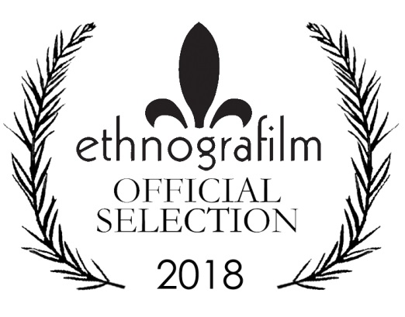

The Ethnografilm Festival
Ethnografilm seeks to enhance our understanding of the social world through film. From the 3rd through the 7th of April 2018 in Paris, France, the festival features over 100 works by documentary and academic filmmakers.

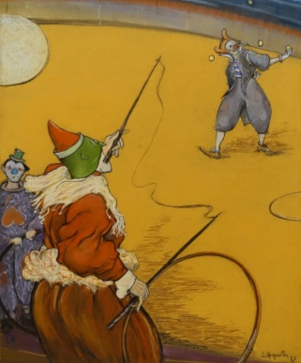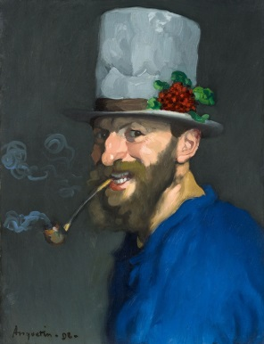
About the Cover
Our cover and 2018 poster feature the Cirque Fernando (1887) by Louis Anquetin (self-portrait above), whose style of flat regions of color and thick, black contour outlines was called cloisonnism. He moved to Paris in 1882, associating with Émile Bernard, Toulouse-Lautrec, and Van Gogh during the early development of Montmartre as the artistic center of Europe and the origin of poster art. In the mid-1890s he returned to the study and methods of the Old Masters, particularly Rubens.

Paris! City of Light & Cinema
Ciné 13 Théâtre is located next to the Moulin de la Galette in Montmartre, the summit of the city. History, character, ambiance? Countless films have been inspired by this corner of Paris.
Take the metro to Blanche station. Step outside to find yourself in front of the historic Moulin Rouge, so memorably re-imagined by Baz Luhrmann. You’re at the foot of the delightful market street, Rue Lepic, where Amélie Poulain worked as a waitress, in director Jean-Pierre Jeunet’s eponymous film. Take a moment to buy a delectable tart at the Petit Mitrons bakery, then stroll up the hill. You’ll pass the apartment where Van Gogh lived with his brother Theo, and the Moulin de la Galette, famously painted by Renoir.
This part of the city is filled with historic film theatres—from the blockbuster Pathé on Place Clichy to the tiny Studio 28, the first avant-garde cinema in France. Here, Louis Buñuel premiered his surrealist collaboration with Dali, L’Age d’or, though by the time it premiered the two temperamental creators were no longer speaking!
The home of Ethnografilm, Ciné 13, is at the corner of Junot and Girardon. The cinema is right across the street from the print shop where Picasso once studied print-making. Down rue Junot is the former home of famous Dadaist Tristan Tzara. Austrian architect Adolf Loos designed the unusual home in 1926. The house next door once belonged to famous poster designer Francisque Poulbot. His illustrations of Parisian street urchins were so well-known that street kids became “poulbots” in the city’s ever-evolving slang. Street life in the 18th arrondissement is still fascinating. On the far side of the Butte, or hill, of Montmartre, is one of the city’s most varied and vibrant neighborhoods, with thriving West African food markets and traditional Arab cafés where you can smoke a hookah or narghile.
Our venue Ciné 13 has its own amazing story. Director Claude Lelouche bought the cinema in 1983 to use as a set. He renovated it into a 1920s-era club for his movie Edith et Marcel, the story of singer Edith Piaf’s tragic love affair with a boxer. Upon completing the film, Lelouche turned his set into an atmospheric movie theatre. Today his daughter, Salome Lelouche, runs the programming. And during Ethnografilm, April 17th to 20th 2014, every festival night we will retire to the argumentarium (our cosy Ciné 13 lounge) to discuss the films over a glass of superlative Bordeaux.

Director’s Welcome
The fifth annual Ethnografilm is a moment to cherish for filmmakers, scholars, and all those who brought this diverse group to Paris. The Society for Social Studies of Science and the International Social Science Council have been instrumental in implementing the vision of a festival to celebrate excellence in movies that enhance our understanding of the social world.
Ethnographic film—“ethnografilm” in Greg Scott’s coinage—has been broadly defined, yielding a huge variety of styles, formats, and themes.
We have the best fringe theatre on the planet at the highest point of Paris! Most important, we have a community of filmmakers and scholars gathered for present inspiration and collaborations yet to come. What could be better?
Wes Shrum

Challenging Audiences—and Filmmakers
How does ethnographic film articulate critical analysis with critical participation? Videographic study can make visible in powerful ways what is hidden in an arena of study. It can challenge dominant images of that arena while formulating and attempting to scale up alternative images. As a form of knowledge production and committed expertise, ethnographic film often races past the written text, challenging audiences both within and beyond its chosen field to think and do differently. To have effect, it must theorize without jargon. It must provoke without driving away or pandering to its viewers. Ethnographic film must both trouble and fit.
The Society for Social Studies of Science (4S) has long supported critical analysis of the production, distribution, and utilization of knowledge and expertise. It now also formally supports creative initiatives to articulate critique with participation. For this reason, the 4S enthusiastically supports Ethnografilm. What is videographic study for? What are ethnographic filmmakers for? The 4S challenges videographers and their audiences to wrestle with these questions, and we look to you for insight and direction. Thank you for accepting the risks and making the effort to rethink and redo knowledge and expertise through film.
—Gary Downey, Past President, 4S

Organization
Executive Director: Wesley Shrum, Louisiana State University
Associate Director: Gregory Scott, DePaul University
Assistant Director: Matthew Harsh, Concordia University
Festival Manager: Mathieu Denis
Local Festival Organizers: International Social Science Council
Festival Production Team: Jewell Simon, Luke Driskell
ART For FILM Team: Susan Arnold, Simon Baxter
Publicity and Design: Steve Coffee
Co-Founders: Wes Shrum and Greg Scott

Executive Committee
Ron Harpelle, Professor of History, Lakehead University, Canada
Kelly Saxberg, Independent Filmmaker, Thunder Bay, Canada
Molly Merryman, Kent State University
William Shewbridge, University of Maryland, Baltimore County
Kathryn Kasic, Montana State University
Michael Frierson, University of North Carolina, Greensboro
Lisa Pasold, Writer, Paris
Sylvie Jacquemin, Cinematographer and Director, Paris
Robin Starbuck, Sarah Lawrence College
Sam Smiley, Astrodime Transit Authority
Roger C. Barnes, University of the Incarnate Word
Audrey Appleby, Filmmaker and Singer
Rik Scarce, Skidmore College

Advisory Board
Kim Fortun, Rensselaer Polytechnic Institute
Xela Batchelder, Waynesburg University
Diana Nicolae, Rowan University
C S Venkiteswaran, Festival Director, Kerala, India
B. Paige Miller, University of Wisconsin, River Falls
Barberine Feinberg, Département Hommes, Natures, Sociétés, Centre National de la Recherche Scientifique, Paris
Jean Claude Penrad, Directeur de l’audio visual, L’Ecole des Hautes Etudes en Sciences Sociales, Paris
Sreevasudeva Bhattathiri, Graphic Designer, Thiruvananthapuram
Linda Layne, Washington DC
Leandro Medina, Universidad de las Americas, Puebla, Mexico
Meredith Gontard, Directrice Artistique–ACM Ballet Théâtre
Kelly Moore, Loyola University, Chicago
Françoise Foucault, Comité du Film Ethnographique, Muséum National d’Histoire Naturelle, Paris
Antony Palackal, Loyola College of Social Science, Kerala, India
Wenhua Kuo, National Yang-Ming University, Taiwan
Steven Zehr, University of Southern Indiana
Madeleine Akrich, Ecoles des Mines, Paris

Partners
International Social Science Council (ISSC), has the mission of advancing the social sciences – their quality, novelty and utility – in all parts of the world.

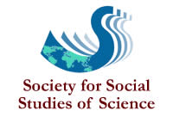
The Society for Social Studies of Science (4s), is a nonprofit, professional association with an international membership of over 1200. The objective of 4S is to bring together those interested in understanding science, technology, and medicine in their social contexts.

The Video Ethnography Laboratory was established at LSU as a resource for graduate teaching and video ethnographic research.

Journal of Video Ethnography

Art for Film
Ethnografilm collaborates with Lee Magnet of Baton Rouge, Louisiana to embellish the gallery of the festival theatre (Cine 13 Theatre in the Montmartre District) with artwork representing the selected films.
Through this initiative, Lee Magnet has created an absorptive environment for the screening and discussion of films selected by the festival committee. Each attending filmmaker will be presented with an artwork based on a screen shot from their film.
Susan Arnold
Director, Art for Film Program, Lee Magnet

Student Artists

Me-Gann Adolpho
Syed Ahmed
Hallah Bakari
Jada Barber
Sydney Barker
Alex Bell
Miracle Bell
Sierra Beverly
Bryanna Brown
Everett Brown
Grace Bruscato
Kayla Bullard
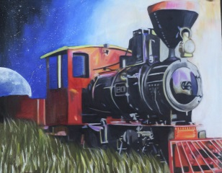Jenna Burns
Jalaya Burrell
Taylior Burton
Destiny Campbell
Ethan Cheong
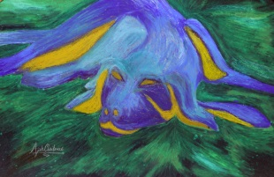
Ajah Claiborne
Anna Cole
Maya Cook
Ariel Cotton
Alaysia Deflanders
Leigha Daliet
Destiny Daniel
Alyssa Dao
Olivia Delahoussaye
Erica Doherty
J Dornier
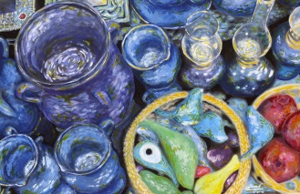Hannah Elkholy
Mckenzy Ellis
Caliyah Eskridge
Alexander Esteban
Joline Fontenot
Bajean Franklin
Kendyl Gipson
Jadon Gunn
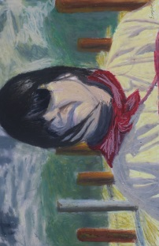Eugene Harry
Serena Herbert
Jordan Hertzog
Raven Hogan
Takeyah Howard
Gabriel Jackson
Keyvon Jackson
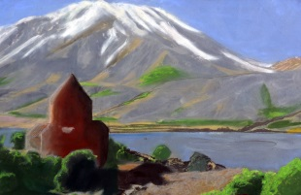Jabril Johnson
Kaelyn Johnson
Kennedi Johnson
Kirstin Johnson
Alaina Jones
Arionna Jones
Kylerian King
Darlene Luzaran
A’niya Lagarde
Tessie Landry
Taryn Lavignette
Hannah Lu
Miracle Marcelle
Ava Martin
Yasmin McCray
Maria Menendez-Flores
Denis Menjivar
Georgette Metrailer
Madeline Miletello
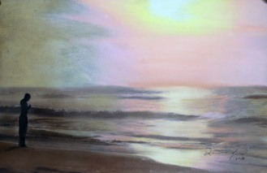Darlene Miranda
Joseph Moore
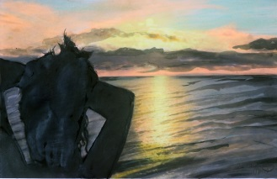Jasmine Morris
Zipporah Myles
Wenlin Ng
Anh Nguyen
Chyna Page
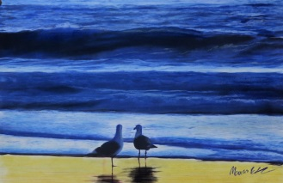Manas Patel
Reymon Paulino-Estrella
Finn Phung
Pratima Pinnepalli
Courtney Platt
Hayden Ponjuan
Taniyah Porter
Da’Kyira Pritchett
Homaira Qalandari
Dilia Reyes-Hill
Victoria Riley
Cayla Royster
Yuxuan Shen
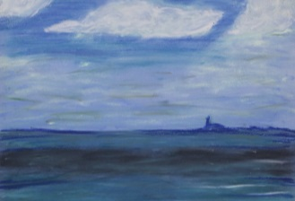Latavia Simmons
Ashlei Smith
Brianna Smith
Lauren Stevens
Michael Stewart
Victoria Crawford-Stewart
Elizabeth Street
Melek Sumer
Elaine Tagge
Genevieve Terito
Olivia Terito
Natasha Thorpe
Lenae Tillery
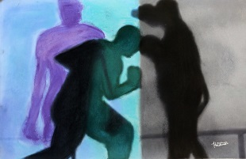Kristina Ton
Krystal Ton
Arianna Tran
Christian Turner
Denise Verrett
Desiree Verrett
Carmise Wade
Jalin Walker
Destiny West
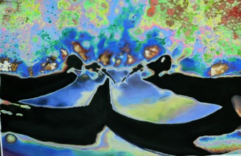Ashlin Wharton
Gaylyn Williams
Geremiah Wilson
Evonne Yang
Sydni York

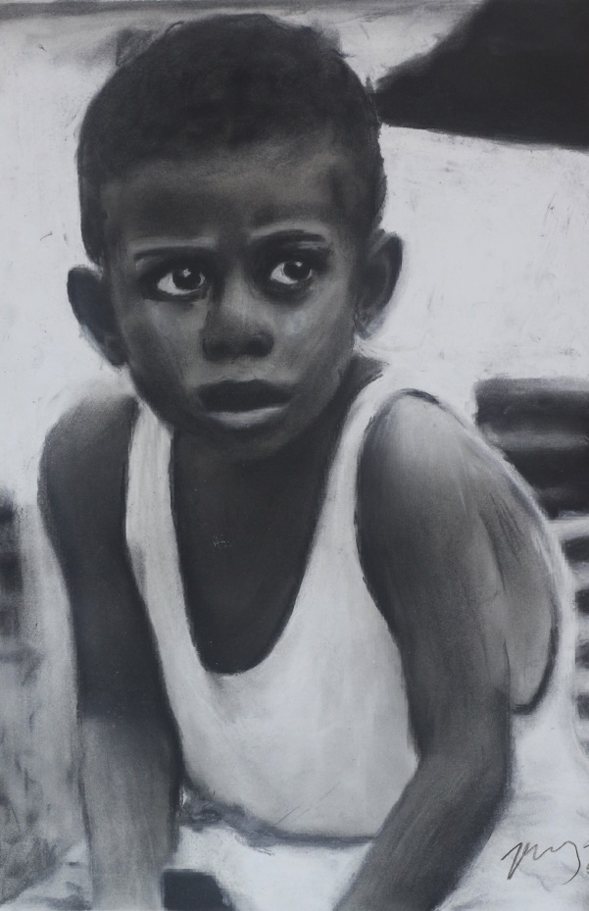

690 Vopnafjordur
Karna Sigurðardóttir / Iceland / 57 min
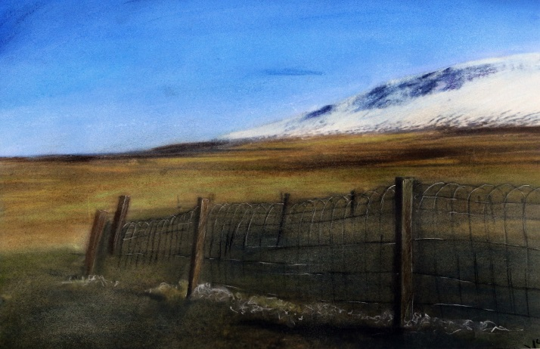
In the middle of nowhere where most could not even imagine living, the 645 villagers of Vopnafjörður can't think of a better place to call home. Where single individuals carry the responsibility of ensuring and defining the community's future, the fear of depopulation leaves no one freed from the pressure of protecting the existence of their little village. Through testimonies of everyday experiences, the people of Vopnafjörður share how its identity is profoundly linked to the fjord.

Across Gender
Anouk Houtman / Indonesia / 25 min
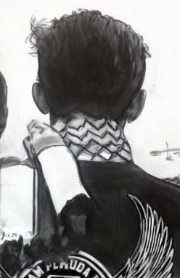
‘Across Gender’ is an ethnographic film about the negotiation of visibility of trans people in Yogyakarta, Indonesia. Focusing on personal experiences of different people who ‘cross gender’ we follow LGBT-activists, drag performers, and students of an Islamic school for transwomen. The stories are documented in the midst of anti-LGBT sentiments and actions in early 2016 and illustrate an ongoing and difficult process.

Actors of Sound
Abelardo Molina / Finland / 82 min

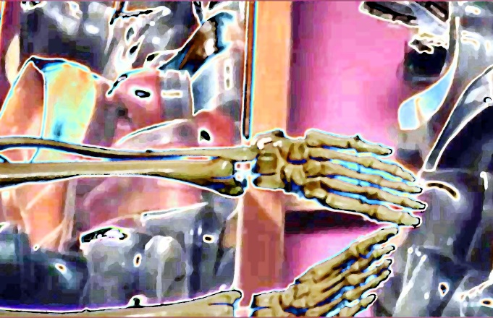
From footsteps to bone cracks, Foley artists bring films to life with their imaginative sound effects, but as digital technology goes full speed ahead in 21st century moviemaking, can Hollywood's low tech Foley artist survive in this high tech age?

AM
Rosie Needham / United Kingdom / 7 min
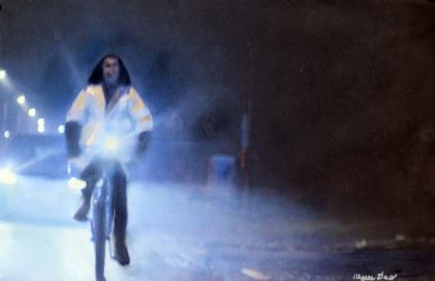
Three intimate and touching stories from people who love working early in the morning.

Ancestors We Hear You
Patty L Collins / Peru, United States / 24 min
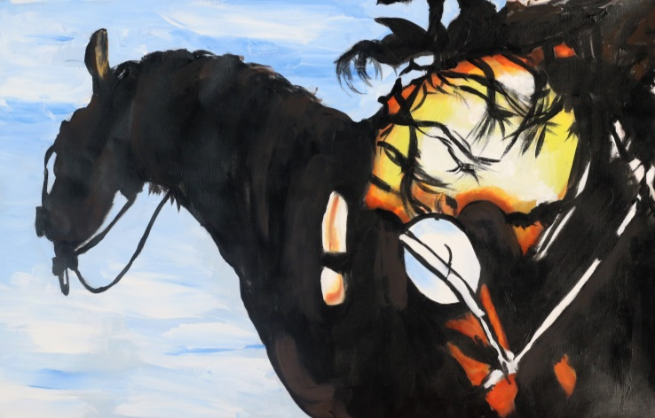
We can change the current paradigm of power and control over people, land, water, and religion. We can restore and mend our relationship with one another and all creation. Ancestors We Hear You is a documentary by spiritual tribal elders. Ancestor Thomas Banyacya(Hopi), Jorge Luis Delgado (Inca), Richard Moves Camp(Lakota), Rosanna Kagenveama(Hopi), and Leon Rattler(Blackfeet) remind us all that our thoughts, prayers, and behavior affect all creation.

Antigone
George Nicholas / United States / 13 min
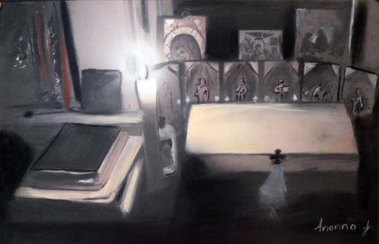
A filmmaker is asked by his dying mother to write her obituary. A twelve minute meditation on life, death, presence, religion, family, emptiness and light.

Atlantic City Character Study
William Linker, Benjamin Carey / United States / 29 min

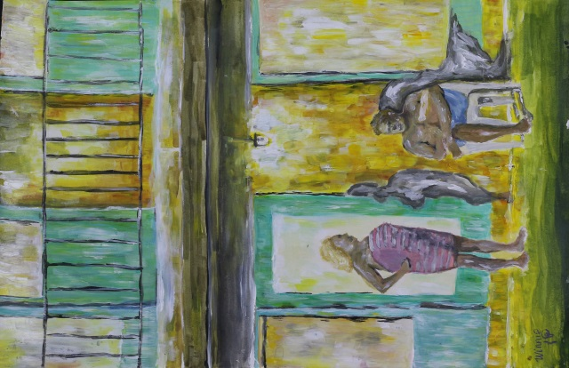
An eerie microcosm of Trump's America, Atlantic City is in the midst of an identity crisis. Once the most popular family vacation destination in the United States, the city has slid into a dystopian version of its former self with beachfront property plummeting amidst vacant lots and deserted high-rise hotels garishly positioned against the coastal backdrop. As the city tries in vain to regain its footing, residents are left living in the broken shell of a city. "Atlantic City Character Study" provides an unfiltered look at what it means to live in a once iconic American resort town, surrounded by the glory of the past as it struggles towards an unknown future.

Authenticity
Wes Shrum - Kerala, India - 19”
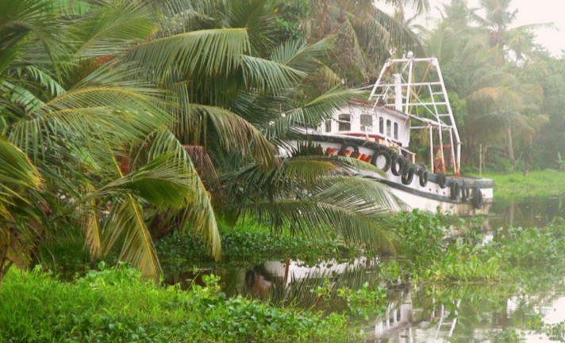
Ayurveda is regarded as the oldest documented healing system in the world. 5,000 years ago in India, medicines were prepared with green plants, herbs, and minerals, while ancient manuscripts were preserved on bark and stone. For most of its 5,000 year history, healers have sought authentic ayurvedic practice. We examine five different ways of realizing authenticity, ending with the oldest—with surprising results!

Bakery
Hashim Didari / Afghanistan / 8 min
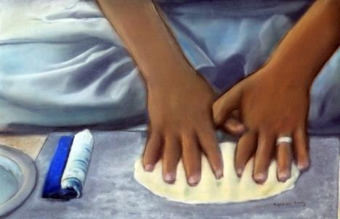
The oven is hot. Bread is made. The man says he has worked at the bakery for 15 years. He is 25 or 26 years old. He does not know for sure. Times are hard, but for a year he has had his own bakery where he employs trainees. Baking bread is a difficult skill. The hardest thing is to make the dough from which the bread is made.

Ballad of the Knife Sharpener
Khalid Ali / China / 19 min
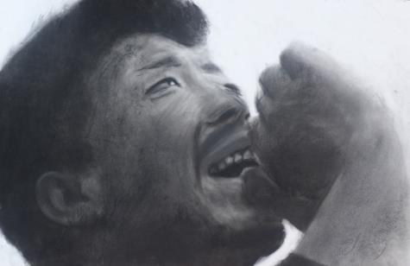
A young knife sharpener from rural China uses his penetrating voice and songs to attract customers as he tries to make ends meet on the streets of Beijing.

Becoming Beautiful: Ballroom Dance in the American Heartland
Joanna Bosse / United States / 19 min
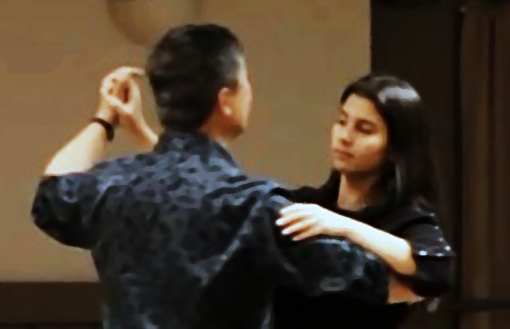
A documentary film about the transformative power of dance in the lives of average, everyday midwestern Americans.

Belgian Blues
Kevin Waldie / United Kingdom / 25 min

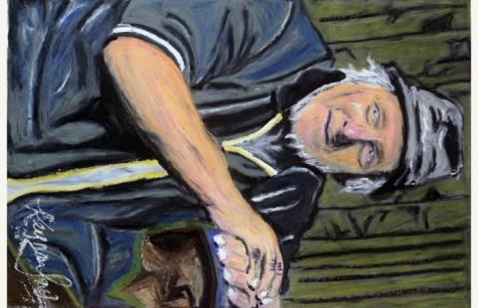
Richard has just turned 70 years of age, but he has no plans to retire, just yet. He works alone, tending a small herd of dairy cattle. Even though the relentless physical demands of the work are now taking their toll, Richard finds it hard to imagine what a future life would be like without his cows. An observational documentary, filmed during the summer of 2016 against the backdrop of the EU referendum.

Bell Tower of False Creek
Randolph Jordan / Canada / 12 min
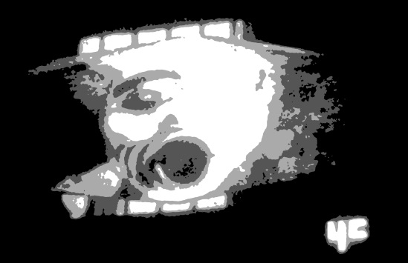
Bell Tower of False Creek is an experimental documentary investigating overlapping issues of urban soundscape design, indigenous land claims, and creative archival practices in the city of Vancouver, BC, Canada. The film uses the church bell as metaphor for the traffic on Burrard Bridge. It juxtaposes archival recordings of the WSP members in conversation about the city’s endangered sounds with new audiovisual material exploring current indigenous presence around the bridge. Amidst the fog, listeners are invited to imagine the sound of traffic noise recasting the bells of old as markers of territorial boundaries, and challenging stereotypical biases against urban noise pollution in order to rethink narratives that posit the death of indigenous culture in the face of modernization.

Beneath the Crown
Susan L. Gallagher, Lisa Mills / United States / 23 min
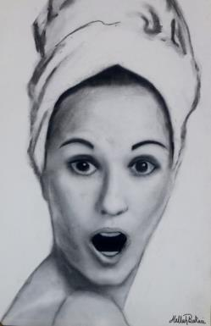
In 1967, Sylvia Hitchcock won Miss Alabama in a borrowed bridesmaid's dress. Less than a year later, this athlete and artist was crowned the most beautiful woman in the world. As her sparkle fades away in a small Florida town, Sylvia's inner beauty lives on beneath the crown.

The Biola of the Riau Islands
Karen Kartomi Thomas / Indonesia / 13 min
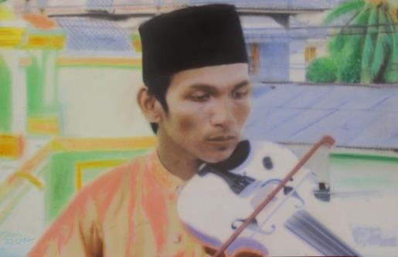
This is a first ever short film documentary on the violin (biola) of Indonesia's Riau Islands of the South China Sea. Original footage shows the beauty of the islands, the people, the musicians, and performing arts still largely unknown to the rest of the world.

The Blessed Envoy
Costas M. Constantinou / Cyprus / 26 min

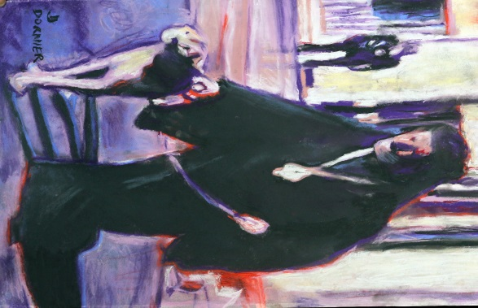
How is diplomacy akin to theatre? What kind of diplomacy did Cyprus exercise after independence? How far was it influenced by the religious office of its first President? What ambivalent scripts and visuals did Cypriot public diplomacy produce and disseminate? This essay film reflects on these questions through creative editing and explanatory analysis of nine documentaries, filmed between 1962 and 1973. These documentaries chronicle the official visits of President Makarios abroad, touring mostly Third World countries which were, like Cyprus, members of the Non-Aligned Movement. The Blessed Envoy speaks to the original footage and narration of these documentaries, doing so in an engaging and affective way, while reflecting on the spectacles and rationales of Cypriot and contemporary diplomacy.
Bonjour Bonsoir
Balteau Emilie / France / 54 min

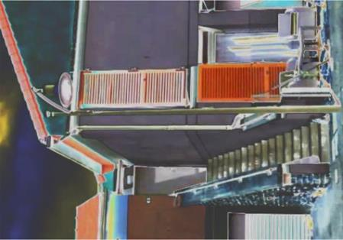
In a suburb of Auxerre (France), the three old towers gave way to small houses. Inside, inhabitants show us this movement. What it conveys of breaks. What it transports of continuity - that of a common condition, all in all popular, and alive.

Borderline Views: A Golan Heights Documentary
Simon Luling / Israel, Syrian Arab Republic / 29 min
The film looks at the border between Israel and Syria, through the experience of the Druze community - living in the occupied Golan Heights, they maintain a Syrian identity yet inhabit an Israeli reality, subject to the whims of the region's geopolitics. In the Occupation's 50th year, and with the Syrian Civil War raging, questions arise on the Golan and its Druze community.

Butterfly City
Director – Olga Černovaitė – Lithuania - 52”
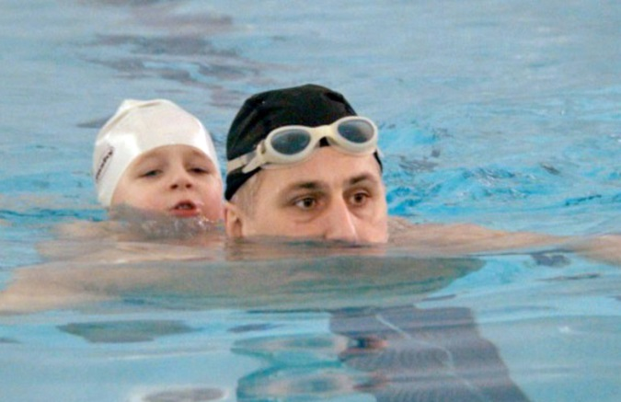
The Lithuanian city of Visaginas was created in the 1970s in order to service a powerful Soviet nuclear power station. Literally designed and shaped like the wings of a butterfly, it was intended to be a window of Soviet progress to the West. After USSR disintegration, EU membership meant Lithuania had to close the plant, the city’s main industry. At a time of growing geo-political tension, and in an ambiance of mutual mistrust, what does the future hold for its 25,000 Russian-speaking townspeople?

Charkpen (Hope)
Paulino Cadórniga / Argentina, Chile / 14 min
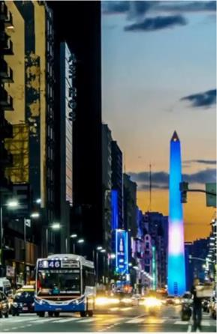
In the language of the indigenous Selk’nam people of the Isla Grande of Tierra del Fuego “Charkpen” literally means “hoping for something”. Corruption, wars, terrorism, environmental destruction, chaos. This is the reality of the “first world”. On the other hand, the indigenous villages and the legendary figures of the “gauchos” live directly in contact with nature, fighting to maintain languages, customs and ways of life.

Chidra
Nadav Harel / India / 50 min
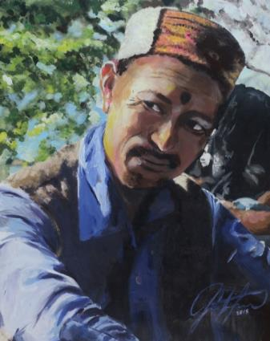
Chidra is an ethnographic essay on a hitherto undocumented human sacrifice ritual that takes place on the Himalayan frontier of the Hindu religious sphere. The film follows Ram Nath, a low caste peasant, as he travels to perform his duty as sacrificial scapegoat to the god Shiva. Transformed into a god in his own right, Ram Nath uses his powers to pierce through karma (“chidra”), absorbing society’s sins over three eventful days that culminate in his staged killing and resurrection. Chidra explores the humane undertones of this archaic murder ritual in a rapidly modernizing India.
China In Ethiopia
You Zhou / Ethiopia / 30 min
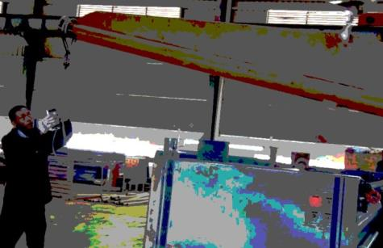
China in Ethiopia tells the stories of two employees from a Chinese manufacturing company in Ethiopia which produces plastic products. The first subject is an Ethiopian employee called Seifu who is an interpreter of Chinese. A Chinese employee Lei Zhang is my second subject, the sole resources purchaser for that company. With Chinese investment increasing, Ethiopia's economy has been growing rapidly in recent years, and Chinese manufacturing companies are the optimal work places for most Ethiopians.

Cockpit
Luke Malone / Indonesia / 5 min
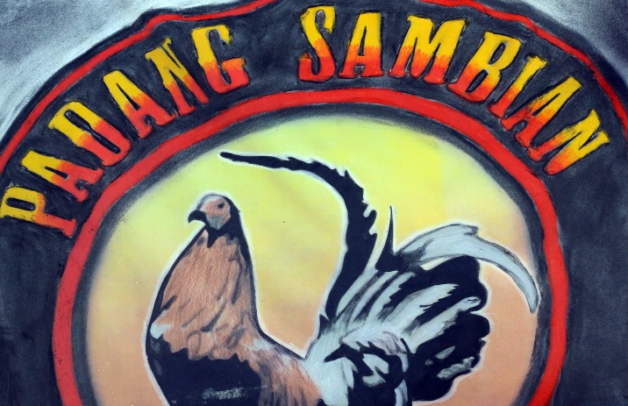
An illegal cockfighting event in Bali, Indonesia.

Coming Out of the Shadows - Albinism in Fiji
Christine Nestel / Fiji / 18 min
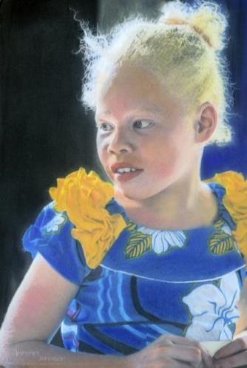
The untold story of Fiji's albino people and why, until now, they have been living in the shadow

Dominguez vs Dominguez
Tracey Anarella / United States / 15 min
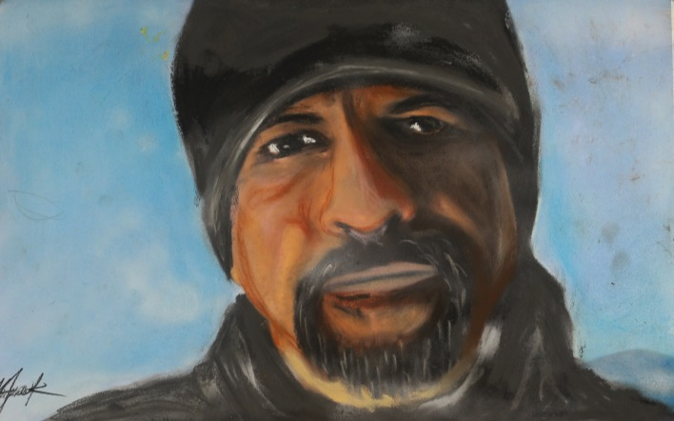
Michael Dominguez is a 61 year-old former championship boxer. The film explores why and how Michael went through his entire life as a boxer without ever learning how to read or write. A 61-year old boxer who won the 1981 Golden Glove 132-lb Open Championship Dominguez was also a member of the USA boxing team with Gold medalist Mark Breland. The opponents he was never able to beat are achieving literacy and himself. The film features Gold medalist Mark Breland, his sister, singer/songwriter Brenda K Starr, and Golden glove Trainer, Willie Dunne

Drag Kings
Elizabeth-Valentina Sutton / United Kingdom / 10 min
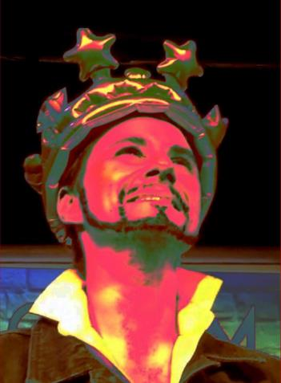
Explores the staunch and resilient spirit of people who perform masculinity on stage. Three drag kings from across the UK struggle with inequality they face within the drag community. In the shadow of drag queens, the kings are create art that holds a mirror to what it means to be human, rather than simply being defined by their assigned gender.

Drokpa
Yan Chun Su / China / 57 min
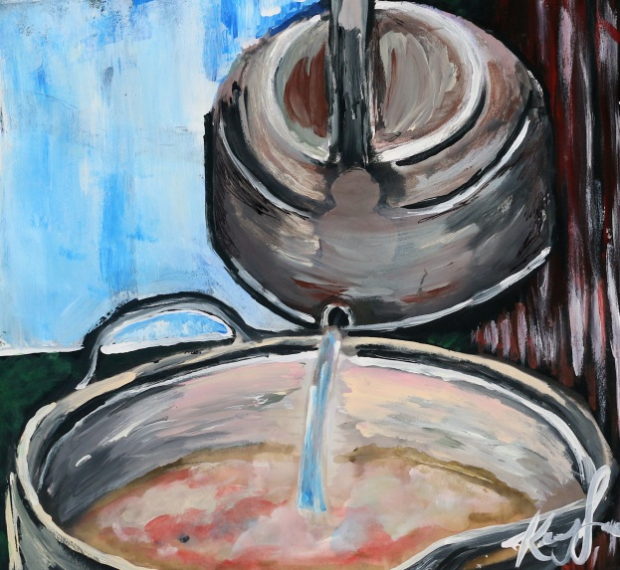
Set in the high plateau of eastern Tibet, Drokpa is an intimate portrait of the lives and struggles of Tibetan nomads whose life is on the cusp of irreversible change. The grasslands of the Tibetan plateau are home to the source of Asia’s major rivers. Nearly half of humanity depends on this water for survival. Tibetan nomads, known as DROKPA have roamed on this land for thousands of years. In recent decades, these once lush grasslands are rapidly turning into deserts.

Elegy For The Time Being
Tram Luong / United States, Viet Nam / 33 min
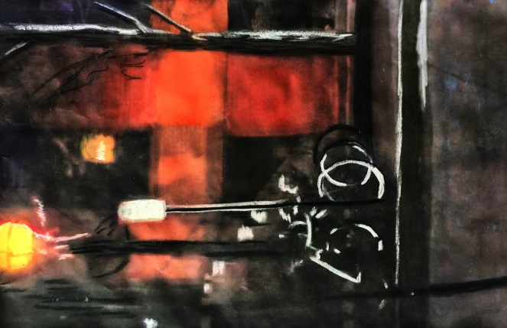
'She said no', and in that moment there was despair and hope. When the archive of memories become dead weight, stories have to be told anew. Elegy for the time being moves through the alleys of the life of Huỳnh Sanh Thông to weave together moments that glimmer and sink, waiting to be told, and retold. Enmeshed with the musical quest of An Tran, a young Vietnamese guitarist and a personal seeking of Tram Luong, a young storyteller, the life and times of Huỳnh Sanh Thông find a new spirit.

Every Other Couple
Mia Halme / Finland / 58 min
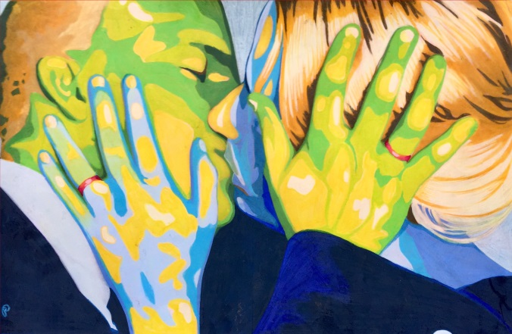
’That morning, neither of us knew that the same evening, we would be getting divorced. There had been no planning but when it happened, it was a moment of clarity.’ ‘Every Other Couple’ is a documentary film about moments when we realize that our life is going to chance for good. It’s a film about separation. The cast consists of three ex-couples. Some of them remember the moment of their separation in a radically different way. Their stories deal with events of common past and life after divorce which exists in scenes where ex-couples still have to deal with each other.

Face My Tribe
Michael Zomer / Myanmar / 4 min
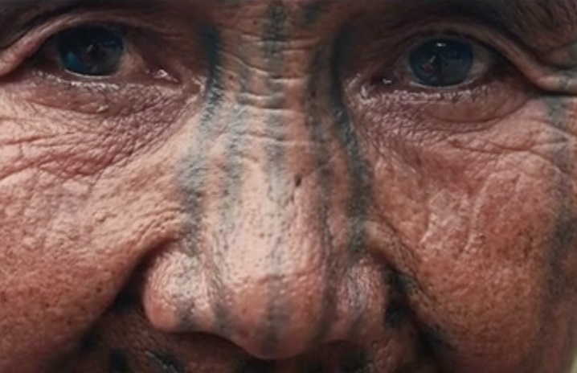
Take an exclusive look at the last generation face tattooed women living in the remote mountain areas of Myanmar. An ethnographic short documentary that uncovers the story behind their face tattoos and reveal how these tribes still maintain their life like their ancestors.

The Farm on Rice Lake Road
Justin Jones / United States / 11 min
This short film captures the filmmaker's family days before they will depart from their longstanding home on Rice Lake Road. A personal story about the significance of place and the ties that bind us to it.

A Feeling for Leaving
Dan Boord, Luis Valdovino / Czech Republic, Germany, United States / 9 min
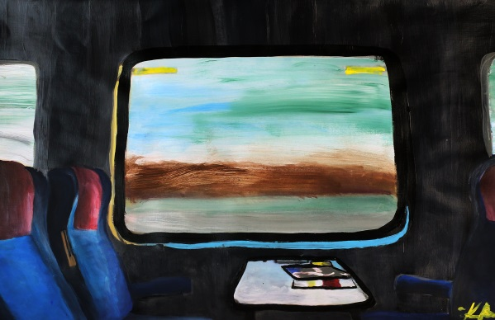
Think “…of anybody who goes anywhere or stays at home and is an American and you will realize that it is something strictly American to conceive a space that is filled with moving.” ― Gertrude Stein Stay all night, stay a little longer, Dance all night, dance a little longer, Pull off your coat, throw it in the corner, Don't see why you can't stay a little longer. ― Lyrics by Bob Wills and Tommy Duncan In this video we see a world from a rearview mirror, passing along 19th century settlement trails, monuments, gas stations, deserts, dinners, postwar suburbs and a movie motel drive-in.

Finding My Lebanon
Mark Abouzeid / Lebanon / 21 min
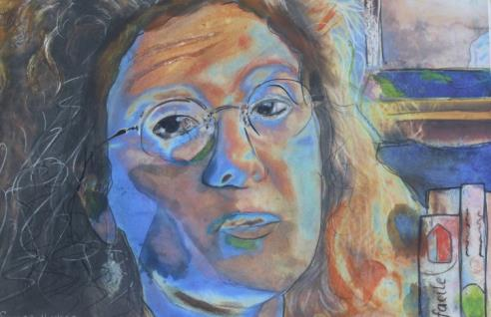
This is the story of a “modern nomad”, the kind of man who was raised without any knowledge of his roots, his past, his heritage. Before his father died, the nomad interviewed him on their family history and for the first time his past was revealed to him through stories, pictures and never met before family members. The film captures the lives of three men: the grandfather who left, the father who died and the son who returned to discovery his ‘home’…and the Lebanon he found.

Flight
John Mann / USA / 5 min
'Flight' was shot on Super 16mm film. It is a collaborative dance for the camera created by Susan Leslie Mann and John Bright Mann. The film explores the contemporary phenomenon of global diaspora.

Forever 'B'
Skye Borgman / United States / 53 min
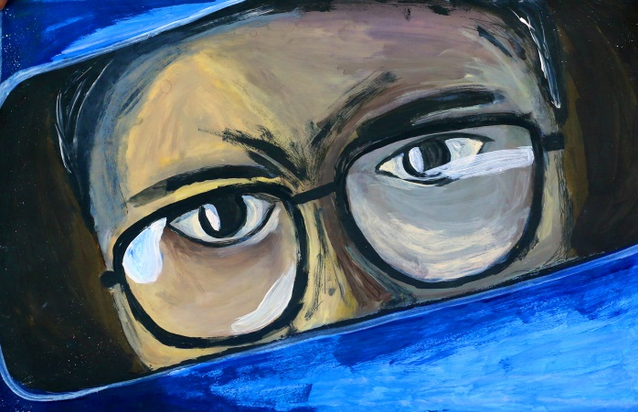
On October 17th, 1974, in the quiet town of Pocatello Idaho, 12 year old Jan Broberg was kidnapped by her family's best friend and neighbor. 18 months later, out on bail and awaiting trial for kidnapping, Robert Berchtold (Brother 'B' to Jan and her family) abducted Jan a second time, triggering a nationwide FBI manhunt. Through threats and brainwashing, Brother ‘B’ successfully turns Jan against her own family, while simultaneously manipulating her parents who paved the way for Jan’s abduction, in plain sight.

Fresh Start
Cigdem Slankard / USA / 13 min
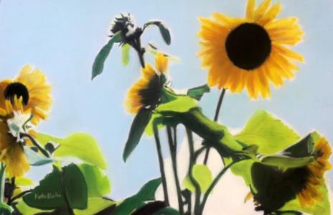
Fresh Start chronicles the experience of a refugee community who came to the US with one marketable skill, farming. It is the story of farmers with no farm, examining the American identity, the value of land and food in a brave new world.

Girls Don't Fly
Monika Grassl / Ghana / 52 min
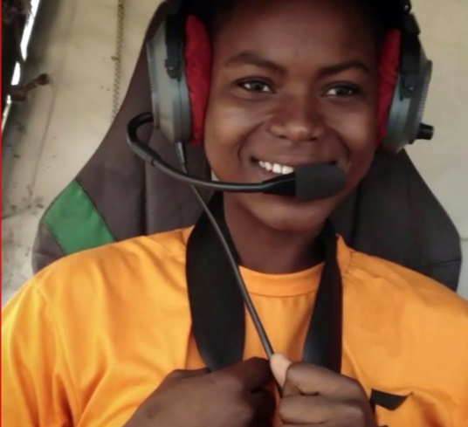
An airstrip, a hangar and a classroom somewhere in rural Ghana: This is the place where 18-year-old Lydia and 20-year-old Esther hope to achieve their dream: learning how to fly. They have joined the first aviation school for girls in West Africa. There, an ambitious Englishman wants to train young women from rural areas to become pilots. According to the praise it received resulting from vast media coverage, this flying school might be no less than a godsend for young ambitious girls, looking for a future beyond the patriarchal structures of their society. But appearances are deceiving.

Gold in the Ashes
Beth Grannis / Nepal / 17 min
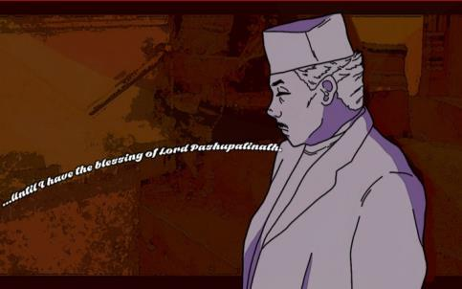
A Nepalese hospice doctor at a Hindu, open-air cremation site in Kathmandu, struggles to make sense of life and death in the moments surrounding the devastating 2015 earthquake.

Gorgeous Sisters
Inesa Kurklietyte / Lithuania / 30 min
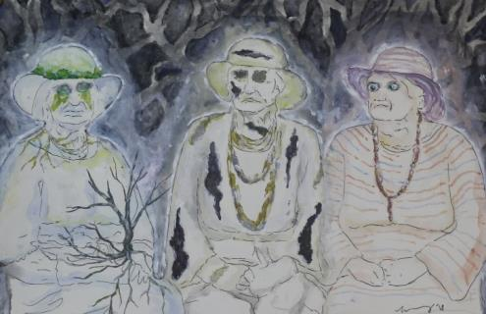
With humor and wit 4 eccentric singing sisters from Lithuania explore life, death, and the atrocities perpetrated by the Soviet empire upon their entire family.

Govan Young
David Archibald, Cara Connolly, Martin Clark / United Kingdom / 30 min
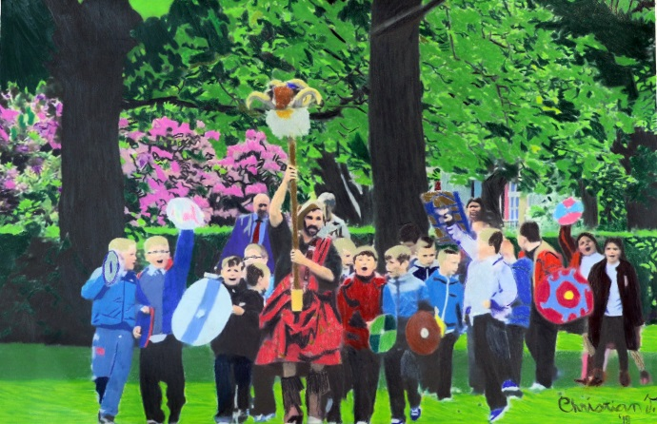
Govan Young follows a group of schoolchildren as they learn the rarely-told story of the Viking invasion of Central Scotland and the subsequent establishment of the medieval kingdom of Strathclyde, which had its spiritual centre in Govan. How will the children react when they discover that Vikings and kings walked on the ground below their feet?

I Shot Einstein
Dan Evans / United Kingdom / 8 min
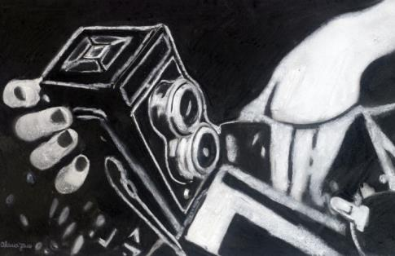
New York, 1948. Marilyn Stafford is handed a Rolleiflex, and told she is to take photographs of Albert Einstein. A film about the life and work of veteran photojournalist Marilyn Stafford, who blazed the trail for modern female photographers.

The Iron Dream
Yaser Talebi / Germany, Iran, Islamic Republic of / 36 min
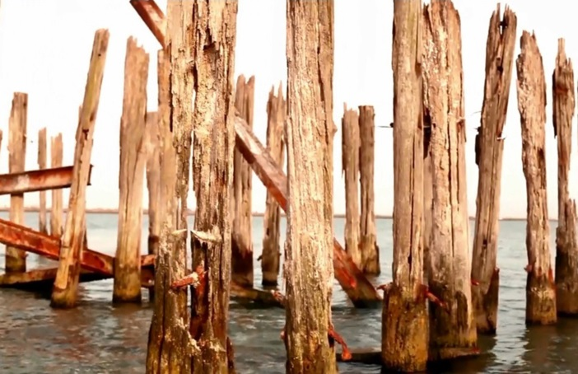
A revolution was launched after Reza Shah inaugurated the North-South Railway in 1938. Construction of the Iran’s countrywide not only changed the Middle East but it also changed the whole world. This Railway was famous as the “bridge of victory” by the allied forces.

The Island
Adam Weingrod / Israel / 59 min
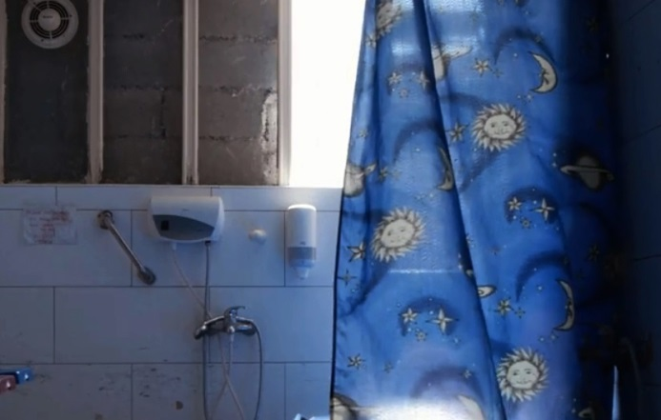
An intimate glimpse into the rich human mosaic of the St. Louis French Hospital- a Hospice for terminally ill patients, situated on the tense border between East and West Jerusalem across from the walls of the Old City. For two years the Director accompanied patients and caregivers – each one and his own story. In the film moments of humor and sadness from life itself between the hospital walls.

The Journeys of Mário and Tzara
Maria Nefeli Zygopoulou / Brazil, France, Romania, United Kingdom / 33 min
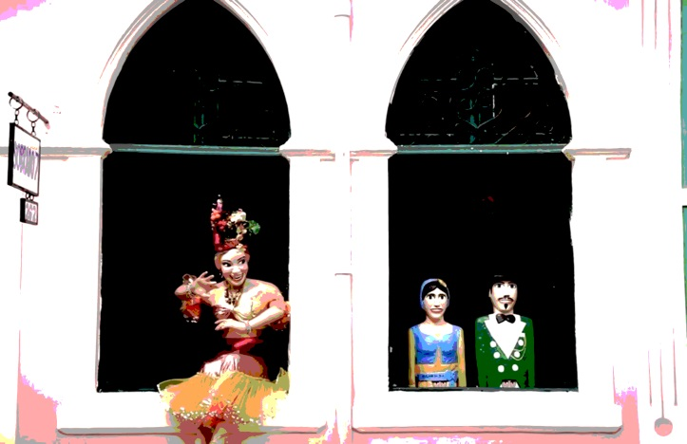
From Brazil to Romania, the film is a comparative look at the journeys and work of Tristan Tzara, the founder of Dadaism and of Mario de Andrade, a key player of Brazilian modernism. Through their life and travels, we look at their contribution to the body of 20th-century avant-garde and at the surprising similarities between them.

Keep them Talking
Simon Frey / Jamaica / 20 min
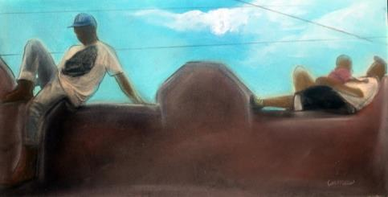
United-Kingdom, Jamaica / 2016 / Jamaican Patois and Jamaican English In Youthy’s world ‘nobody can be trusted’! Set in rural Jamaica Keep them Talking tells the story of Youthy, a farmer struggling to make a living. Everybody is against him. They steal from him, put spells on him and try to keep him down. It has all got too much and this is the final straw. The only way to turn things around is to take action and to throw spells back at them. Keep them Talking gives an exclusive insight into today’s social reality of Obeah (witchcraft), an illegal practice in Jamaica since 1760. Obeah is shown not only as a means to reach one’s personal goal but rather as a key point in social relations.

Kitani, my son returns from the groves
Lorillard Marie / Côte d'Ivoire / 47 min

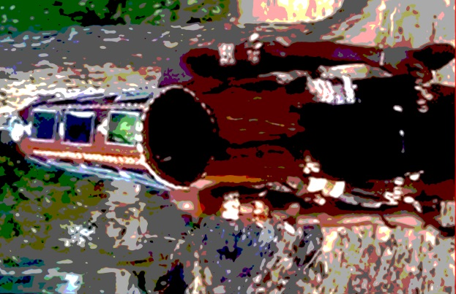
March 2013, Northern Ivory Coast… in the village of Fonnikaha. We are awaiting the return of Kitani, the youngest son of a family from the village, who left to undertake his initiation rites in the sacred groves. The Senufo people refer to this initiation as poro. Men and women alike wait with bated breath for the moment when the tchélé, those undertaking the initiations, ‘return from the groves’ and rejoin the community. Are they still alive? Through words and gestures, the women translate their emotions, which this special day arouses. A poetic documentary of ‘many voices’ filmed around this ritual.

Kukshel Guys
Salavat Yuzeev / Russian Federation / 34 min
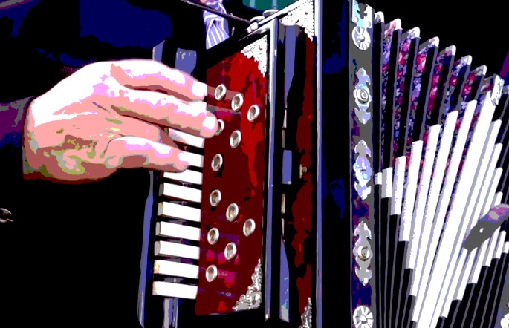
The film shows an ancient sacred unique Tatar rite of Seren, preserved in the village of Kukshel, Kukmorsky district of the Republic of Tatarstan. According to ethnographers, the rite is connected with seeing off the recruit men. It referes to the rite of male initiation. It is organized by young guys. They are specially dressed in national Tatar clothes. All the villagers take part in the ceremony. The rite starts at midnight, continues throughout the night and till the following afternoon. It ends only after the guys have bypassed with songs and dances all the streets of the village and visited every house, collecting gifts, thanking the hosts for the prizes and treats, and inviting everyone to the festival.
Kwanxwala - Thunder
Sarah Shamash / Canada / 28 min
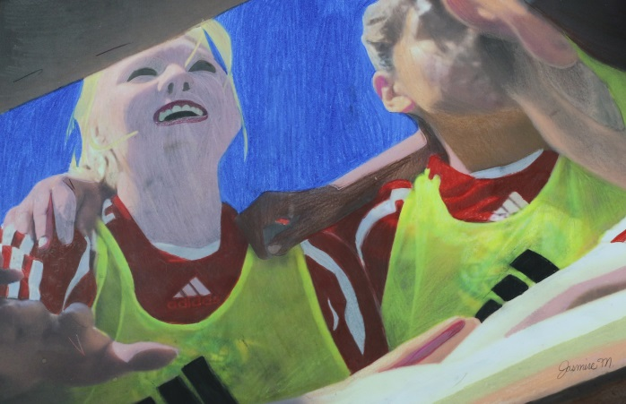
Kwanxwala – Thunder intertwines Canadian history, indigeneity, colonial legacies, feminisms, and sport. Shot over the period of several years (2009-2015), this creative documentary constructs a portrait of Alert Bay through soccer and its history. The film's impressionistic approach takes us through the history of the incorporation of soccer into kwakwaka'wakw culture despite its colonial roots while highlighting multiple generations of women soccer players. The multiple formats used to make this film: archival footage, stills, super 8, standard definition, drone, and HD, establish a less linear documentary tone in an aesthetic that is more akin to the film essay, DIY and experimental film.

La Débutante
Lena Tosta / France / 45 min
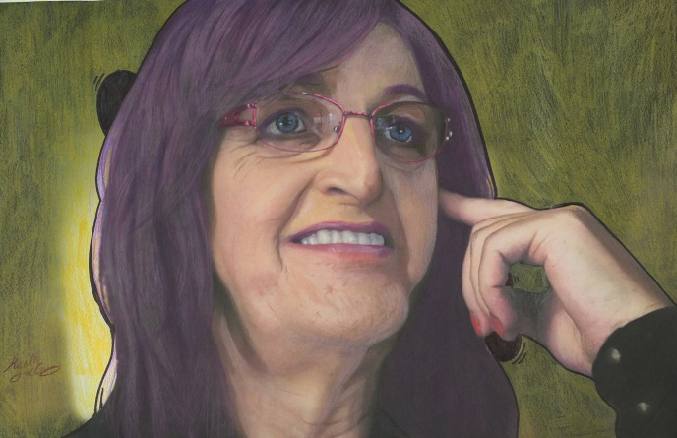
LA DÉBUTANTE journeys into the life of a 56-year-old trans woman who realizes it’s either transition or death. The documentary film is an inspiring portrayal of the blossoming of womanhood and a testament that it’s never too late to become who you are.

La Flor Settlers
Florencia Bohtlingk / Argentina / 57 min
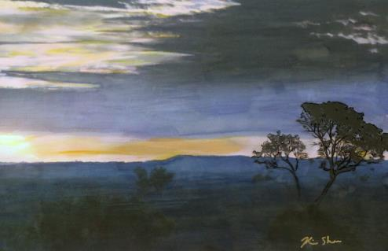
Portrait of a small farming and herding village in Misiones jungle, Argentina.Testimonies of the arrival to the place with little or almost nothing, are mixed with affective histories and the daily tasks of food provision. "La Flor Settlers”is a pictorial and human documentary about the feeling of belonging and the struggle for the land.

La Otra Manera (The Other Way)
Joshua Marks / Peru / 9 min
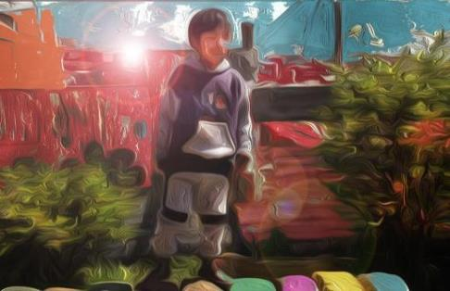
Just outside of the major tourist city, Cusco, Peru lies Tankarpata— an impoverished, rural community. Although the town's local primary school focuses on traditional education, Eduardo Huaynamarca encourages liberal arts and creativity at the after-school program, "CooperarPeru." Through the organization, Eduardo and volunteers strive to develop each child's potential, as well as promote the overall health of the community.

Lady Eva
Dean Hamer, Joe WIlson, Hinaleimoana Wong-Kalu / Tonga / 11 min
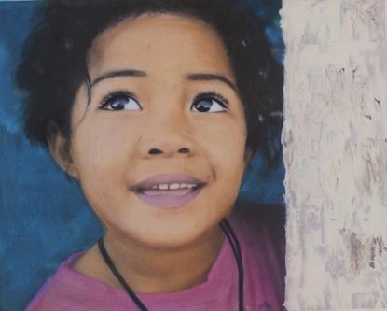
A brave young transgender woman sets off on a journey to become her true self in the conservative Pacific Island Kingdom of Tonga – with a little inspiration from Tina Turner along the way.

The Last of the Fashions
Ilary Sanna / Italy / 21 min
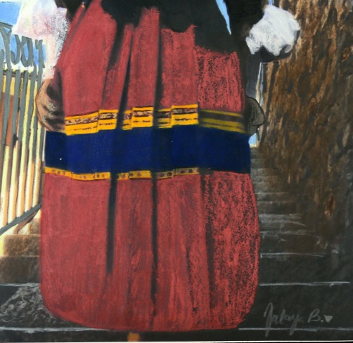
Stigma of backwardness or proud symbol of identity, in the last decades of the 20th century the memory of the Sardinian traditional costume has been given in custody to museums and folk groups. In 2017, just a very small number of elderly and stubborn women in a very small village in the centre of the island still wears it. These ninety-year-old women never wore anything but the traditional costume since they were children, and they are not planning to give up their colourful dresses and headscarves for civvies.They are the last guardians of a centuries-old tradition.

The Last Pig
Allison Argo / United States / 55 min
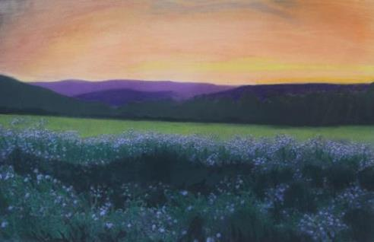
THE LAST PIG is a lyrical meditation on what it means to be a sentient creature with the power to kill. Deeply immersive and experiential, the film follows a pig farmer through his final year of slaughtering pigs. The bucolic life of the pigs on the farm is ruptured by weekly trips to the slaughterhouse. Through sparse, intimate musings, the farmer reveals the growing conflict of a life spent “peddling in death.”

The Last Warriors
Valentina Ippolito / China / 12 min
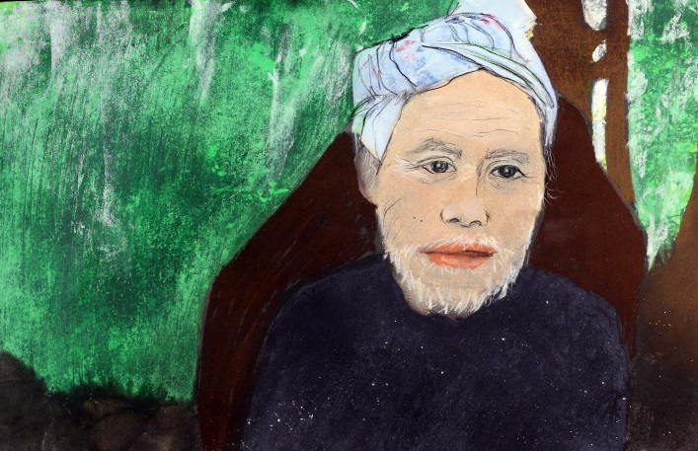
Set in the thickly forested mountains of Guizhou Province among the wooden houses of the Miao people of Basha village, The Last Chinese Warriors is an episodic short film exploring the gendering of Miao warrior culture throughout the circle of life, as seen through the outsider lens of a female European filmmaker. The film represents Miao men as caregivers and pillars of strength in their society. Beginning with the end of life, the film deconstructs the male Miao journey into five distinct phases: death, senescence, adulthood, youth, and birth.

Life is Art
oksana sokol / Australia, Indonesia, Russian Federation, Switzerland / 44 min
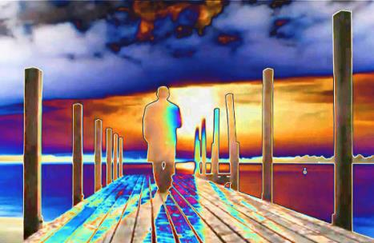
“Life is Art” is a homage to the creative principles of one of Russia’s most extraordinary contemporary artists, Anatol Brusilovsky - a collagist, an inventor and a lover of life. Brusilovsky has been pushing the boundaries of art in new directions since the 1950’s and has been called the Russian Picasso and Dali of his time. Anatol Brusilovsky is a Surrealist and Abstractionist who is famous for both his cutting edge work and the notoriously vivacious and colourful life he’s carved out living under the perils and structures of the Soviet regime.

Lighting the Abyss
Lucas King Weber / Greece / 6 min
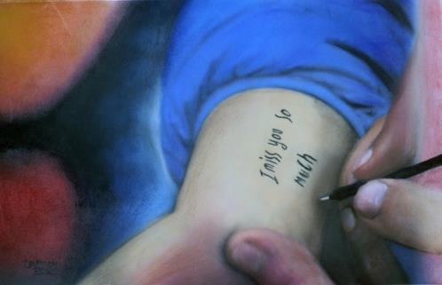
At the height of the Syrian refugee crisis, early 2016 widespread media coverage took hold of the issue. Reporting became less focused on the theaters of war about more about those displaced by such atrocities. This is one story. One of many millions. Since the time we were there, February 2016 many of the borders have closed. Alongside most other journalists attempting to demystify one of the worlds most complex situations— we left; confused by the injustice. Meanwhile, tens of thousands of people are trapped in faltering Greece—forgotten by the world.

Like Shooting Sardines in a Barrel
Lieza Louw / South Africa / 64 min
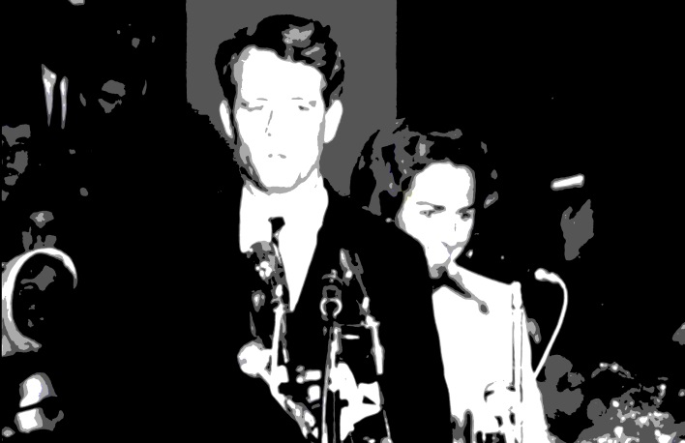
In South Africa, as in the rest of the world, students are recognised as change agents. When the apartheid government proposed a bill to enforce separate universities for blacks and whites, students and staff from the University of the Witwatersrand, staged the first ever-academic protest march. … like Shooting Sardines in a Barrel focuses on anti-apartheid protests at Wits from 1957 to 1987. The documentary situates these events within the historical and political context of the country at the time.

Lives among Waters
Oana Ivan / Romania / 50 min
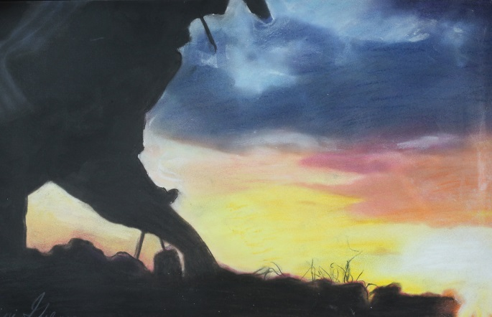
The summer of 2009 I start my PhD research in anthropology, in a fishing village inside the Danube Delta UNESCO Biosphere Reserve (Romania). I do not speak their language, I am 800 kilometers away from home and, walking by myself, I can only buy bread. For everything else I need a boat, as the Khakhols, the small ethnic group that I am studying, live in a remote, idyllic place, surrounded by waters. Everything looks wonderful. The “hands in” approach (filming while cooking and fishing myself with the locals) offers me an inner perspective. I understand how tourism, conservation management of the ecosystem and poaching put tremendous pressure on this small community.
Love Cuts
Karen Reis / New Zealand / 20 min

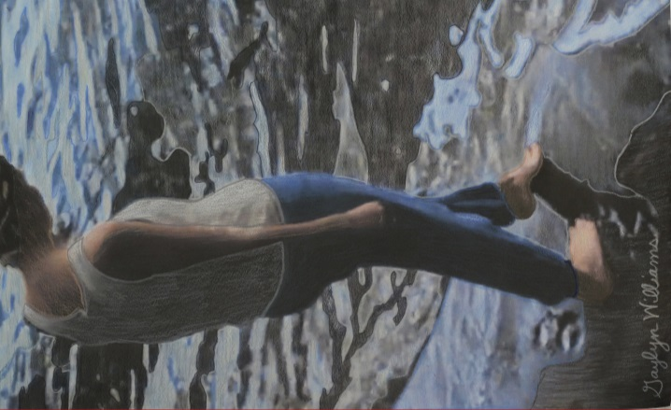
The speculative nature of this short documentary investigates what love is now, within the perspective of four young people living in Auckland, New Zealand. Their revealing thoughts are presented through intimate forms of poetry and an unaltered realism that infuses their never ending questions and anxieties about what it means to be in love.

Mada Underground
Denis Sneguirev , Philippe Chevallier / Madagascar / 26 min
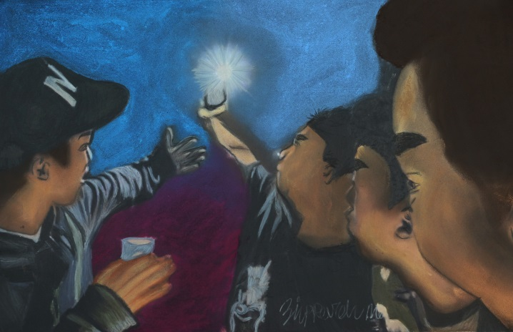
They are musicians, poets, street artists, skaters. They are Caylah, Naty Kaly, Totté, Temandrota. They come from the capital or from a little village in the south of Madagascar. Middle class or poor, they are dreamers, pragmatic, subversif or spiritual. Four artists, four projects, four different ways. They are MADA underground. We chose them to represent the every day combat of the creatives for their art, for their dreams. It's definitely not easy to be an artist on the Red Island.

Mariachi Plaza
Misho Antadze / United States / 20 min
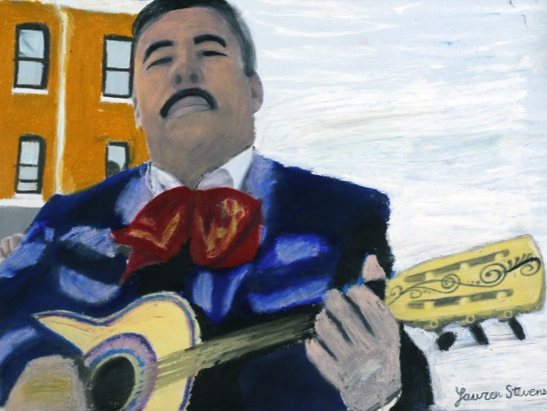
The Los Angeles neighborhood of Boyle Heights is gentrifying quickly. At the very heart of the area is Mariachi Plaza, a place for traditional musicians of this Mexican genre to socialize, wait for clients, and practice. Here, a man sits near a metro station and sings. Someone tunes a violin. Skateboarders pass, a vendor sells corn. Despite the noise, a Mariachi band in full attire serenades passers-by. A portrait of the place at risk of changing forever.

Mike Mollo Prepares for a Fight
Jake Zalutsky / USA / 8 min

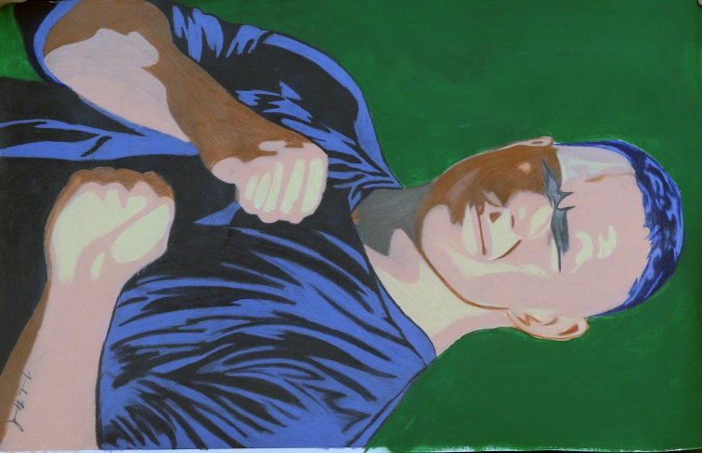
Mike Mollo prepares for a fight.

Mill Study
Geoffrey Cox & Keith Marley / United Kingdom / 11 min
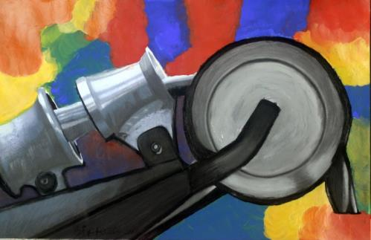
Shot at Spa Mill, a textile mill in West Yorkshire, this short film uses sound and image to evoke the working environment of the mill shop floor. It does not attempt to tell the story of how the yarn produced is made, rather it gives a sense of both the everyday and surreal aspects of the place and people who work there. At times the camera is used to reveal hidden elements of the machinery and the film is loosely organised into sections that depict varying types of mechanical and human movement.

Molokans: The Fifth Generation
Harry Tamrazian / Armenia / 25 min
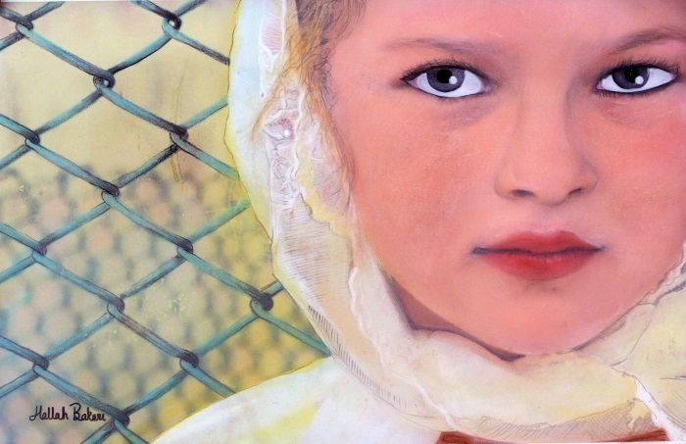
Gives viewers a glimpse into the life of descendants of a Russian religious sect whose followers were deported to Armenia centuries ago. They rejected the power of the Russian Tsar and the authority and hierarchy of the Russian Orthodox Church, considering themselves spiritual Christians. Molokans, who were also persecuted by the communist government have remained true to their traditions and cultural identity, surviving into our own days with their unique mode of life and adherence to their faith and traditions, cultivating their land against the backdrop of the biblical Mount Ararat.

Mr Rock's Rooster
andrea ruffini / Haiti / 7 min
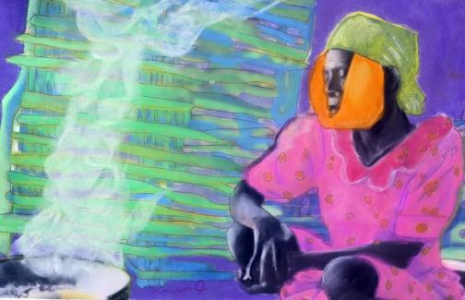
The drought destroyed all the crops of the Rock's family, living in South-East Haiti. Mr Rock's only hope to gain some money is that his rooster win the fight...

The Muse of San Francisco
Katrine Holmgren / United States / 22 min
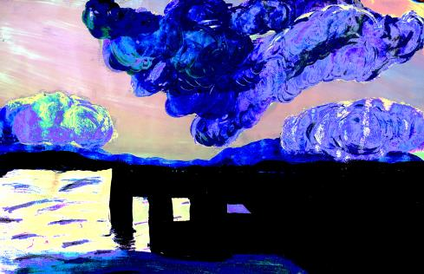
This film portrays Linda Martinez – a 79 year of age life drawing/pin up model and actress in low-budget underground art films. In The Muse of San Francisco, the filmmaker has set off to find out who the mysterious Linda Martinez really is. It follows Linda in her life in San Francisco as well as to her hometown Burlington, Iowa. Rather than hiding performance-based aspects to the filming process, this film tries to uncover how documentaries often have been performed, staged, reenacted – especially when your main character is a true performer like Linda Martinez – The Muse of San Francisco.

My World (9546 km)
Sergio García Locatelli / Spain / 4 min
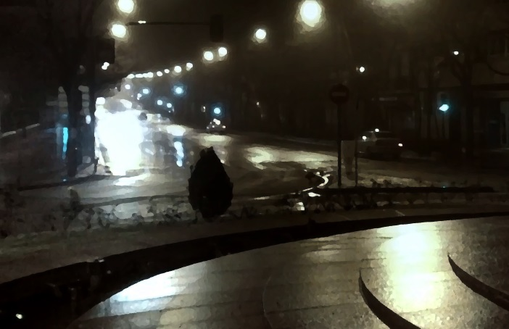
I keep looking into myself if Madrid is my city. I came here more than 7 years ago from a place 9546 km. far away from here. With the daylight I feel foreigner no matter nobody can tell unless I speak.

No Man's Land: A Folktale
Ty Turley / Sierra Leone / 15 min
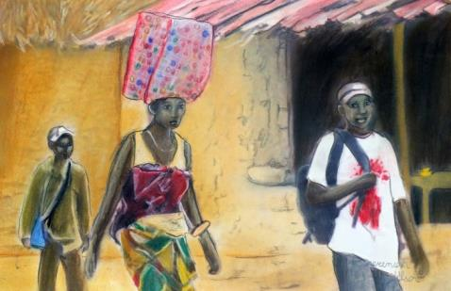
A stubborn farmer moves his family into a new village, and decides he wants to farm in the sacred forest. But the spirits in the forest have a plan of their own. This film enacts a folktale from Sierra Leone, a story about being stewards of the land.

No Right Turn
Luke Robson / Australia / 10 min
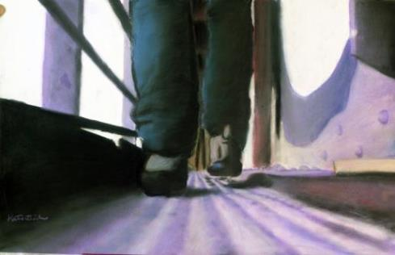
NO RIGHT TURN is a self portrait documentary on what it would be like to be homeless in Melbourne. Presented by Marina Loncaric, filmmaker Luke Robson spends five days and four nights living on the streets whilst participating in the fundraising campaign 'Live Below the Line' where you have a food budget of just $2 a day.

One Way
Parisa Ghaderi / Iran, Islamic Republic of, United States / 21 min
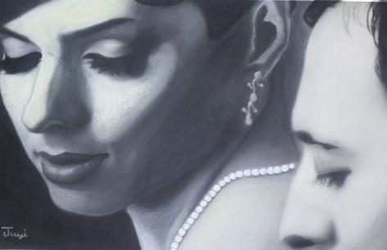
"One way" is a short documentary about an Iranian couple who were separated since May 2015 because of U.S. visa regulation for Iranian students. Mojde and Yasser moved to America in 2013 for higher education. Mojde, went to visit her family in Iran in 2015 and she could never come back since then. Her visa got rejected three times, due to unrelated and insufficient reasons. Her husband is still here in the U.S. trying to finish his studies to join her soon. This is a rare and unusual case.

Osiba Kangamuke - Let's go kids
Haja Kalapalo, Tawana Kalapalo, Thomaz Pedro and Veronica Monachini / Brazil / 20 min
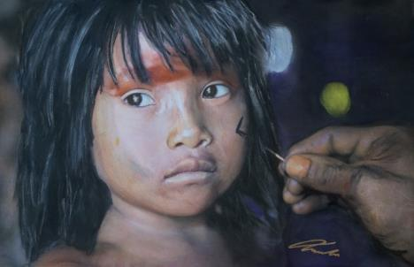
The kids from Aiha Kalapalo village, located at Alto Xingu Indigenous Park (MT, Brasil), decided to show some of the aspects of their routines and culture. From the school, where they learn Portuguese, until the ritual of ikindene fight, those little Kalapalo demonstrate a subtlety peculiar of those who know their traditions. Osiba Kangamuke – Let’s Go Kids, is the result of a video workshop held with the children in the village so they participate not only in front of the cameras but also throughout the recording process.

Panoramique de l'immatériel
Joshua Reiman / France / 22 min

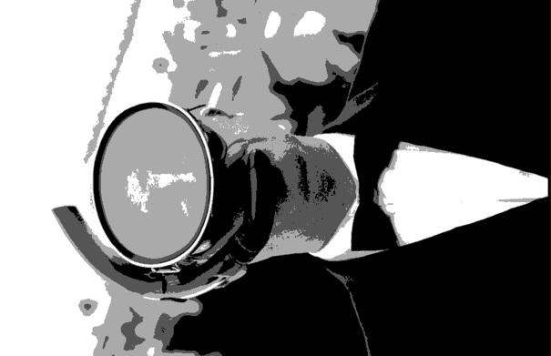
Panoramique de l'immatériel (Panning for the Immaterial) follows a man who is panning for gold along The Seine River, from Paris to the sea. He is looking to find the gold that the artist Yves Klein dumped into The Seine in Paris during one of art histories most seminal conceptual artworks, Zones of Immaterial Pictorial Sensibility. Klein’s work involved a collector buying an “immaterial zone” (a space that does not exist) for $10,000 in gold dust or leaf. Klein would sign a receipt for this artwork in front of a witness. He would then ask the collector if they would burn the receipt. If they agreed, Klein would then dump the gold into The Seine, completing the cycle of “the immaterial zone.” This exchange in value for a moment and a memory is where this film begins.
Paparon
Romin Johnson / France / 24 min
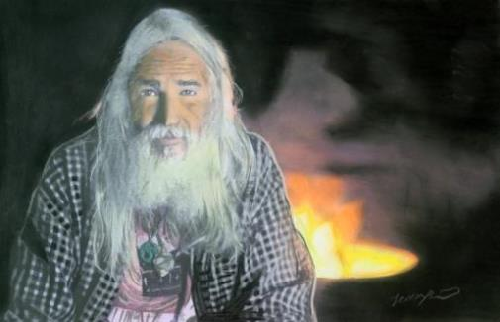
A portrait of an aging Vietnam veteran and his family as they struggle to adapt to changes in the wake of his breakdown.

People of the Forest: Orang Rimba
Isaac Kerlow / Indonesia / 14 min
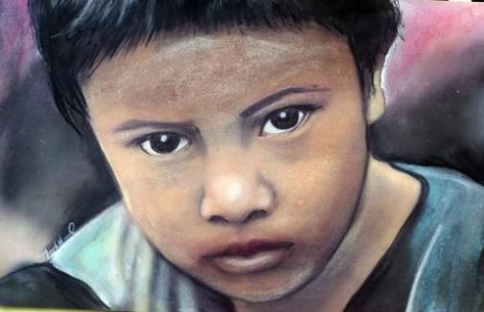
The ancestral forests of the nomadic Orang Rimba have vanished. In the short span of three decades oil palm plantations have replaced much of the tropical peatland rain forests in Jambi, Indonesia. The People of the Forest, Orang Rimba in their dialect, have nowhere to go.

Pistons, Passions, Pleasures - A Sicilian Dream
Philip Walsh / Italy / 60 min
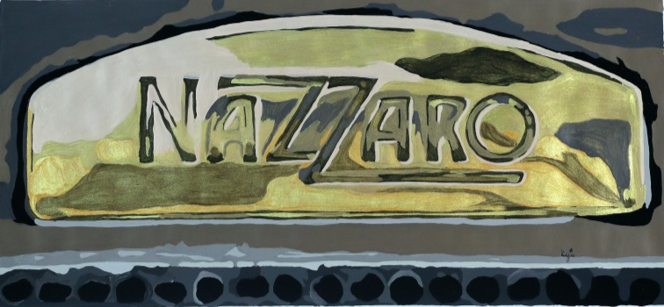
The story of Vincenzo Florio, creator of the Targa Florio Road Races in Sicily, 1905 to 1977.

Por Los Camiones Del Sur
Sven Kirschlager, Sirio Magnabosco / Mexico / 54 min
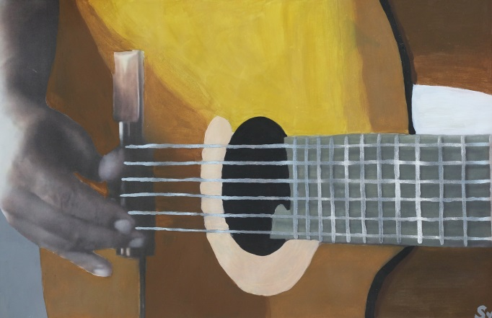
In the documentary “Por los Camiones del Sur” the stories of six musicians meander along curvy federal roads through the breathtaking scenery of southern Mexico. The protagonists do not perform in the spotlight of big stages but earn their living with guitars and accordions in the narrow aisles of beaten country buses. Dripping with sweat, they drown out geriatric motors while slipping through the tightening net of inspectors and controls. Beyond the roadside ditches, they philosophise about the qualities of fighting cocks, tout nutritional supplements or dress up inside filthy backstage rooms of Acapulco nightclubs while dreaming of their leap to stardom.

Quantified Life
Btihaj Ajana / Denmark / 13 min
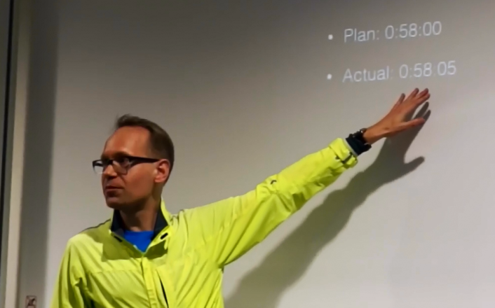
Practices of self-tracking and self-quantification have become commonplace recently. Over the last few years, we have witnessed a rapid development in wearable tracking technologies. From smartphone apps that measure our activity and sleep, to digital devices that monitor our health and performance at the workplace, the culture of measurement and tracking is currently on the rise. Everyday, millions of people across the globe are routinely recording a myriad of physical and emotional variables, in the spirit of improving their health and wellbeing, and charting their fitness progress.

Rastas' Journey 'Home'
Maria Stratford / Ethiopia, Jamaica / 40 min
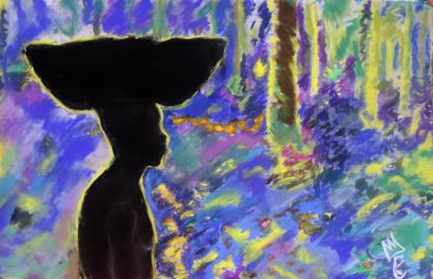
Reggae music often refers to the greatness of Africa and the desire of members of the Rastafari movement to return to the land of their ancestors. But how many Rastas make the journey 'home' and how successful is the act of ‘repatriation’? Rastas' Journey 'Home' is a documentary that explores the process of returning to one's roots and through interviews with members of the Rasta community reveals the conflicted emotions that they experience in their new homeland of Ethiopia. The documentary also highlights reggae music that features the discourse of Africa, Zion and being African.

Reading Through the Body
Mersolis Schöne / Austria / 8 min
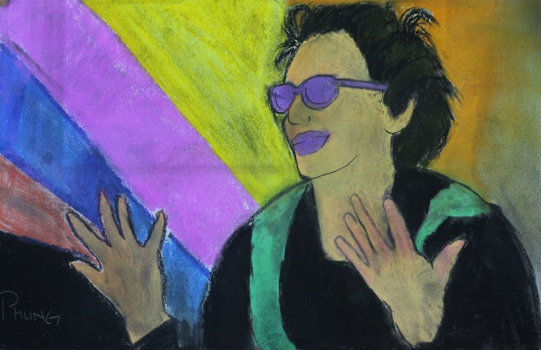
What happens, when the act of reading is being applied into sign language? When suddenly, eyes listen and hands talk? What if something that’s rather common, suddenly gains an appearance, a behaviour, and becomes an entity? This „Culture“ of physicality and visuality is where our attention lies. We observe, with an ethnografical eye, how a deaf woman tries to comprehend and appropriate a very specific text in an experimental setting. In stillness she reads the words to herself for the first time. Afterwards, she presents her interpretation of the writings, in sign language. Finally, using the movement in space to transport language into performance, she reveals its true meaning from her point of view.

The Ring I Hide
JOY KONG FANYUE / China, United States / 23 min
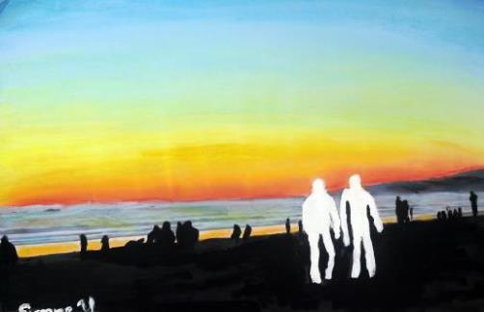
This is a 23-minute observational documentary follows the story of a Chinese man, Kenny, who has married an American man. Kenny hasn’t come out to his parents, let alone told them about his marriage. During the most recent Chinese New Year, Kenny took his husband back to his family home in China, however introduced him as his best friend.

The Rookie Season
Hannah Nemer, Molly Nemer / United States / 28 min
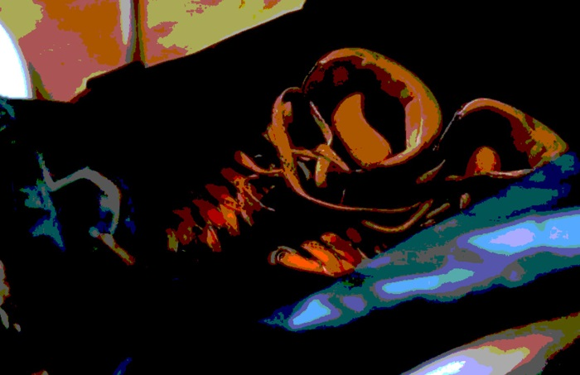
The Rookie Season follows Minnesota Roller Derby hopefuls through the try-out and drafting process, revealing and celebrating the strength, quirk, and joys these athletes radiate.

Sand Men
Tal Amiran / United Kingdom / 14 min
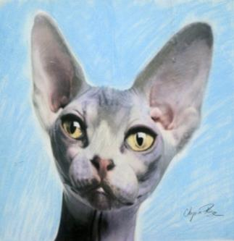
Neculai, Aurel and Raj all left their homes in Romania for the same reason - to seek a better life for their family. Now, in Britain, with their loved ones depending on them, they survive by creating sand sculptures on London’s streets. They try to find hope in the hardships they endure, while thoughts of their children's futures keep them going.

The Sara Spencer Washington Story
Royston Scott / United States / 28 min

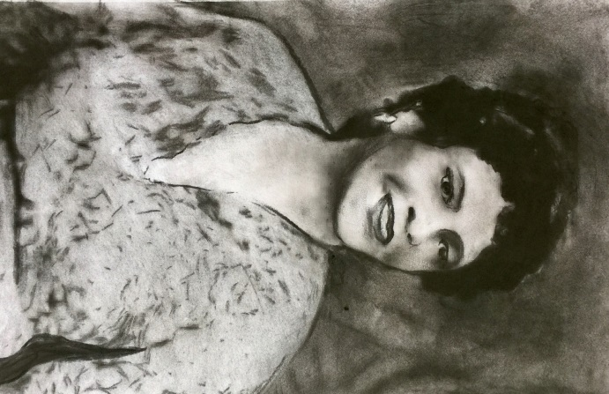
Recall the life of a young black woman who became a phenomenal success selling her line of hair products door to door in 1920's Atlantic City, New Jersey. A business that lasted through The Great Depression. A business that became a million dollar empire. A business that gave tens of thousands of black women the opportunity to become self sufficient. She called the Business Apex, and they called called her Madame Sara Spencer Washington.

Sekar Arum - Forging the Javanese Gamelan
Maurice Gunning / Indonesia / 8 min
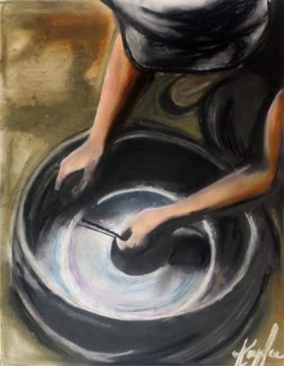
The forging of a Javanese Gamelan gong, including the firing, moulding and tuning of a new bronze instrument. Filmed on located in Pak Saroyo’s forge in the Sukoharjo regency of Surakarta in Central Java, the documentary focusses on the making of one of the 40-plus instruments in the set, revealing the musical nature of the forging process, from the rhythmic beating of red-hot metal, to the dance-like quality of the gongsmiths, as they work in concert to bring a single gong to life.

Shame
Lipika Pelham / Bangladesh / 59 min
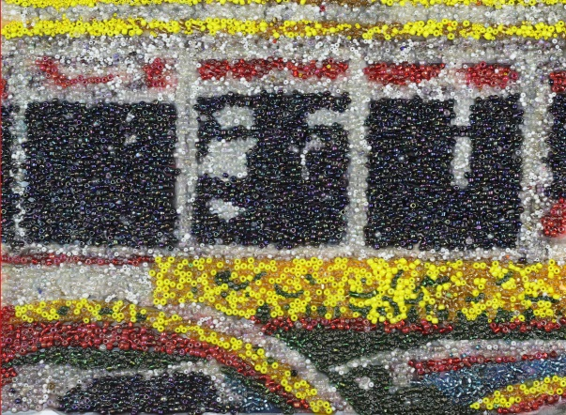
Traveling undercover with hidden cameras to a remote part of south eastern Bangladesh, reporting on claims of human rights abuses against indigenous Buddhist minorities of the area. Chittagong Hill Tracts are home to thirteen indigenous groups practising mostly Theravada Buddhism. Thousands were forced off their lands from the 1960s until the 1990s by Bengali settlers who were sent there by the government, which eventually imposed a military rule. An insurgency that started in the mid 1970s ended in a peace settlement in 1997 under which the army was supposed to withdraw but it continues to maintain a tight grip on the area.

Shortwaves
Samuel Leal / Brazil / 15 min

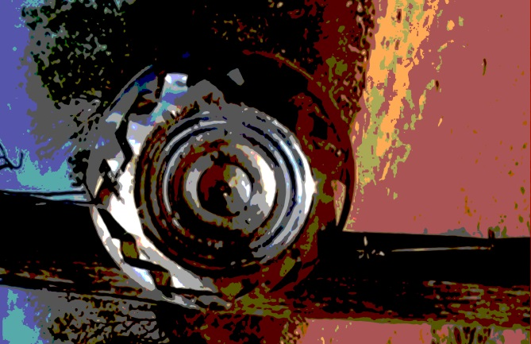
The Xavante are a indigenous group who lives at Brazil Central Highlands. For more than 50 years, they have been in constant relation with mass media communication technologies, specially the radio. This video propose a look into this technical mediated relation between a local traditional cultural and the capitalist society.

A Single Garden
Monica Klemz / Brazil / 16 min
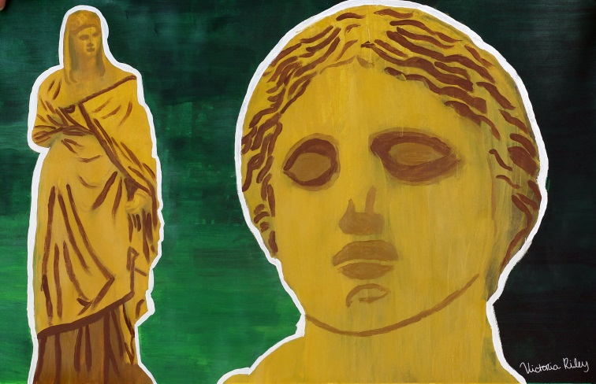
The relationship of a historical and urban garden, in the city of Rio de Janeiro, with the people that transit through it, in a space-time crossing.

The Site: Building Resistance
Mateusz Laszczkowski / Italy / 30 min
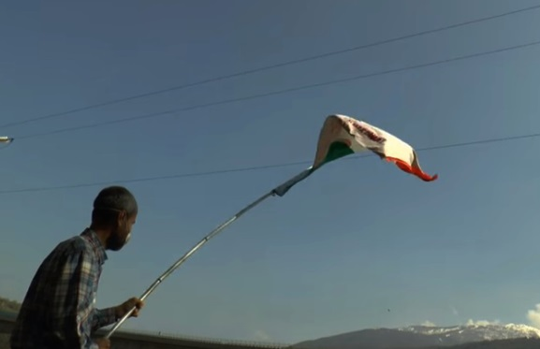
An ethnographic documentary about the No TAV movement in Val di Susa, in the Italian Alps, which fights against the planned construction of a high-speed railway from Lyon to Turin that would run through the valley. Born in the 1990s as a committee of experts, environmentalists and local political activists, over the years the No TAV movement has grown into an extremely diverse assemblage, bringing together heterogeneous groups, constructing unity while thriving on diversity. Based participatory research in 2014-2015, it features original images and archival footage of direct actions, riots, moments of conviviality, marches and demonstrations in addition to interviews with movement members.

Somebody Clap For Me
Luciana Ceccatto Farah / Uganda / 64 min
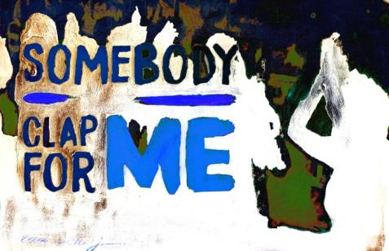
Screener - h264 - Stereo sound ( screeners available also with French or Portuguese Subtitles) In Uganda, youth are re-inventing their ancestral tradition of storytelling into slam poetry nights to fight the silence imposed by an oppressive regime. Ugly Emcee, one of these freedom of speech activists, happens to be a grandson of former dictator Idi Amin Dada.

Stomach and Mr. Z
Boyi Sun / China / 33 min
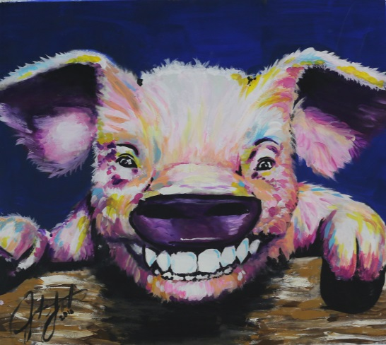
This is a film about my journey on finding the truth about whether a 81 years old tobacco seller has real pain on his belly. The film use various sources to demonstrate how did the concept of “ beauty ” shared and absorb Mr. Z’s living essentials, including his desire, logic and world view.

Texas Paranormalists
David Goodman / United States / 24 min
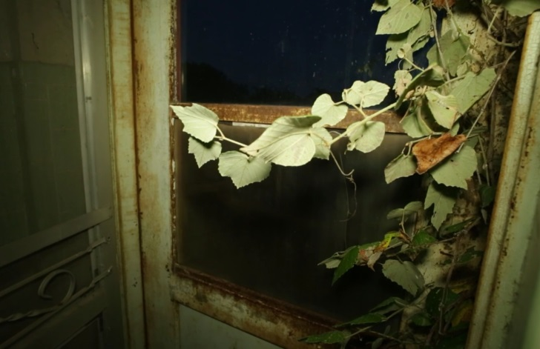
Texas Pararnormalists mixes participatory and observational styles in an effort to portray a small community of paranormal practitioners who live and work in and around North Texas. These practitioners include psychics, ghost investigators, and other enthusiasts and seekers of the spirit world. Through the documentation of their combined perspectives, Texas Paranormalists renders a portrait of a community of outsiders with a shared belief system and an unshakable passion for reaching out into the unknown.

They Always Asked About Africa
Paola Bilbrough / Australia / 4 min
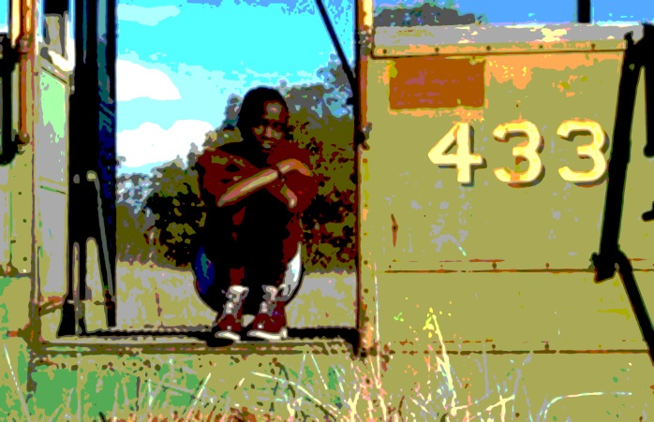
Agot Dell, a young woman with a Southern Sudanese heritage moved from Kenya to Australia at 16 and found that people were more interested in Africa than getting to know her as an individual. In "They Always Asked About Africa" Agot recalls her experiences of trying to 'fit in' at high school and being the only "black kid" in her class. A chance encounter on a tram with an elderly woman reaffirms Agot's belief in our common humanity and the powerful impact of sharing personal stories with one another.

Through the Mirrors
Kathy Kasic / United States / 9 min
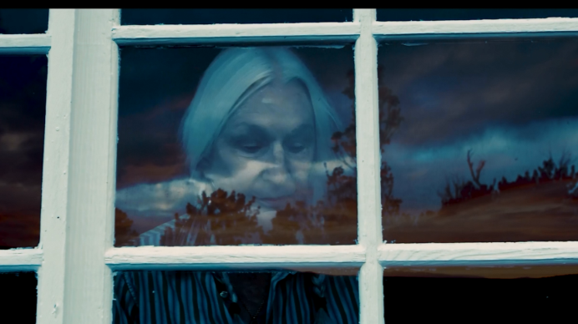
“Through the Mirrors” is a poetic film about the fate of love in the face of time, inspired by the poem “As I Walked Out One Evening”, by WH Auden. Although it uses no spoken word, the film has three voices: a narrator-pianist (Julien Brocal), an elderly woman (Susan Heyneman), and Time. As the woman remembers her love, the pianist performs the tone and rhythm of her memory in a room filled with mirrors, while projections of her life play back into the mirrors. The music that the pianist performs is by Ravel "Miroirs: La Vallée des Cloches” and Mompou “La Fuente y La Campana”; both compositions relate to the passing of time.

A Time for Making
Phillip Vannini / Canada / 7 MIN
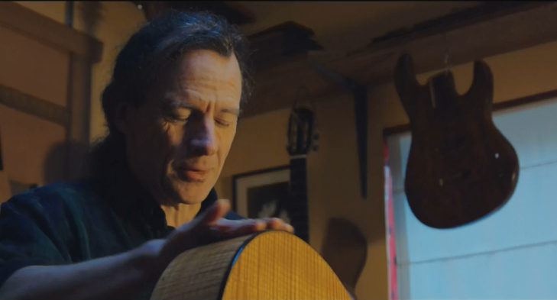
Explores the cultural and social value of handmade craft through the perspectives of nine artisans based on Gabriola Island, British Columbia. The film ties together the binds connecting woodworking, silversmithing, glass-blowing, weaving, potting, and bread-making by exploring artisans' shared sense of place, lifestyle rhythms, and community belonging. A time for making was filmed over the course of four seasons in 2016-2017. In the sequence you are about to see we witness Patrick, a luthier, at work while winter makes its arrival.

Tohossou
Ran Muratsu / Benin / 29 min
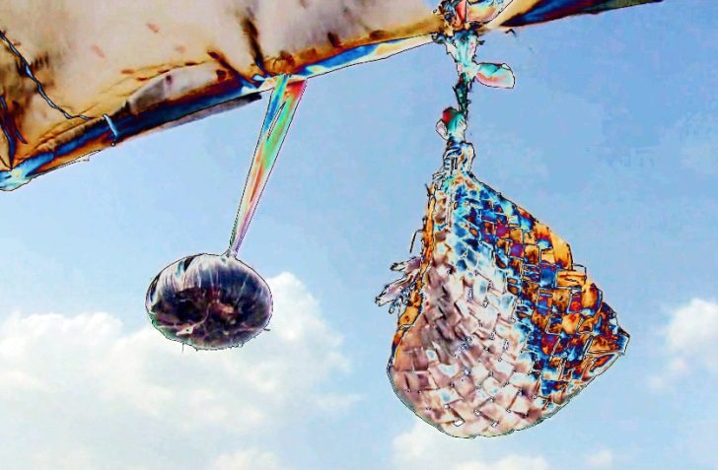
Daily life of a man born with disability who considered to be a god in Vodun.

Traces on my skin
Stefanie Klemm / China / 17 min
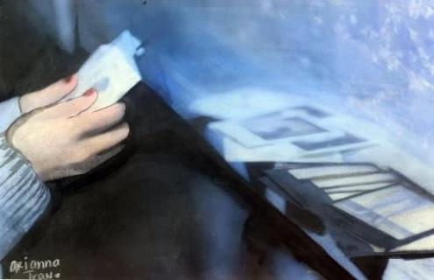
Shanghai 2016: Four young Chinese unified by their passion for life and self-determination, long for an escape from anonymity. They become part of an extraordinary art project.

Train to Peace
Jakob Weyde / Germany / 10 min
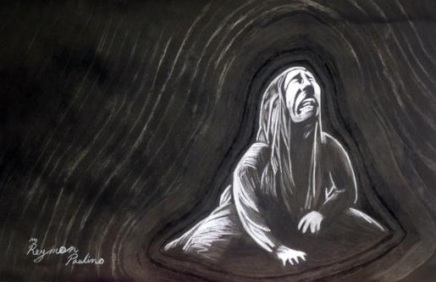
The sound of the Berlin subway takes a stranger back to the history of his country - Iraq- where peace is rare and happiness only comes as a guest.

Trampe
Jonas Hustad, Lina Ingeborgrud and Ivana Suboticki / Norway / 7 min
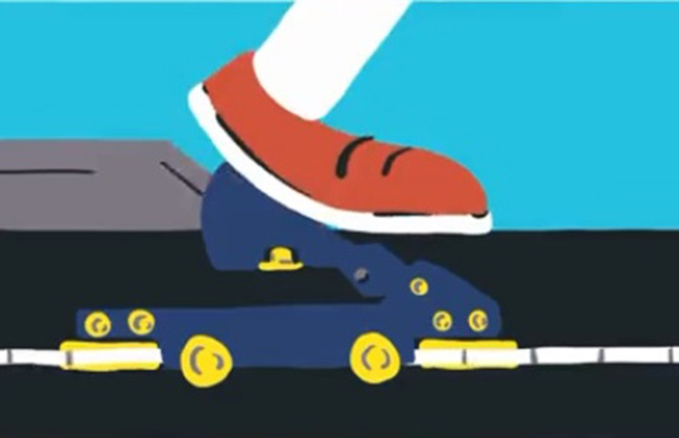
How are technologies invented and how are they used? A short story about a peculiar technology, a bicycle lift in Trondheim, the only one its kind. Why did it come about and what is it really about?

Treasures: The Face Jug and the Wanderers
Christi Koelker / United States / 31 min
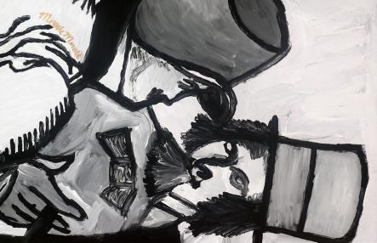
Treasures: The Face Jug and the Wanderers, follows a Philadelphia woman, named April Hynes, on an astonishing journey that began when she inherited a mysterious piece of pottery - known as a face jug - unearthed by her plumber grandfather in the 1950s. The jug leads her 700 miles south to one of the centers of the Confederacy, where she discovers extraordinary connections between the descendants of the Wanderer

Tribal Radio
Sean Owen / United States / 21 min
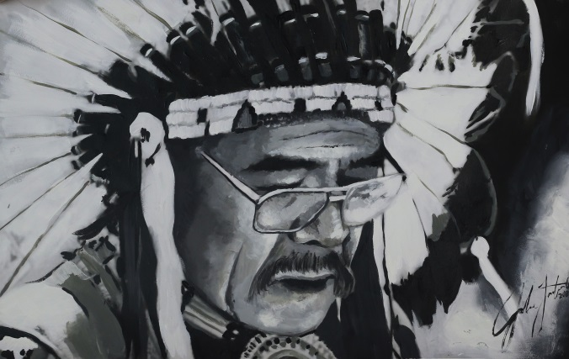
Over 35 tribal radio stations are scattered throughout Native American reservations that serve local communities. They provide a source of traditional tribal music, announcements of ceremonies, community news, personal messages, weather warnings, local sports events, and national native news. Often the stations are manned by a few professionals and volunteers operating on a shoe string budget. “Tribal Radio” tells the story of the KSUT radio station located on the Southern Ute reservation in Ignacio, Colorado.

Unsilencing Sabeen
Anabelle Marshall / Pakistan, United Kingdom / 9 min

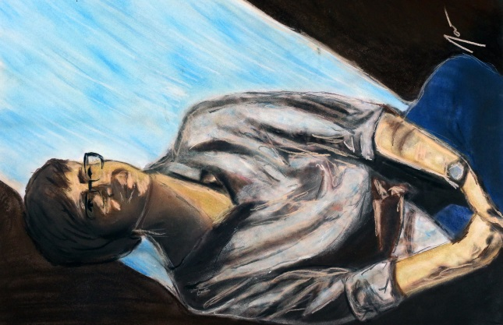
On April 24th, 2015 gunman shot and killed activist and cafe owner Sabeen Mahmud in Karachi, Pakistan. That evening Sabeen had hosted a talk about the separatist movement in Baluchistan at her cafe The Second Floor. Upon news of her death, candlelit vigils were held around the world, hundreds attend her funeral and her life was covered in the international media. In a country such as Pakistan, the importance of a space for open dialogue and artistic expression such as The Second Floor is invaluable. Through interviews, experts, and Sabeen’s own voice, we depict the life of an activist who paid the ultimate price.
Village Tales
Sue Sudbury / India / 24 min
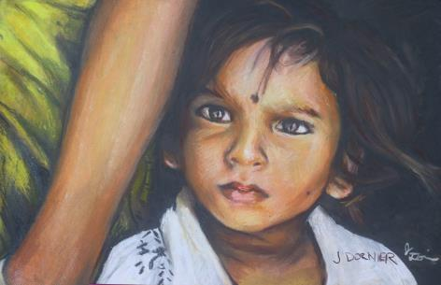
A group of young women in rural India is being trained as video reporters as part of a local government initiative to give women a voice. As child brides themselves, they choose to make their first film about the problems of child marriage, a continuing practice in their villages. Village Tales follows these women as they make their film but also asks four of them to turn their cameras of their everyday lives, giving us an unprecedented view of life as it is lived today in many Indian villages. They film their husbands, questioning them from behind the camera and for the first time speak out about their lives.

Vous êtes ici
Mark Wihak / France / 70 min

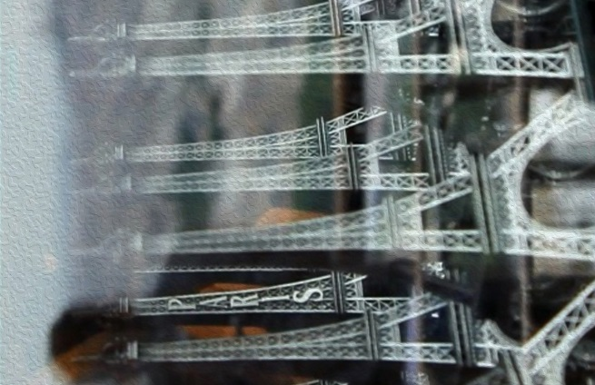
Every year, millions of people, from all around the world, come looking for a Paris that doesn't exist anymore.VOUS ETES ICI (You Are Here) is an exploration into the experiences of tourism, in the number one tourist destination on earth: Paris, France.

Walkalong
j. robinson / United States / 9 min
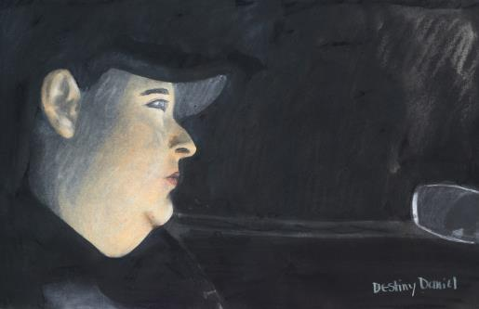
A night on the town, between the bars.

Water is Life
Joseph Erb / United States / 5 min

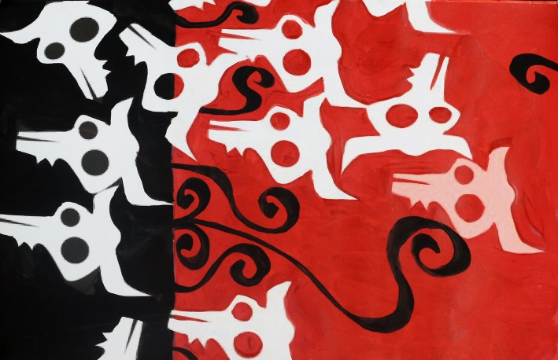
An animated film that talks about the issue of the Standing Rock Sioux Nation and their struggle to survive as they try to protect the water source into their small nation. Narrated by The Standing Rock Chairman.

Weavers of Imagination
Sadegh Jafari / Iran, Islamic Republic of / 21 min
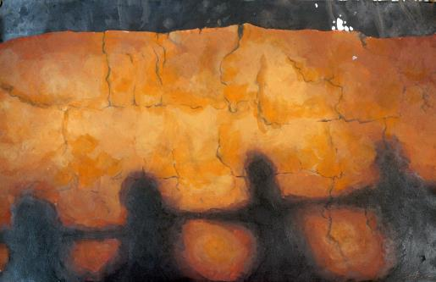
Story of some unsighted people who weave carpets by using Brail. Weaving carpets requires precision and sight and it is difficult even for the sighted people. The unsighted people think if there was a place where the sighted people did not bother them, they would have a better life.

Weed Ontology
sam smiley / United States / 5 min

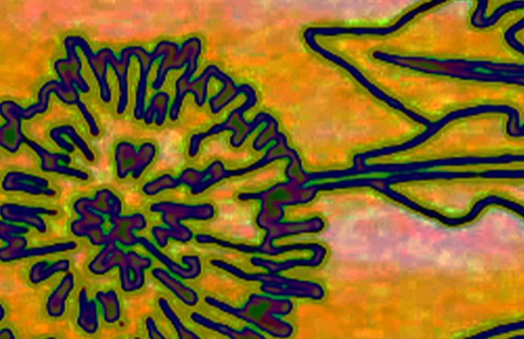
Using in-vivo coding, this short film extracts texts from interviews with participants at the reception of the Weed Science Society of America. This conference took place Feb. 7-10, 2011 in Portland Oregon and was produced by AstroDime Transit Authority, an international research and media arts collective.

When Mother Goes to Work
Azar Kafaei / United States / 10 min
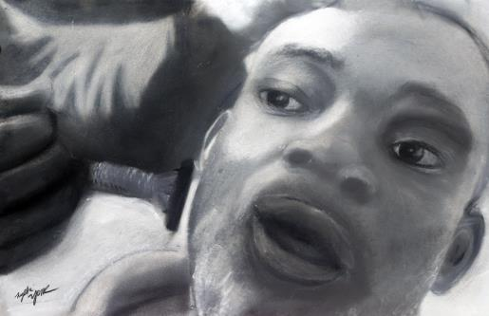
Newark, NJ is one of the most unsafe inner-cities in the United States. Marked by a history of racism and segregation, people of Newark are heavily policed on a daily basis. In this film, three siblings from Newark have to find a way to spend time together in the absence of their mother who is away working three long shifts.

Where Is My Mother's House
Selma Nayebi / Islamic Republic of Iran/ 15 min
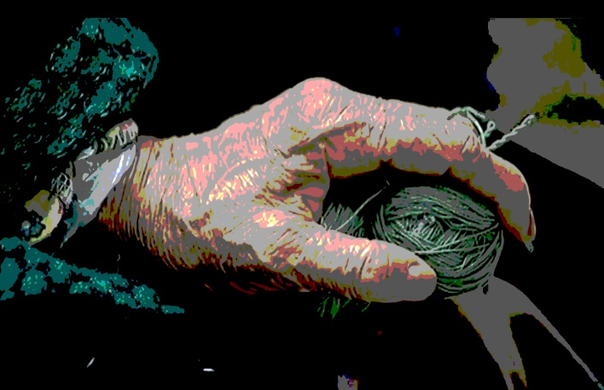
Old and the elderly people in nursing homes have been abandoned by their children and they suffer from lack of their love. Look forward to seeing their families, looking uncertain future. Despite the good conditions sanatorium like to leave and return to the bosom of their families. Madam Keshvar help to Fereshte who is blind woman. she take her to the Spinning looms every day. They unfasten skein of yarn and do it over and over. It seems that this futile repeat is much hope for their survival.

Why Me ?
HARISH SHAH / India / 20 min
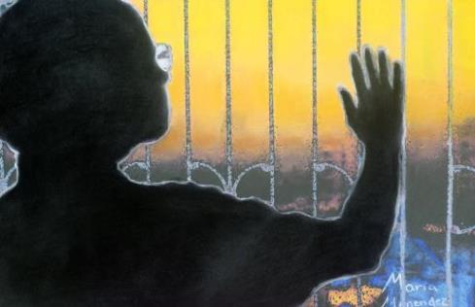
This film is inspired by the true incident of the life of Mr.Harish Shah who by profession is a film producer director and suffered terribly from throat cancer and its about his journey as in how he fought against it. Mr. Harish Shah himself acted and directed it.

Wilhemina's War
June V Cross / United States / 62 min
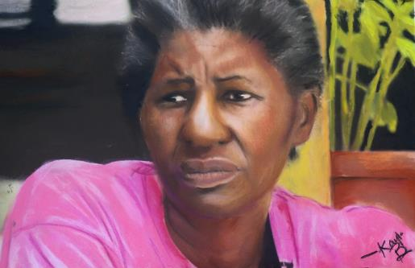
For 5 years, Emmy-winning director June Cross documented how the South has become the epicenter of HIV in the United States. In WILHEMINAS WAR she tells the story of a matriarch and her granddaughter who try to bring AIDS awareness to rural South Carolina, and discover the cruel consequences.

The Woman All Women Once Were
Francesca Di Marco / USA / 23 min

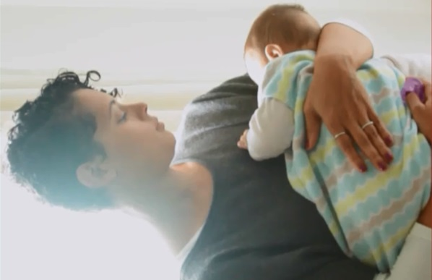
This film explores the existential crisis of three career women in the Silicon Valley during the very overwhelming year or two following the birth of their children.These highly educated, well-off women have been engaged in advocating for women's rights and gender equality in classrooms and women's shelters. They are privileged enough to have choices; they have actively differentiated themselves from their mothers and stubbornly achieved advanced degrees and professional recognition. Childbirth and the unfairness in the working place that follows soon after, though, make them question the very foundations of their efforts: how to be faithful to their beliefs when they can no longer find signs of 'modern womanhood' in their existence?

The Yard
Elisabeth Tsouctidi, Ari Bafalouka / Greece / 30 min
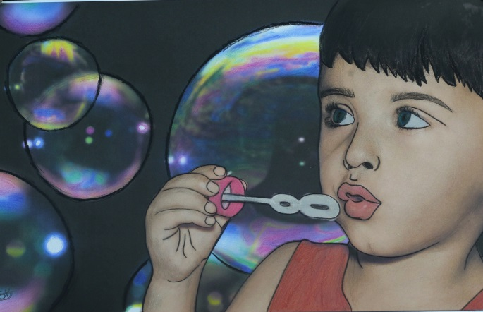
Two hundred and sixty refugees, men, women, and children, were, for a variety of reasons, forced to leave their homes. These people of all ages left the place in which they were born. They were persecuted, tortured, and threatened. Different routes were taken to reach the Refugee Reception Centre in Lavrio (Grece).

Zawawa - the sound of sugarcane in the wind
Rupert Cox / Japan / 15 min
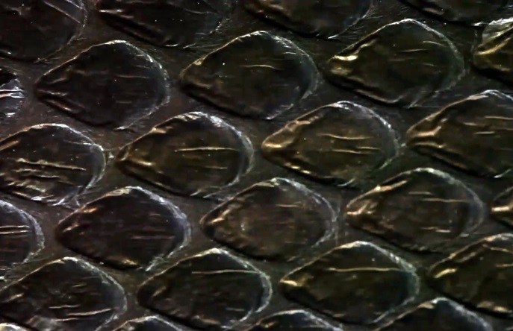
It is a strange and bitter irony that the US naval bombardment which launched the Battle of Okinawa in 1945 was called the 'typhoon of steel', invoking the turbulent winds that annually buffet this small island. Okinawans sought shelter from the battle in natural features of the environment such as caves and within sugar cane fields, creating memories that reside in the sounds of these places today. This film results from a ten-year collaboration between a landscape artist, an acoustic scientist and an anthropologist. listens in on and makes sense of these sounds through the stories of individuals and the recordings of these sounds.

