The Ethnografilm Festival

Ethnografilm seeks to enhance our understanding of the social world through film. From the 29th of March through the 2nd of April 2016 in Paris, France, the festival features over 100 works by documentary and academic filmmakers.

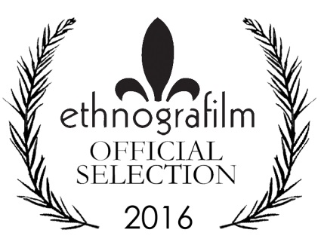

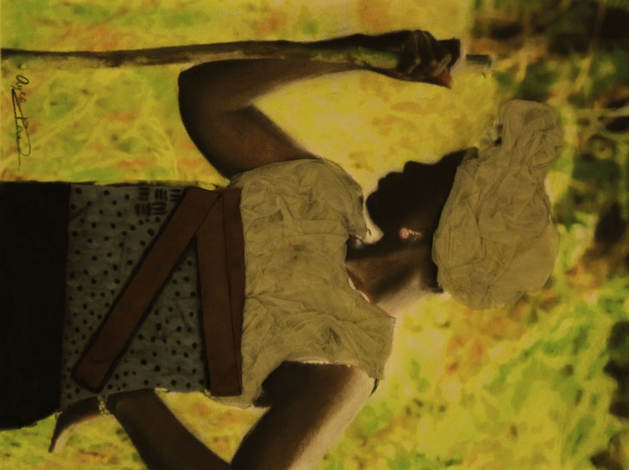

Paris! City of Light & Cinema
Ciné 13 Théâtre is located next to the Moulin de la Galette in Montmartre, the summit of the city. History, character, ambiance? Countless films have been inspired by this corner of Paris.
Take the metro to Blanche station. Step outside to find yourself in front of the historic Moulin Rouge, so memorably re-imagined by Baz Luhrmann. You’re at the foot of the delightful market street, Rue Lepic, where Amélie Poulain worked as a waitress, in director Jean-Pierre Jeunet’s eponymous film. Take a moment to buy a delectable tart at the Petit Mitrons bakery, then stroll up the hill. You’ll pass the apartment where Van Gogh lived with his brother Theo, and the Moulin de la Galette, famously painted by Renoir.
This part of the city is filled with historic film theatres—from the blockbuster Pathé on Place Clichy to the tiny Studio 28, the first avant-garde cinema in France. Here, Louis Buñuel premiered his surrealist collaboration with Dali, L’Age d’or, though by the time it premiered the two temperamental creators were no longer speaking!
The home of Ethnografilm, Ciné 13, is at the corner of Junot and Girardon. The cinema is right across the street from the print shop where Picasso once studied print-making. Down rue Junot is the former home of famous Dadaist Tristan Tzara. Austrian architect Adolf Loos designed the unusual home in 1926. The house next door once belonged to famous poster designer Francisque Poulbot. His illustrations of Parisian street urchins were so well-known that street kids became “poulbots” in the city’s ever-evolving slang. Street life in the 18th arrondissement is still fascinating. On the far side of the Butte, or hill, of Montmartre, is one of the city’s most varied and vibrant neighborhoods, with thriving West African food markets and traditional Arab cafés where you can smoke a hookah or narghile.
Our venue Ciné 13 has its own amazing story. Director Claude Lelouche bought the cinema in 1983 to use as a set. He renovated it into a 1920s-era club for his movie Edith et Marcel, the story of singer Edith Piaf’s tragic love affair with a boxer. Upon completing the film, Lelouche turned his set into an atmospheric movie theatre. Today his daughter, Salome Lelouche, runs the programming. And during Ethnografilm, April 17th to 20th 2014, every festival night we will retire to the argumentarium (that is, the cosy Ciné 13 lounge) to discuss the films over a glass of superlative Bordeaux.

Director’s Welcome
The 2016 edition of Ethnografilm is a moment to cherish for filmmakers, scholars, and all those who brought this diverse group to Paris. The Society for Social Studies of Science and the International Social Science Council have been instrumental in implementing the vision of a festival to celebrate excellence in movies that enhance our understanding of the social world.
Ethnographic film—“ethnografilm” in Greg Scott’s coinage—has been broadly defined, yielding a huge variety of styles, formats, and themes.
We have the best fringe theatre on the planet! Most important, we have a community of filmmakers and scholars gathered for present inspiration and collaborations yet to come. What could be better?
Wesley Shrum
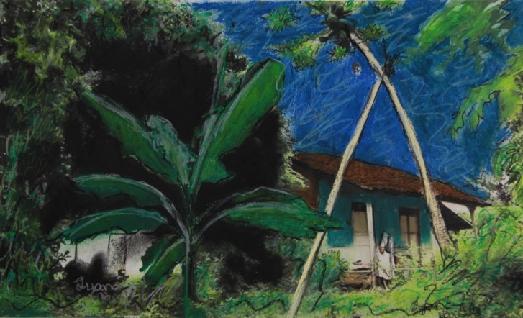
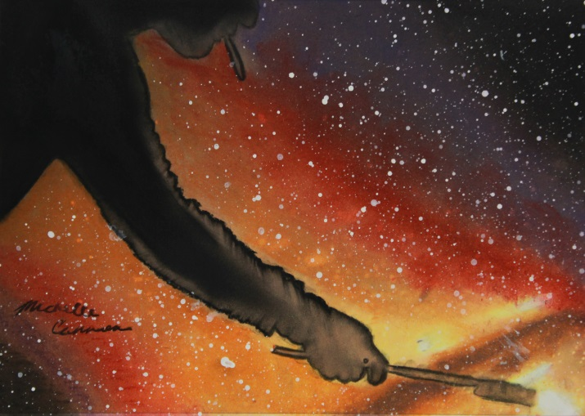

Challenging Audiences—and Filmmakers
How does ethnographic film articulate critical analysis with critical participation? Videographic study can make visible in powerful ways what is hidden in an arena of study. It can challenge dominant images of that arena while formulating and attempting to scale up alternative images. As a form of knowledge production and committed expertise, ethnographic film often races past the written text, challenging audiences both within and beyond its chosen field to think and do differently. To have effect, it must theorize without jargon. It must provoke without driving away or pandering to its viewers. Ethnographic film must both trouble and fit.
The Society for Social Studies of Science (4S) has long supported critical analysis of the production, distribution, and utilization of knowledge and expertise. It now also formally supports creative initiatives to articulate critique with participation. For this reason, the 4S enthusiastically supports Ethnografilm. What is videographic study for? What are ethnographic filmmakers for? The 4S challenges videographers and their audiences to wrestle with these questions, and we look to you for insight and direction. Thank you for accepting the risks and making the effort to rethink and redo knowledge and expertise through film.
—Gary Downey, Past President, 4S
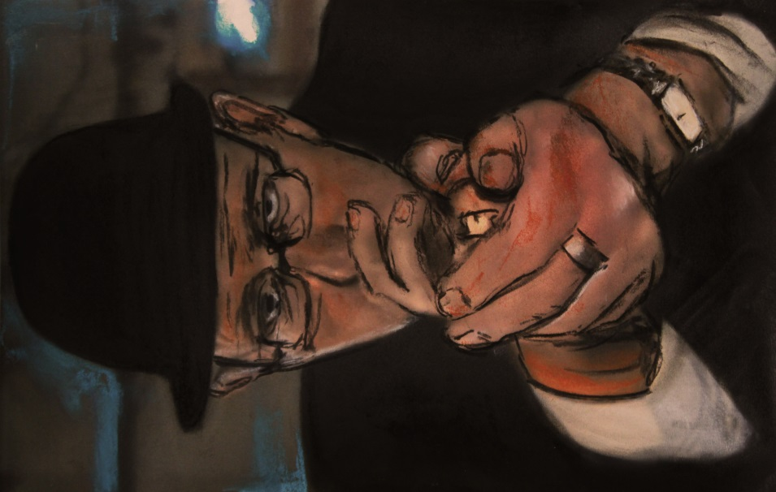

Organization
Executive Director: Wesley Shrum, Louisiana State University
Associate Director: Gregory Scott, DePaul University
Festival Manager: Mathieu Denis
Festival Organizers: Susan Arnold, Jewell Simon, Simon Baxter, Luke Driskell, Laura Winter
Publicity and Design: Steve Coffee
Co-Founders: Wes Shrum and Greg Scott

Executive Committee
Lucy Suchman (e-o), President, Society for Social Studies of Science
Ron Harpelle, Professor of History, Lakehead University, Canada
Kelly Saxberg, Independent Filmmaker, Thunder Bay, Canada
Xela Batchelder, Waynesburg University
Michael Frierson, University of North Carolina, Greensboro
Lisa Pasold, Writer, Paris
Sylvie Jacquemin, Cinematographer and Director, Paris
Robin Starbuck, Sarah Lawrence College
Sam Smiley, Astrodime Transit Authority
Molly Merryman, Kent State University

Advisory Board
C S Venkiteswaran, Festival Director, Kerala, India
Barberine Feinberg, Département Hommes, Natures, Sociétés, Centre National de la Recherche Scientifique, Paris
Jean Claude Penrad, Directeur de l’audio visual, L’Ecole des Hautes Etudes en Sciences Sociales, Paris
Sreevasudeva Bhattathiri, Graphic Designer, Thiruvananthapuram
Sundar Raminathaniyer, Writer, Kerala, India
Leandro Medina, Universidad de las Americas, Puebla, Mexico
B. Paige Miller, University of Wisconsin, River Falls
Meredith Gontard, Directrice Artistique–ACM Ballet Théâtre
Kelly Moore, Loyola University, Chicago
Françoise Foucault, Comité du Film Ethnographique, Muséum National d’Histoire Naturelle, Paris
Antony Palackal, Loyola College of Social Science, Kerala, India
Wenhua Kuo, National Yang-Ming University, Taiwan
Steven Zehr, University of Southern Indiana
Madeleine Akrich, Ecoles des Mines, Paris
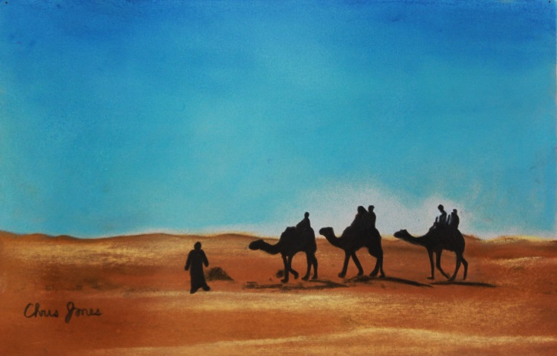

Partners
International Social Science Council (ISSC), has the mission of advancing the social sciences – their quality, novelty and utility – in all parts of the world.

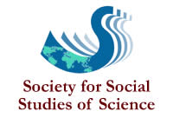
The Society for Social Studies of Science (4s), is a nonprofit, professional association with an international membership of over 1200. The objective of 4S is to bring together those interested in understanding science, technology, and medicine in their social contexts.

The Video Ethnography Laboratory was established at LSU as a resource for graduate teaching and video ethnographic research.

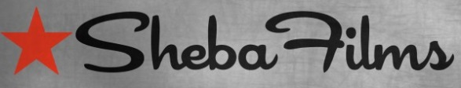
Journal of Video Ethnography

Art for Film
Ethnografilm has partnered with Lee Magnet of Baton Rouge, Louisiana to embellish the gallery of the festival theatre (Cine 13 Theatre in the Montmartre District) with artwork representing the selected films.
Through this initiative, Lee Magnet has created an absorptive environment for the screening and discussion of films selected by the festival committee. Each attending filmmaker will be presented with an artwork based on a screen shot from their film.
Susan Arnold
Director, Art for Film Program, Lee Magnet
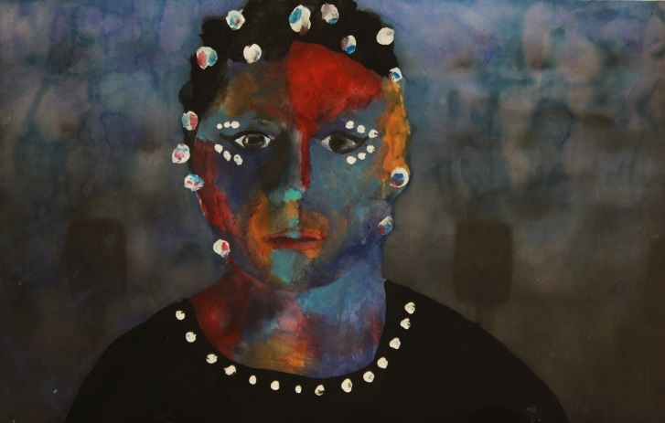

Student Artists

Alexis Allen
Jacori Andrus
Carra Babin
Talia Bell
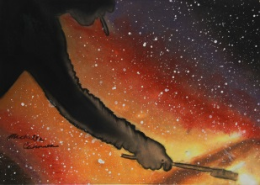Ryane Bickham
Larissa Brewer
Christaijua Brooks
Nhi Bui
Orlando Burks
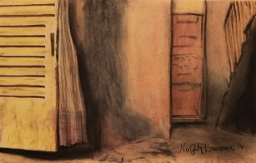Taylior Burton
Candis Bynum
Destiny Campbell
Michelle Cannon
Freddie Coates
Antoine Collins
Kassandra Crissman
David Cruz
Destiny Curtis
Ahlam Dabit
Jakayla Davis
Kyla Davis
Nautica Day
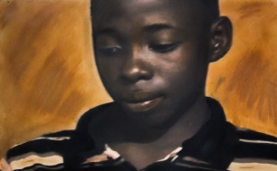Alaysia Deflanders
Jasmine Dobbins
Julia Dornier
Anthony Dyson
Cindy Eburda
Jason Egler
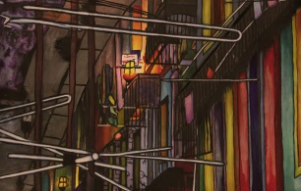Andrew Elliot
D'Ona English
Minerva Florles
Attylaka Follins

Joline Fontenot
Darius Frazier
Lanaya Freeman
Khofie Garner
Jimmie Givens
Kiyanna Givens
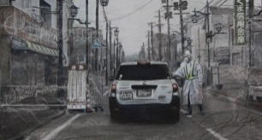Kiara Goins
Garrett Grzybowski
Riley Guidry
Haylie Hansberry
Sidney Hearns
Raven Heard
Raven Hogan
Takia Huckaby
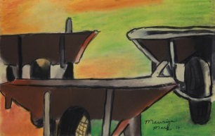Tyronne Jackson
Gabriel Jackson
Germika Jackson
Jaylynn Jackson
Keyvon Jackson
Trinity James
Devon Johnson
Tayshun Johnson
Chris Jones
Alania Jones
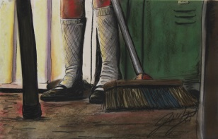Tessie Landry
Nayah Lawrence
Grant Legaux
Simon Lewis
Hanna Lu
Kelsey Mack
Maurice Mark
Alexis Marrioneaux
Torin McClanahan
Danielle McCorkle
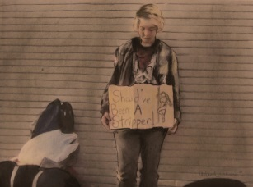Denis Menjivar
Madeline Miletello
Darlene Miranda
Johnté Nelson
Savannah Newman
Anh Nguyen
Destinee Nguyen
Wendy Nguyen
Olivia O'Oalloran
Chyna Page
Aylesha Patterson
Kimberleigh Patterson
Brandon Persica
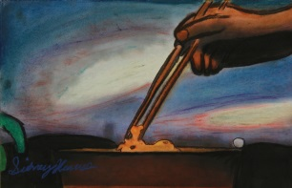Brandon Persica
Taniyah Porter
Je'Koby Prenell-Johnson
Alexandria Rainwater
Tyana Randle
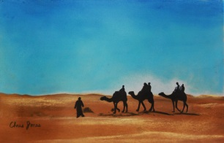Victoria Riley
Lance Sherman
Darius Simmons
Katherine Skiles
Asarel Smith
Jude Smith
Taiya Sterling
Christian Turner
Desiree Verrett
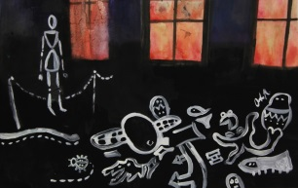Kendalyn Walker
Jalin Walker
Javorian Warren
Ashlin Wharton
Adarian Williams
Ayriel Williams
Chelsea Williams
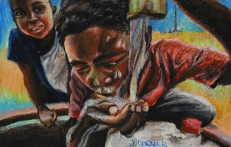Jasmine Williams
Terrika Williams
Dakota Wise
Kyra Wooders
Jumana Zo Al Ghena

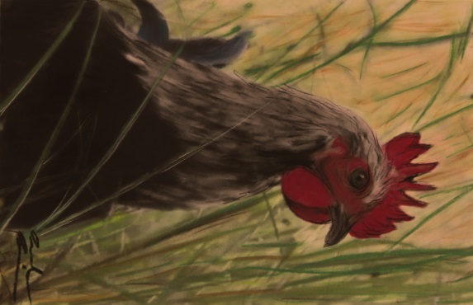

Adelante
Noam Osband / USA / 28 min
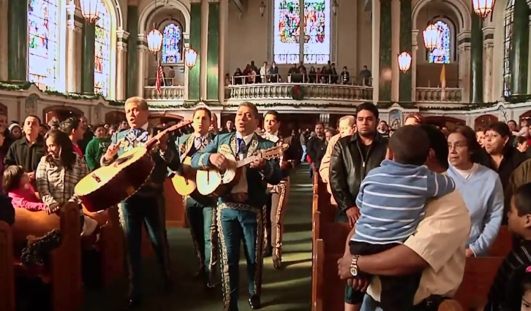
'Adelante' shows the heart of Mexico beating strongly, just outside of Philadelphia, where Mexican newcomers are revitalizing a dying Irish-Catholic parish in Norristown, PA.

Alban Endlos - Umda
David Aufdembrinke / India / 4 min
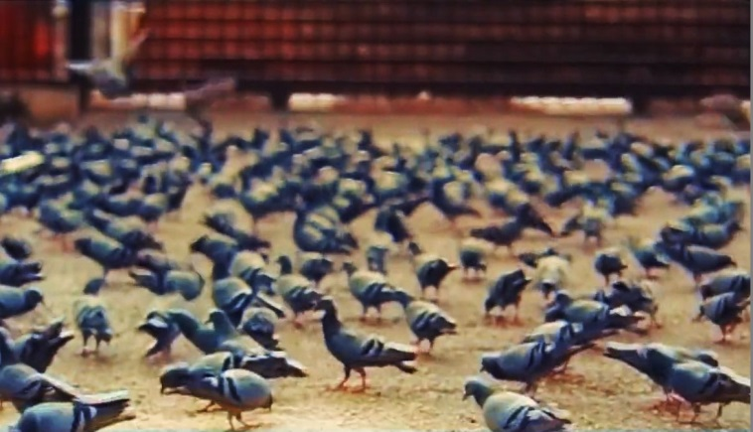
A 6 week journey through India in 4 Minutes match-cuts, colorgraded on a used VHS tape.

Bamako Chicken
Habib Yazdi / Mali / 4 min
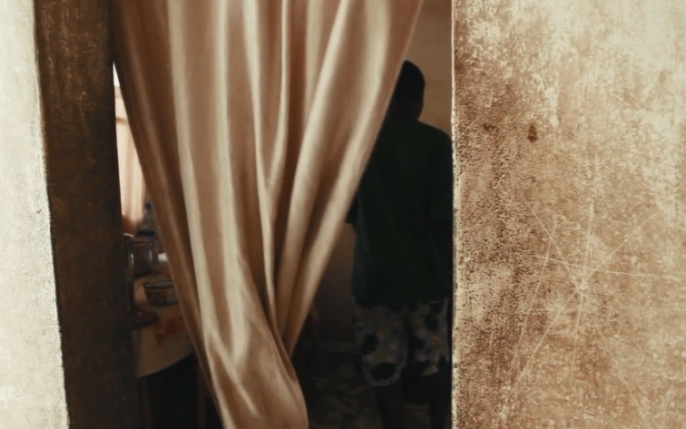
A young Malian boy, Aba Diko, sells chickens to help support his family. From weaving his way amidst the energetic tumult of the marketplace, through the sun-drenched thoroughfares of his commute, to the cooler, quieter spaces of the home where he cooks, Aba works tirelessly. His actions are shown with reverence highlighting elements of deeper ritual behind otherwise routine moments of joy and fortitude in the face of anonymity

Behind The Door
Martin Svinkløv , Rune Bundgaard / Greenland / 15 min
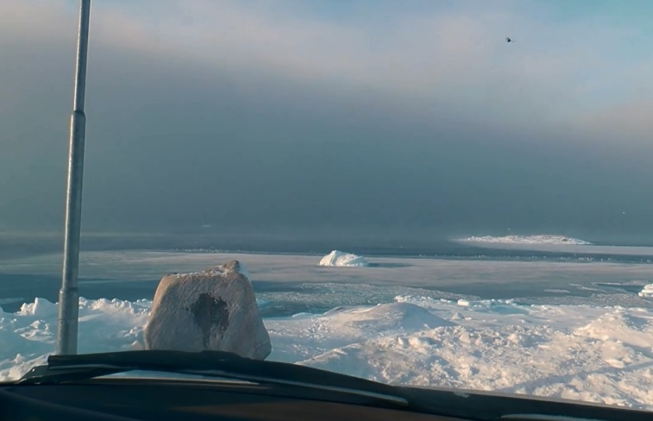
"Behind The Door" is a portrait of a college dorm in the Greenlandic city of Sisimiut. Here, a group of young people have moved far away from everything they know, and now they have to make the day-to-day life work, and make their life meaningful. About change, hope, longing and support, and the balance between holding on and letting go. Based on a filmed ethnographical field study, where the filmmakers moved in to the college dorm to study how young people handle their new situation and how they create a home for themselves.

Birthdates
Arba Bekteshi / Albania / 3 min
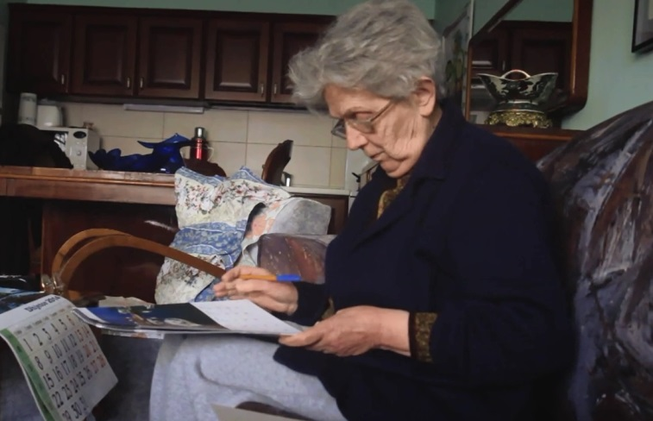
Each year my grandmother marks her calendar as a way to reorganize her role in the family, reaffirm emotional relations and reconstruct her family space. The short explores how the subject's commitment to ritualistic materiality serves and ultimately challenges notions of sociality concerning the elderly.

Bitter Roots
Adrian Strong / Namibia / 67 min
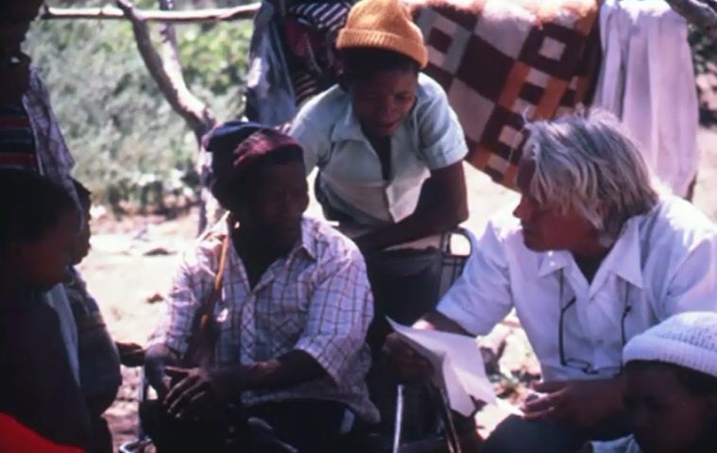
Bitter Roots is set in North East Namibia in southern Africa's Kalahari desert, traditional home of the Bushmen. It updates the ethnographic film record begun in the 1950s by John Marshall, whose films documented 50 years of change, and who together with Claire Ritchie, established a grass-roots development foundation which Adrian Strong (the filmmaker) joined in the late 1980s.Shot in 2007, Bitter Roots documents the return of Strong and Ritchie to Namibia where they observe the erosion of a community-led development process following the imposition of a new agenda by the World Wildlife Fund.

Children of Haliya
Charles Howarth / Nepal / 15 min
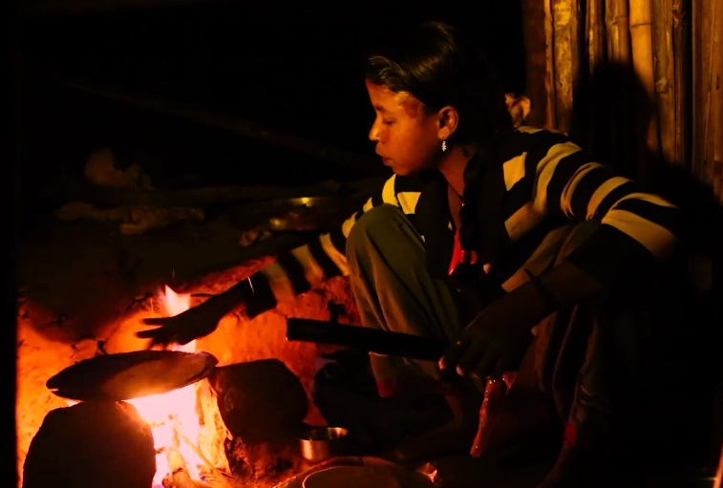
Mesmerising, moving and hypnotic, Children of Haliya combines an insightful exploration of bonded labour in Nepal with the rich narratives of two fascinating characters.

Colors of Life
Goro Ushijima / Japan / 14 min
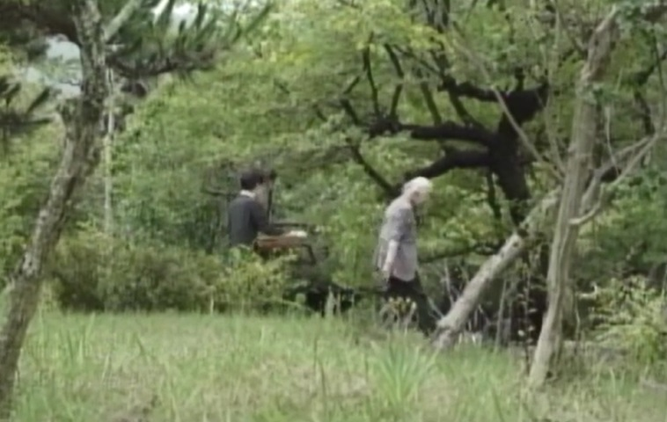
The Shimuras, mother Fukumi and daughter Yoko, devote their daily lives in a lifelong pursuit to understanding and preserving the national treasure that is Japanese textiles.

Computing Cultures
Matthew Harsh / Kenya / 15 min
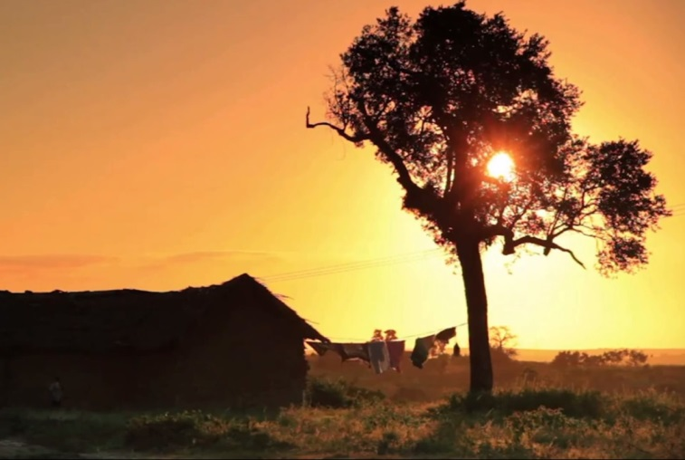
Portraits of knowledge production in East Africa.

Conter sa Vie
Héloïse Dériaz / France / 30 min
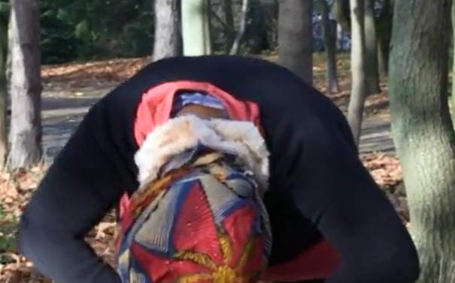
En partant de l'Afrique, la conteuse Catherine nous plonge dans la musique, les épopées héroïques, le rêve et l'imagination...

Cuckoos' Children
Inesa Kurklietyte / Lithuania / 25 min
Twelve lost children live in a remote country house near Silute town. Their mother is Ona who was an orphan herself. Ona takes her foster children to meet their real mothers. She wants them to know their roots.

The Diambourou: Slavery and Emancipation in Kayes - Mali
Marie Rodet / Mali / 23 min
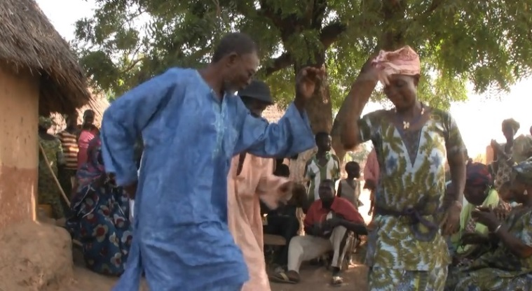
African slavery was officially abolished in Mali by the French colonial authorities in 1905, but effective emancipation of formerly enslaved was a lengthy process, the repercussions of which were still felt long after Mali's independence in 1960.This documentary tells those communities resisting slavery and founding new independent and free communities in the Kayes region (Western Mali) in the first half of the twentieth century. The film presents a unique audio- visual archive of slave emancipation in Mali.

Easter Rock
Joyce Jackson / USA / 15 min
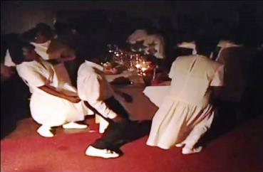
This annual Easter Rock ritual is centered on the death and resurrection of Jesus Christ and involves spiritual-based music and the performance of circular movements or “ring-shouts.” This pre-Civil War ritual provides an alternative lens and allows us to see that women in the “black folk church” base their leadership and power on direct control and preservation of ceremonial and ritual events. They are not passive minions of black male church leadership but rather active agents in the cultivation of female authority through “hidden transcripts.” The researcher/director draws heavily on observations and ethnographies of participants collected over several years from a field site of a plantation church in northern Louisiana.

Eating Cultures
Holly Giesman / United Kingdom / 15 min
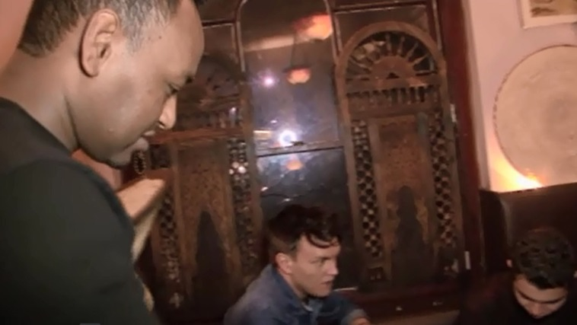
Eating Cultures is a documentary journey through three foreign national restaurants in London (Eritrean, Pakistani and Argentinian). Restaurant staff and customers share their experiences of working and eating in the restaurants as the filmmaker examines how 'authentic' is understood and how culinary worlds are reconstructed and adapted for a multicultural London audience. Both the restaurant staff and the filmmaker engage in storytelling across cultural boundaries, yet they are charged with the accurate representation of an aspect of real life and bound by claims and expectations of authenticity. The film explores the intricacies of 'mediating worlds' alongside the sensory-rich, somewhat touristic experience of 'eating cultures'.

Evening Classes in Ouagadougou
Félix Compaoré, Marc Pilon & Paraté Yaméogo / / 9 min
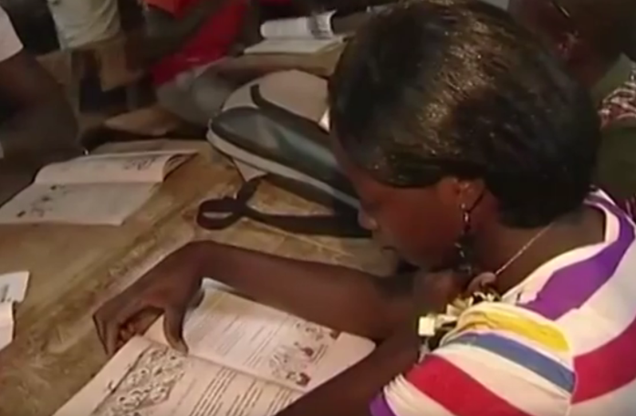
This documentary looks at evening classes phenomenon, in full development in Ouagadougou (capital of Burkina Faso) since the late 1990s. For the primary level, among learners (along with young children who never attend school and do not achieved or succeed), there are young adults, mostly rural migrants, rather active in the informal sector, and who firstly need functional literacy in French.

Everyday School Management in Rural Benin
Sarah Fichner & Paraté Yaméogo / / 11 min
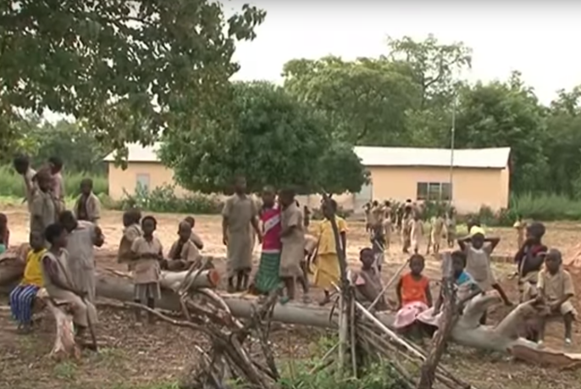
In the context of the global Education for All campaign a number of public primary schools opened their doors in remote villages in African countries. The film shows how local actors (the school principal, parents and teachers), in the village of Ganrou in the north east of Benin, manage its everyday functioning and deal with problems such as teacher shortages and insufficient classrooms at the beginning of the school year.

Exit Wounds
Pattie Collins / Australia / 10 min
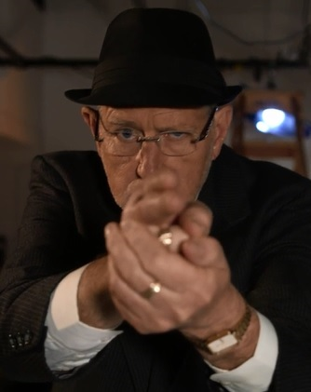
A Conversation with an Australian Army Medic aboutthe Rwandan Civil War (1994-95)

Eye of the Storm
S. Kramer Herzog / United States / 16 min
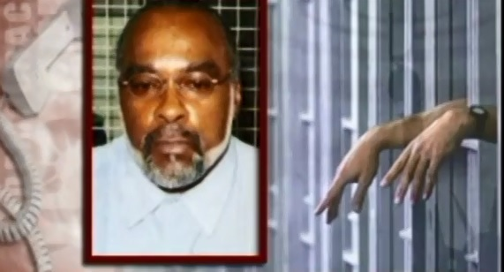
A harshly real view of the media and the circus that it can create, the documentary was shot during the hours leading up to the 2005 execution of Crips founder Stanley "Tookie" Williams at San Quentin State Prison. While that fracas was caught on film, anti-execution demonstrators tried to shout down a Fox News broadcast. When the news team tried to re-establish its position, the demonstrators shouted louder, claiming Fox was interfering with their freedom of speech. The showdown escalated from just a shouting match to shoving and hitting.

Face to Face
Chuan Chung / / 15 min
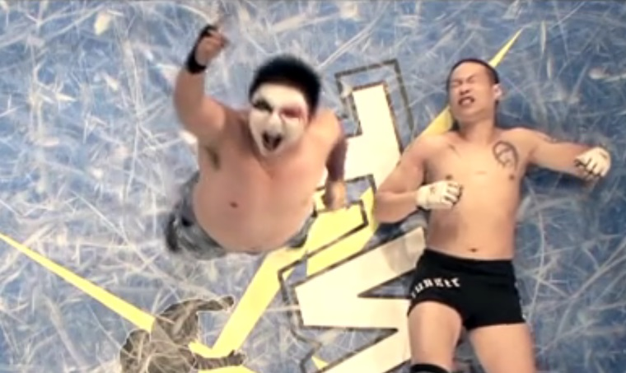
A film about a group of life losers.They achieved nothing in reality, but life needs to go on. So they picked a road to the stage of performing wrestling, they played roles that are dangerous to others. In the world of wresting ring, they tortured themselves to become the villains on the stage, and they seek the last bit of dignity among the whispering and clapping from audiences.

The Family and the Animals
Jacob Hesmondhalgh / Zimbabwe / 15 min
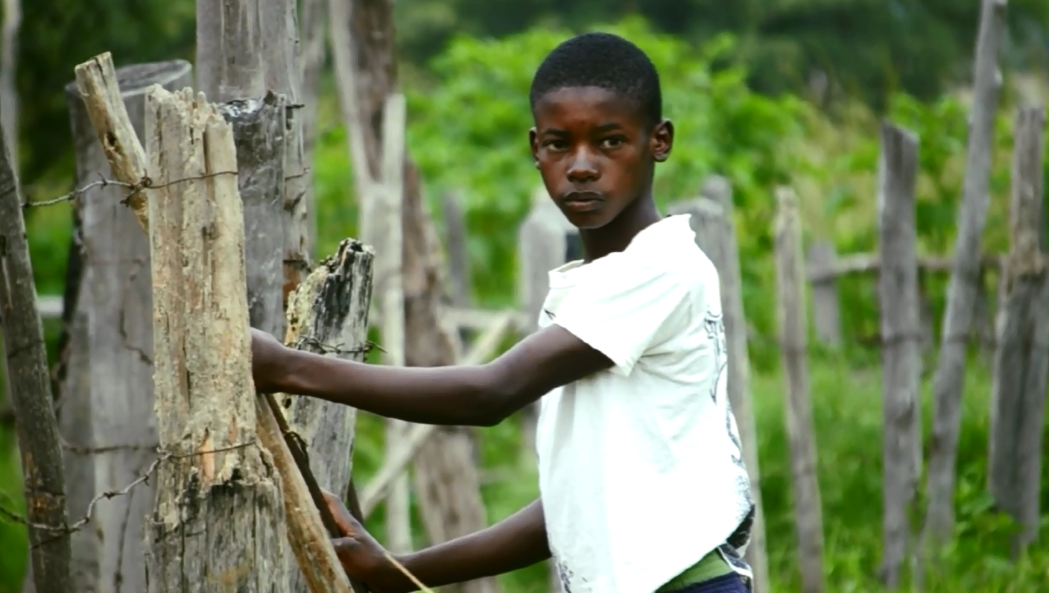
Sunrise to sunset. A day in the life of a rural Zimbabwean family and their animals.

Femen Naked War
Joseph Paris / France / 57 min
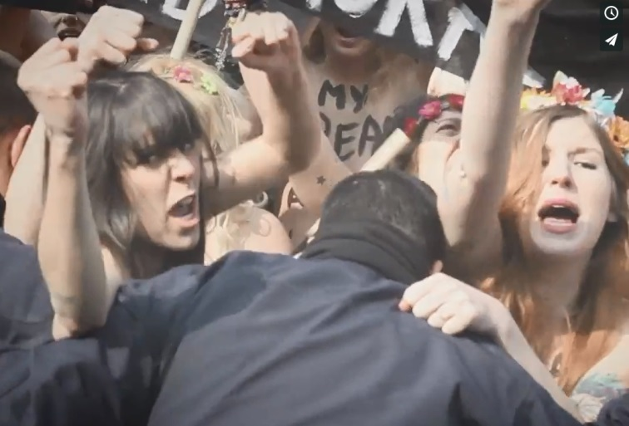
Joseph Paris met the revolt of Femen - the women's urkrainian movement - in spring, 2012 and during more than a year, he followed and filmed them. In his documentary, he tries to discern better what tells this revolt, with the help of Annie Le Brun (poet) and Benoit Goetz (philosopher) who bring a fresh perspective about this radical feminism.

Finding Beauty in the Rubble
Matthew T. Burns / Japan / 5 min
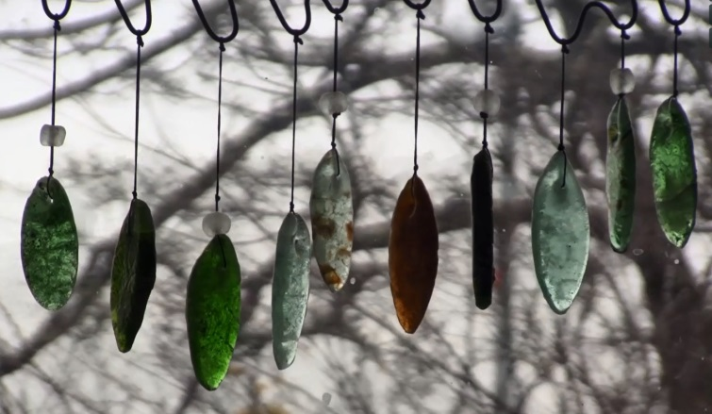
In Japan, a survivor of the tsunami turns beach debris into jewelry.

Finding Refuge
Torsten Kjellstrand, Rob Finch, Jamie Francis / United States / 26 min
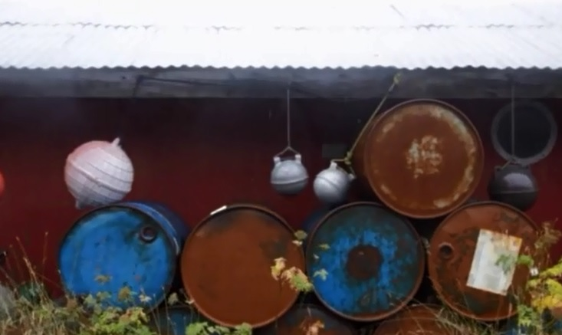
The efforts of one dying woman to preserve her Native culture don’t end when she passes, but prompts a renewal in finding pride in that culture. She confronts the violent event over two centuries ago that began the destruction of her people and the shame that colonialism created.

Four Keeps: Dakaake
Robin Starbuck / USA / 10 min
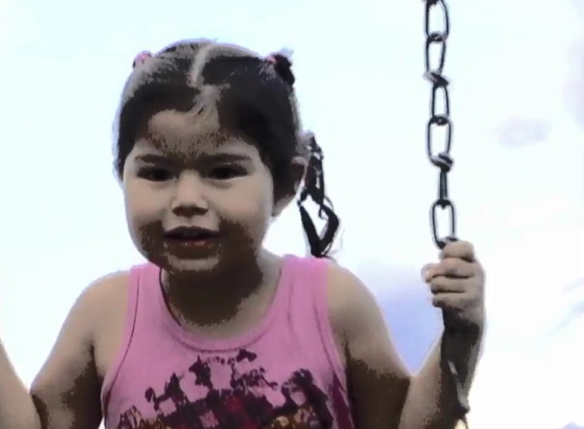
This short essay film is based on Crow/Apsaalooke native tribal cosmology in which air characterizes one of the four cardinal points and when called upon represents a powerful blessings for the people. In this film Dakaake or Bird represents air. The traditional Crow story accompanying this film, 'The Story of Moon and His Bride', was first written down by Helen Pease Wolf. The story was read for this film by her great-granddaughter, Ramona Russell Real Bird. An experimental documentary this short film unfolds with a dreamlike weaving of text and image.

Galvanized
William Noland / USA / 15 min
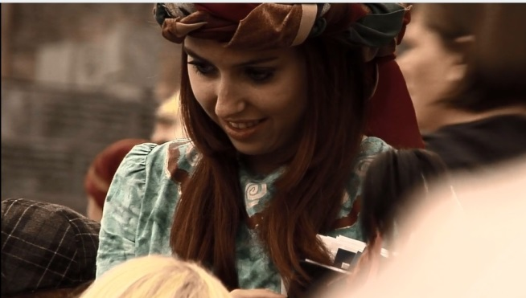
In "Galvanized" three groups of individuals, representing distinct approaches to belief and action, are viewed consecutively: Mormons preparing to perform at the Hill Cumorah Pageant, an outdoor religious drama staged annually in Palmyra, New York; Occupy Wall Street activists participating in a one-year anniversary event in New York City; and participants in Charlotte 714, a movement of Kingdom-minded Christ-followers gathered to exalt Jesus in Charlotte, North Carolina to coincide with the 2012 Democratic National Convention. The film explores the margins and boundaries of the political, examining both the public and private spheres. The gatherings are linked by a particular moment in time, and the aim is to put these groups and their divergent goals into telling relation to each other.

Guardians of Risk
Melanie Pitteloud / Switzerland / 29 min
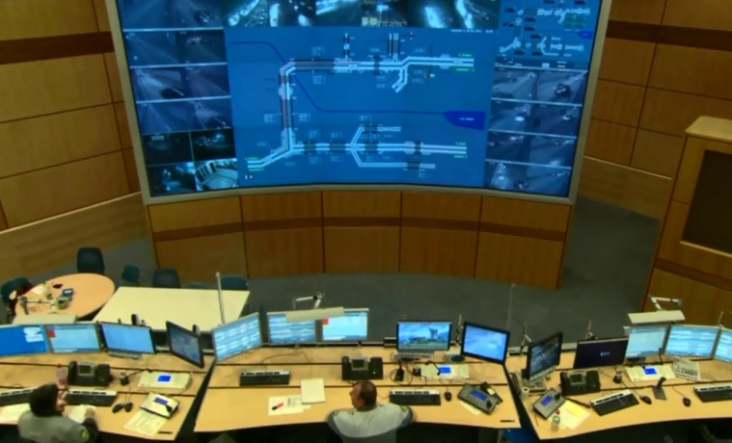
Behind their screens, operators keep watch around the clock to ensure that risks don't become disasters and that our networks and systems - air and road traffic, electricity, weather forecasts, natural disasters, etc. - run smoothly. Filmed 'behind the scenes' in five different control rooms, the film was made as part of a social science study in which the filmmaker was involved. It offers us a glimpse of the everyday lives of these 'guardians of risk' who live on the cusp of the routine and the unexpected - a job that demands perpetual vigilance and, yet, that no one every talks about... except when things go wrong.

Haaviv Shell Demeter
Daphna Mero / Israel / 20 min
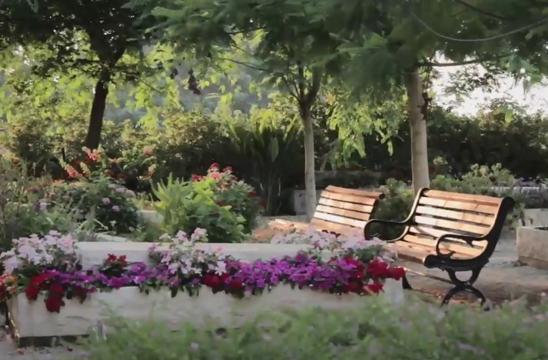
The film draws a portrait of a secular Cemetery in an Israeli kibbutz as it follows a single life cycle observing the cemetery as it withers and blooms again.

Haight Love
Grant Hayes, Melody Edwards / United States / 16 min
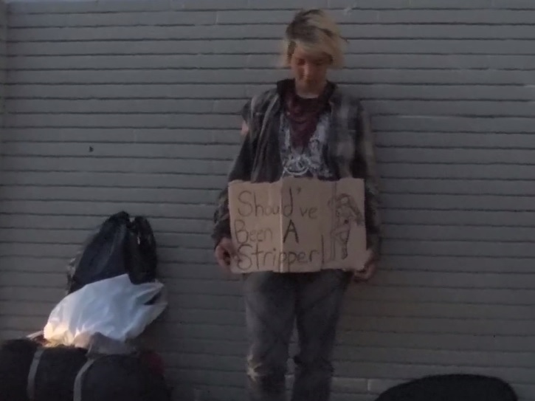
The Haight Ashbury district of San Francisco became a site of historical significance following its central role as the epicenter of the counter-cultural movement in the 1960s.

Hanging Fish
Jose Carlos Barquero Montero / Panama / 11 min
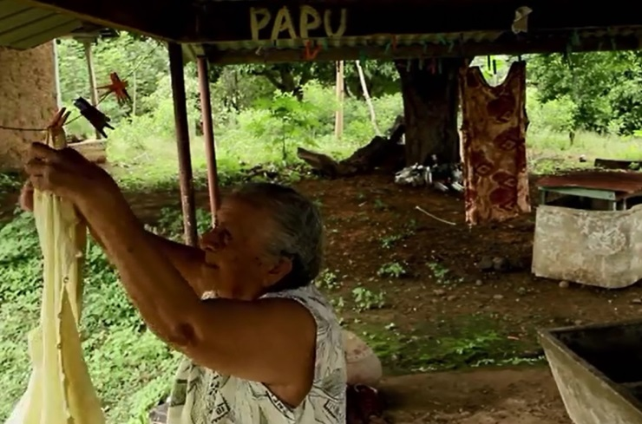
At Villa de Los Santos - Panamà. At a river full of life. A washerwoman and a fisherman share their memories as weather, pollution and economic development condemned their trades into oblivion, taking away their traditions and their lives on Rio La Villa.

Highland Lives
Molly Merryman / USA / 20 min
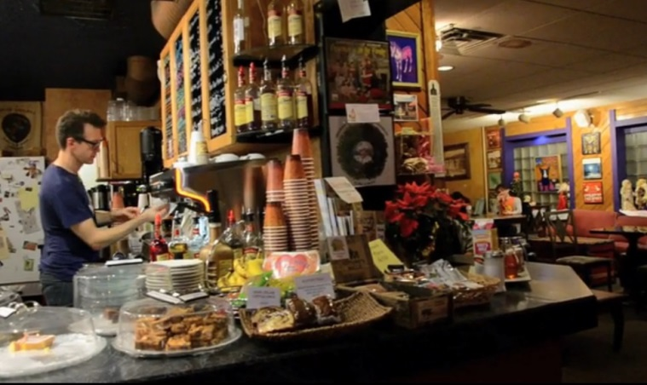
Highland Lives interconnects the original interviews of 13 residents from Akron’s Highland Square neighborhood to create a video snapshot of a dynamic and flourishing neighborhood, which is considered to be the heart of Summit County’s LGBTQ population. Archival photos are used to describe the history of Akron and Highland Square, while interview and b-roll footage combine in telling the stories of some of the gay, lesbian, transgendered and straight people who call the neighborhood home.

Historias del Balcones
Helle WindelÀv-Lidz_lius / Cuba / 28 min
In the colorful Cuban capital Havana the balcony is a micro cosmos full of life and death: In a dilapidated neighborhood in Havana an old blind man perceives life from his beloved balcony. From this his both private and public platform he stays in close contact with the surrounding world. Despite not being able to see, the old blind mans balcony allows him to follow each breath and move from his neighbors and the people passing by in the street below. Despite not being able to see his surroundings with his eyes, he is seeing it all with his body and senses. The old man has advice about love to give and balcony tales to pass on the next generation, before he gets too old.

The History of Women
Darian Stansbury / / 10 min
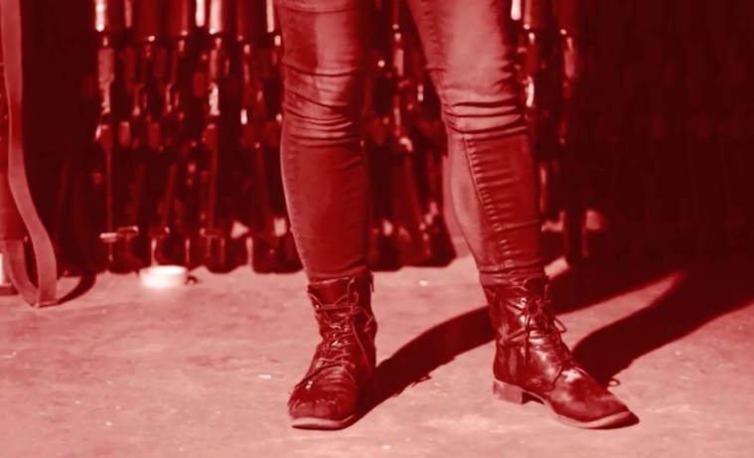
The title is an allusion to Michel Foucault’s The History of Sexuality; not a chronological study of women, but rather a video essay discussing the construct of womanhood. A main focus being to seek out the distinction between the filmic objectification of women and the filmic abstraction of women. Narrative vignettes feature a secret society of women who experience mystical sensations during their menstrual periods.

I want To Be Afsaneh
Selma Nayebi / Iran, Islamic Republic of / 38 min
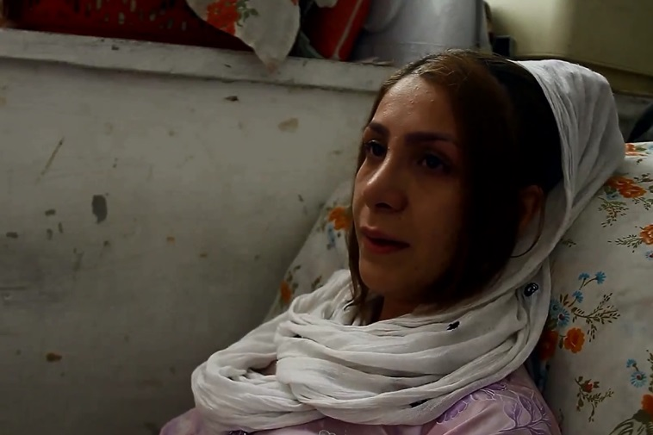
Afsaneh is forced to marry at the age of thirteen because of her mother’s behavior that she discriminated between Afsaneh and her brothers. A story of marriage, child-bearing, and separation, she lives with her daughter Sahar in a dilapidated house, with 40 years of problems on her shoulders.

Il Taglio del Maggio - The Wedding of the Trees
Melanie Kindl, Clemens Wolfart / Italy / 18 min
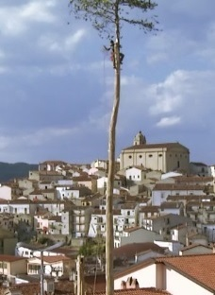
In Southern Italy a pagan fertility ritual has survived over the centuries. It is an ancient tree cult with a unique convergence of magic and religion, belief and superstition, craftsmanship and excessive partying.

In the Shadow of Ebola
Gregg Mitman / Liberia / 27 min
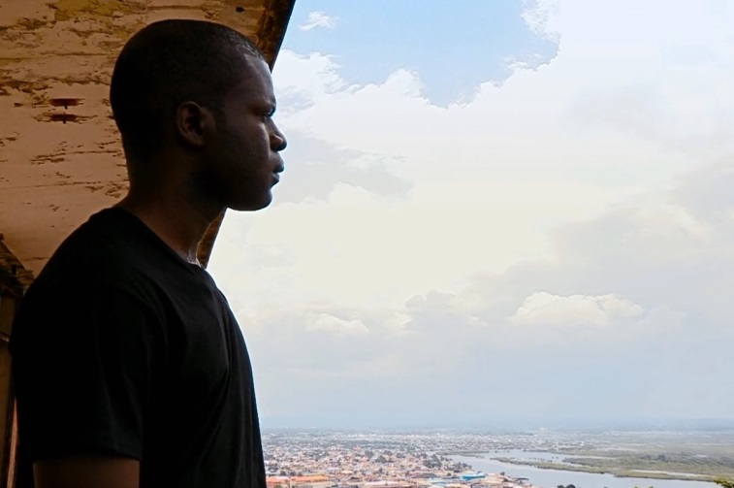
'In the Shadow of Ebola' is an intimate story of a family and a nation torn apart by the Ebola outbreak. We follow a Liberian student and his family living divided between the United States and Liberia, who open our eyes to the ripple effects the outbreak is having on Liberians living through this crisis. Caught in an invisible war that is painfully reminiscent of the chaos and confusion they lived through during a fourteen-year civil war, a family and a people find the compassion and inner resolve to combat the virus's spread.

The Indian Priest
Mattias L_w / India / 59 min
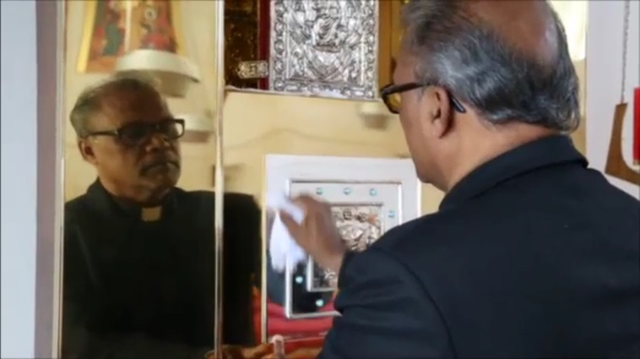
Almost fifteen years ago, a Catholic priest from south India, Raphael Kurian, arrived in secular Sweden to do missionary work.

It's Better To Jump
Patrick Alexander Stewart, Gina Marie Angelone, Mouna B. Stewart / Palestine, State of / 75 min
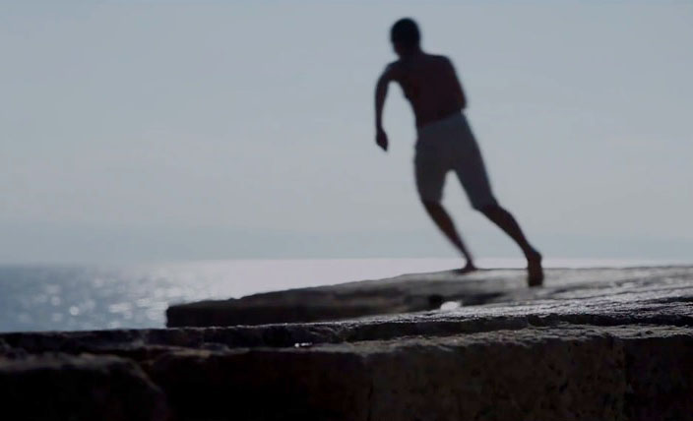
It’s Better to Jump” is a feature-length documentary film that gives voice to Arab inhabitants of the ancient walled city of Akka (located on Israel’s northern coast) as both the people and their town face a very uncertain future.

It's Complicated
Zimu Zhang / Belgium / 11 min
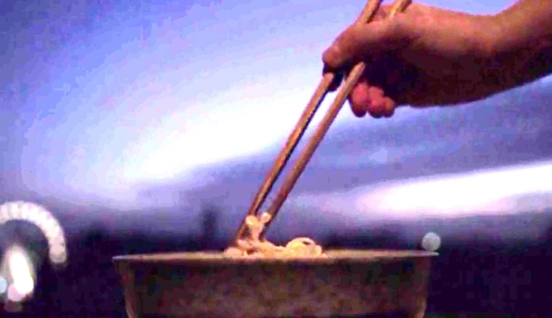
A surrealistic work exploring what physical and cultural differences could impose on us, through a piece of banal reality.

Jiàoliàn [Coach]
Esteban Argüello / China, United States / 60 min
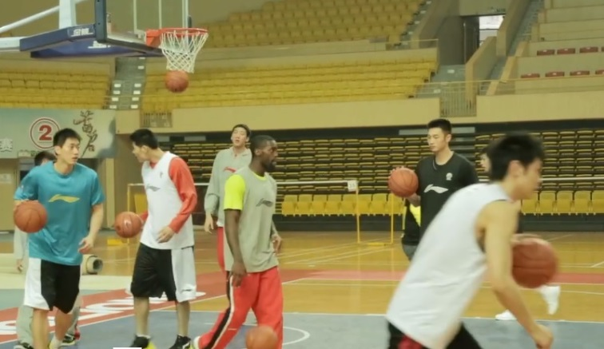
Jiàoliàn [Coach] is the story of 27 year-old Norman de Silva, an American who overnight becomes the head coach of the Foshan Long Lions, a professional basketball team in China, and in order to win he must help his player’s regain their love of basketball.

Journey to the Maggot Feeder
Liivo Niglas, Priit Tender / Estonia, Russian Federation, United Kingdom / 68 min
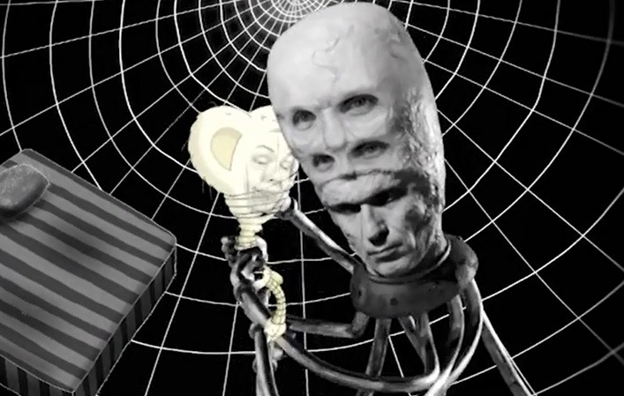
“Journey to the Maggot Feeder" tries to solve the mystery of a bizarre Arctic fairy tale. Priit Tender, an Estonian animator, makes a film about an old Chukchi legend – The Maggot Feeder.

A Journey to Namie
Sulfikar Amir / Japan / 12 min
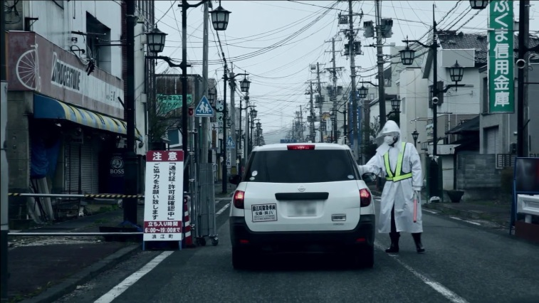
A small town was abandoned by its residents in the aftermath of the Fukushima nuclear disaster.

Juanita
Ximena Amescua Cuenca / Mexico / 24 min
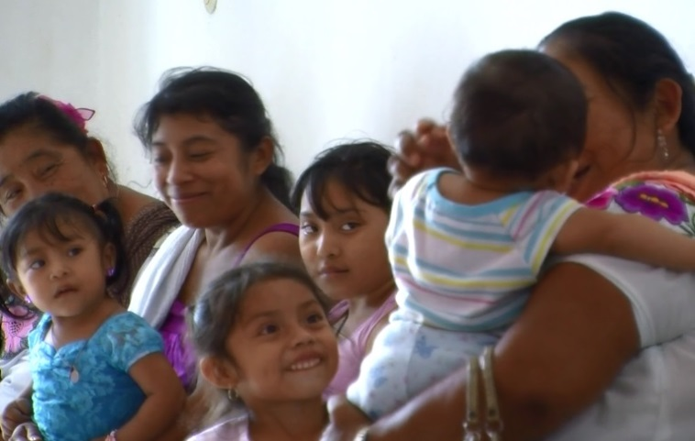
A glimpse into the everyday life of Juanita, a Mayan traditional doctor, midwife, nurse and activist. Leader of "The Awakening of the Women who Heal,"; an organization of midwives in the Orient of Yucatan, Mexico.

Kandahar Journals
Louie Palu, Devin Gallagher / Afghanistan, Canada, United States / 77 min
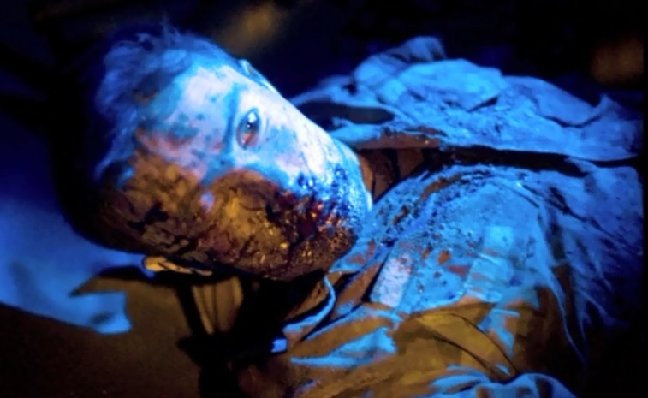
Kandahar Journals is the story of a photojournalist who reflects on the events behind his psychological transformation after covering frontline combat in Kandahar, Afghanistan from 2006 to 2010.

The Ladies
Tyler Zoanni / USA / 10 min
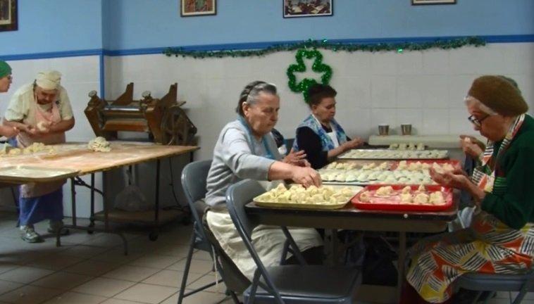
For 50 years, a group of Ukrainian women has gathered in New York's East Village to make dumplings for their church. This observational short offers an evocative portrait of 'the ladies' and the work, faith, gossip, and humor that brings them together. (In Ukrainian with English subtitles)

The Last Bonesetter: An Encounter with Don Felipe
Adam Booher / Peru / 27 min
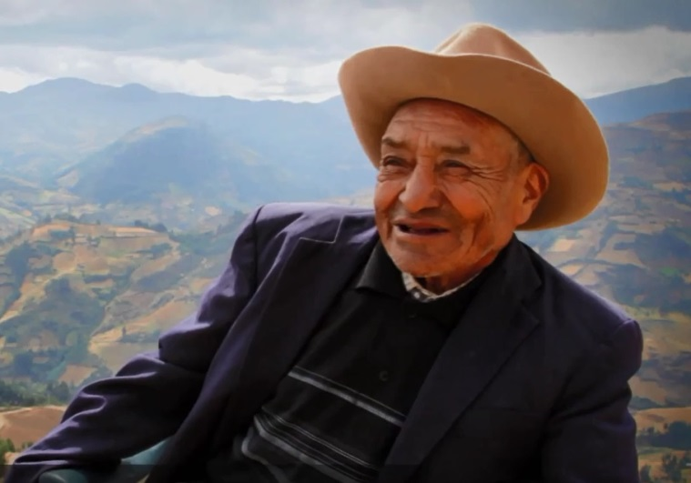
In some remote areas of the Peruvian Andes, bonesetting has all but disappeared. Due to the rigor of peasant life, a high demand exists for this ancient healing tradition that involves massage, adjustment, and setting breaks. The career of bonesetter Don Felipe is traced across 25 years, including efforts to find an apprentice before it's too late.

The Last Refuge: Food Stories from Myanmar to Coffs Harbour
Mandy Hughes / Australia / 16 min
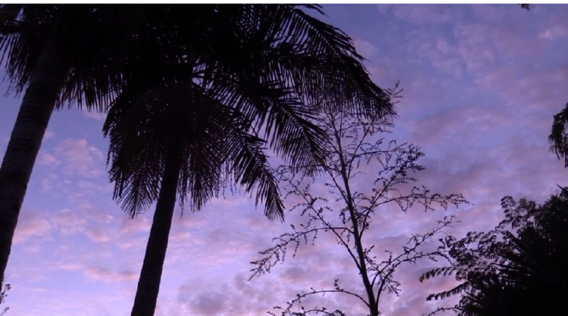
More than 300 people from Myanmar have settled in the regional town of Coffs Harbour, Australia. Some of these settlers have spent more than 20 years in refugee camps. They have fled their homeland with little more than their memories and their stories.

Limpiadores
Fernando Mitjans / Brazil / 15 min
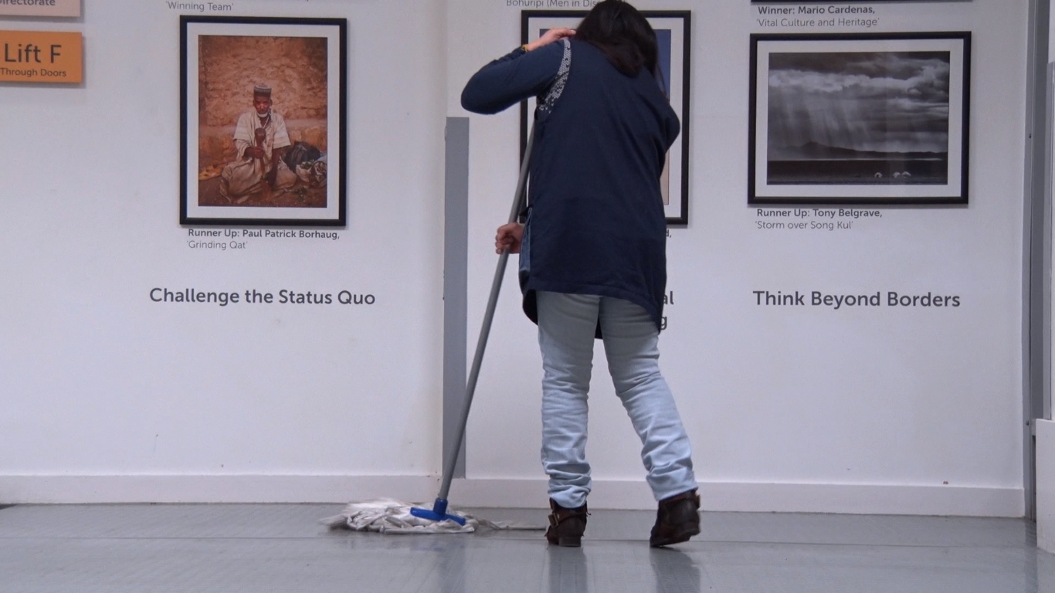
'Limpiadores' portraits the life and struggles of the invisible migrant workers that make sure offices and classrooms are clean and tidy before professors and students arrive for their morning classes at some of London's most prestigious Universities.

Literacy in Fula Language in Senegal
Marie-Eve Humery & Paraté Yaméogo / / 12 min
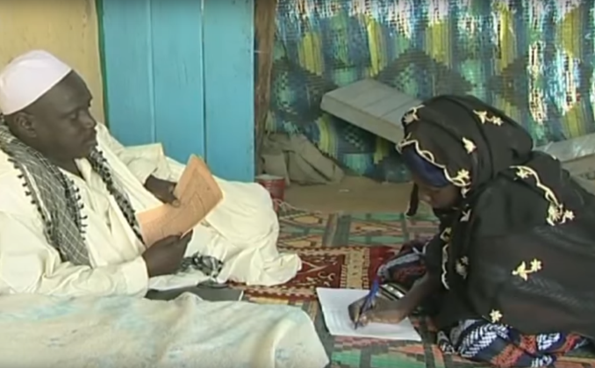
In the Senegal River Valley (Senegal and Mauritania), the 1980-2000’s period has been characterized by a grassroots mobilization for literacy in the mother tongue (Fula language). This film enlightens the main inputs and stakes that have come out through this literacy movement, joined by the interest of the international development actors and NGO’s, now removed from the area. Internet has given a second chance to the scripturality in Fula language, but local people cannot become literate in their own language anymore.

Loose Horses
Kathy Kasic / USA / 60 min
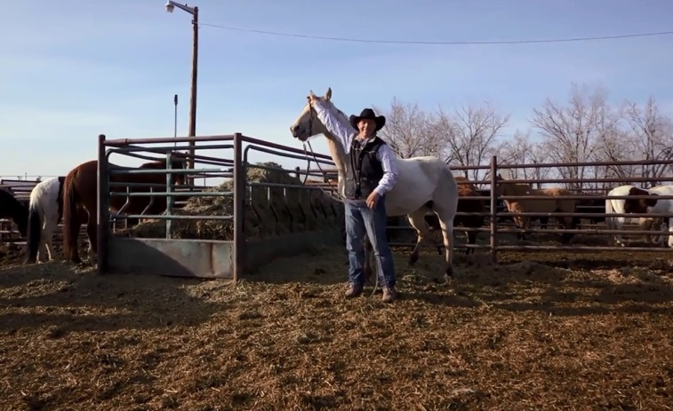
Loose Horses is a feature length documentary about a livestock auction in Billings, Montana and the horses and people affected by cultural politics.

Michael's
Kunnawut Boonreak / Myanmar, Thailand / 48 min
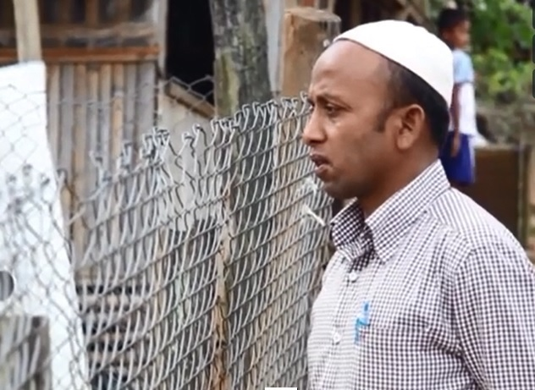
Among different background of economic and religion networks in Mae Sot district, a city along Thailand-Burma border, ‘Michael Right’ and Yameen ‘Michael Muhammad’, two Rohingyas have been struggling for their livelihood.

The Migrant Woman
Eli Jean Tahchi / Canada / 20 min
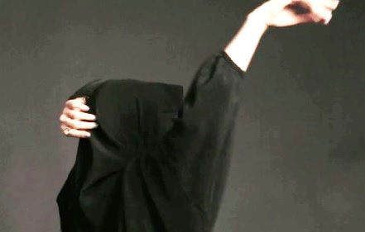
To approach the complexity of a subject, such as the veil in Islam, we decided to film a cast of potential women for the role of a veiled woman in a short film in preparation. The primary objective is to gather evidence that would be more narrowly, of nuances and understanding about the veil. The audition becomes an experience, and the experience becomes the film.

Milk Men: The Life and Times of Dairy Farmers
Jan Haaken / USA / 50 min
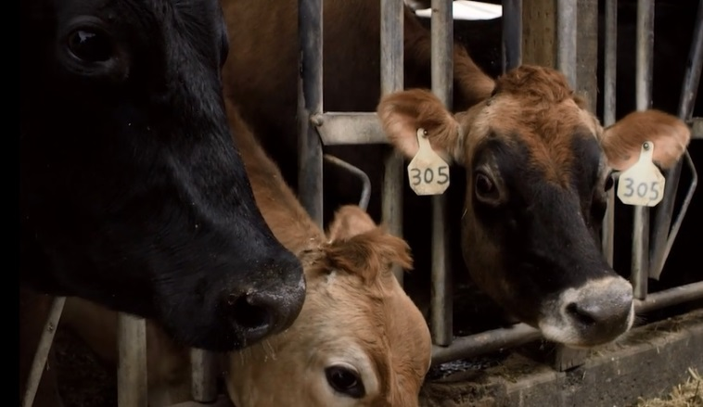
Psychologist and filmmaker Jan Haaken revisits the region where she spent childhood summers on her aunt and uncle's dairy farm, following four families as they try to survive amidst intense pressures that have led most dairies to go under.

Mill Stories: Remembering Sparrows Point Steel Mill
William Shewbridge / USA / 35 min
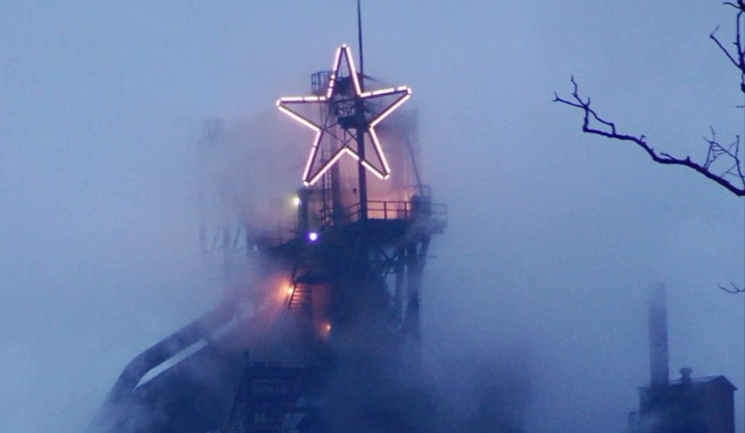
After 125 years of operation, the Sparrows Point Steel Mill in Baltimore, Maryland closed forever in 2012. Mill Stories presents a collection of personal stories based on over 30 ethnographic interviews collected at the time on the mill's closing. The documentary aims to examine the importance of the mill from the perspectives of former workers and community members while connecting these distinctive experiences to the larger narrative of American industrial boom and bust. Here, the memories and stories of former workers are framed as living heritage.

A Miscellany of Families
Zoe Aiano / Czech Republic / 30 min
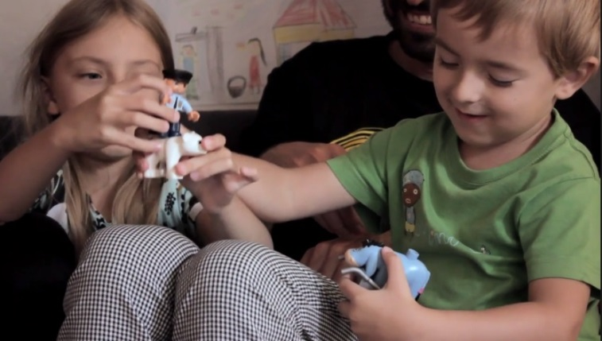
A playful exploration of the role of storytelling in our families and values

The Modernization Process of Qu’ranic Schools Daaras in Senegal
Clothilde Hugon & Paraté Yaméogo / / 13 min
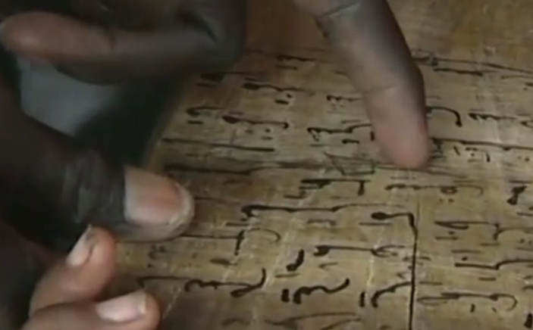
In the context of the global education for all campaign, Senegal has undertaken a new policy of modernization of the Qu’ranic schools, known as daara. The film gives an example of a « modernization » process in the commune of Diourbel, that engaged local actors in the reflexion. It also asks several questions : what is meant by « modernization » ? Which actors are involved and what rôle the Qu’ranic teachers play in this reflexion?

My Way
Zuzana Gedeon / USA / 10 min
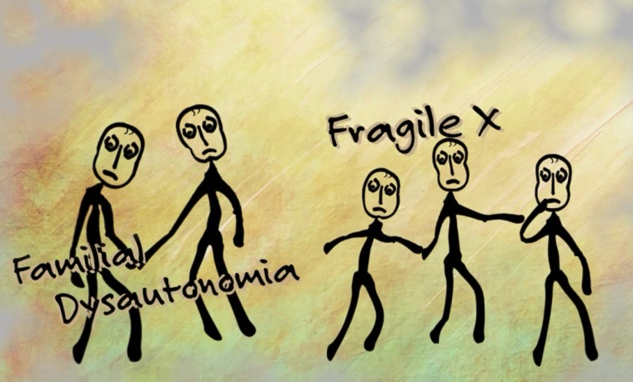
My Way is a story of a scientist who choose the road less traveled.Facing a dilemma between her career and the family, inspired by a holocaust survivor, one scientist patiently follows her calling. Following in the footsteps of Rita Levi Montalcini, a neuroscientist who proceeded to do a Nobel prize worthy research while in exile, Frances Lefcort decides to move to Montana to face the weather and separation from mainstream science, to research a disease which runs rampant in her family. My Way is also a study on some issues that drive women out of science.

Nation
Ali Nobil Ahmad / Pakistan / 22 min
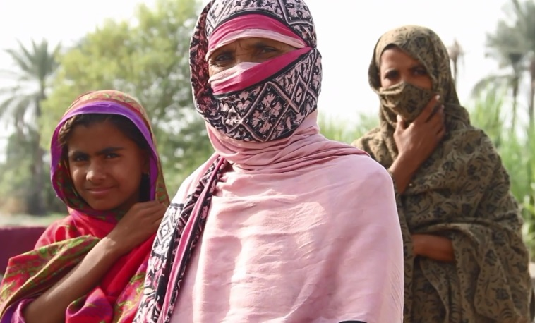
In 2010 catastrophic monsoon floods led to the worst natural disaster in Pakistan's history, displacing 20 million people and killing thousands. Waseb documents the response of one heavily affected community to these events. Investigative in scope but poetic in style and format, the film charts experiences of escape, survival and political mobilization through observation and interviews with local people in the months following the disaster. The film is Interwoven with poetry, giving dramatic voice and aesthetic power to the poor's collective grief and outrage against politicians and officials.

Ndzou Camp
Denise Dragiewicz / Mozambique / 17 min
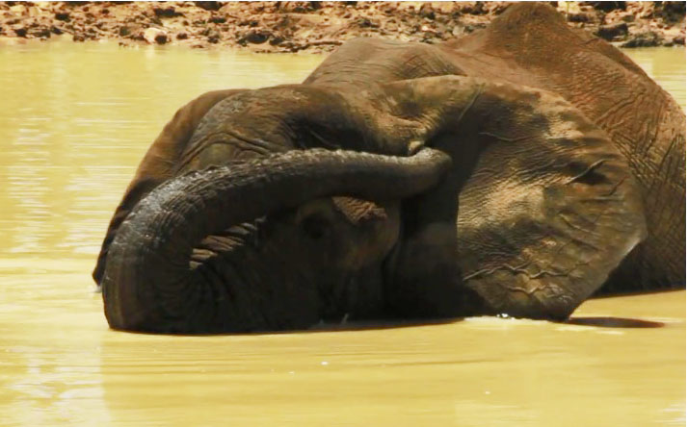
Filmed in Mozambique, a nation ravaged by deforestation and constant warfare, Ndzou Camp tells the story of a community determined to protect their elephant population and conserve their natural resources while pursuing tourism as a means of a more sustainable future. In modern-day Africa, elephants are being squeezed into smaller and smaller areas, and, oftentimes, lured by foods they enjoy eating, they will raid and destroy local crops, causing farmers to lose their entire livelihoods due to one overnight raid. These animals inspire fear and anger in those who share their land and are often killed in retaliation.

Near the Coffee
Flynn Donovan / Puerto Rico / 16 min
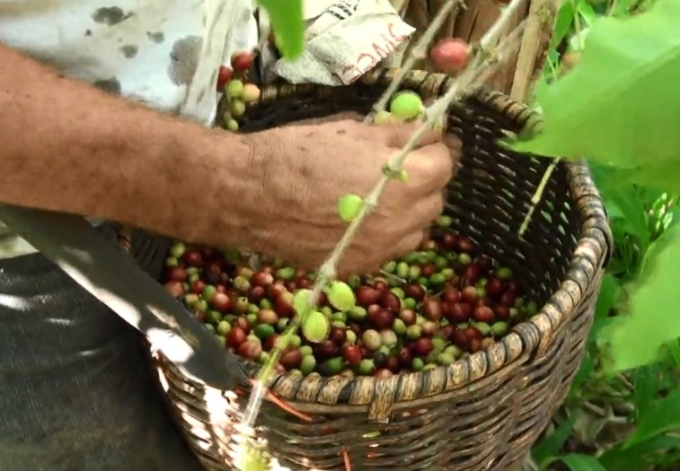
Coffee culture in Puerto Rico.

Neps
Joel Davidson / Nepal, United Kingdom / 15 min
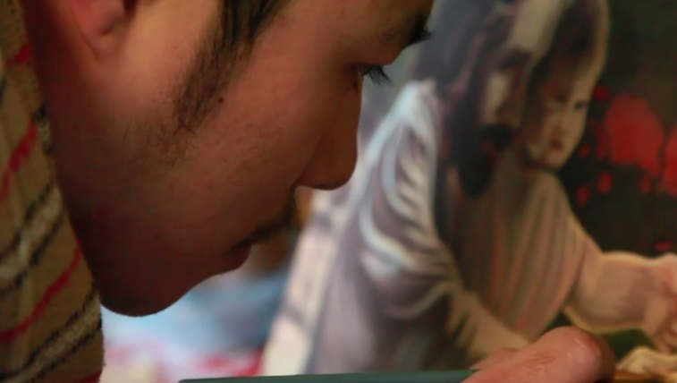
The identity of Nepalese youth living in Britain is examined through a trip to Nepal to explore their cultural identity, their past and future. Bijaya, having recently converted to Christianity finds himself needing change in his life, a process of rebuilding his religious foundations. He joins Suraj, a friend turned film producer, to rediscover their old home towns and childhood memories. Filmed as a collaborative project three weeks before the disastrous Nepal earthquake.

Nomad
Jean-Benoit Malzac, Kevin Falhon / United Kingdom / 8 min
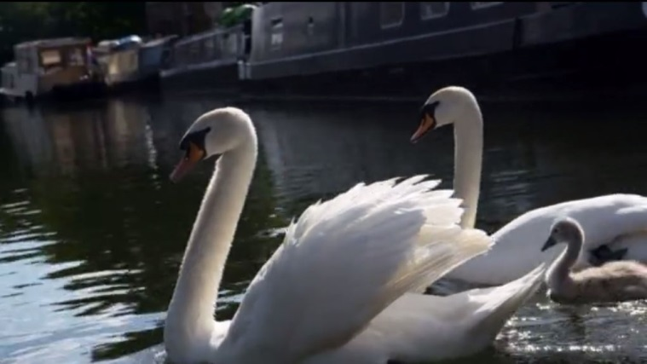
'Nomad' is a modern tale that takes you onboard the London canal. Discover the lifestyle of those who choose to belong to this floating community.

Nu Guo. In the Name of the Mother
Francesca Rosati Freeman , Pio d'Emilia / China / 58 min
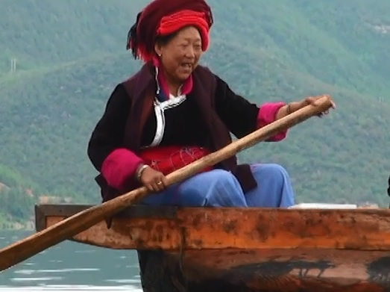
China, in the foothills of the Himalayas, the Mosuo, a non-violent society has for millennia offered proof that a harmonious and peaceful life is still possible.

Of A Few Days
Timothy Fryett / USA / 14 min
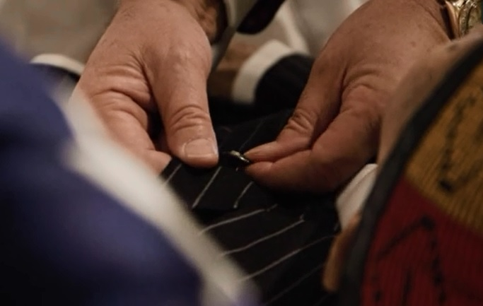
Inside a funeral home on the south side of Chicago, a series of quotidian workplace vignettes reveal a peculiar intersection of the existential and the banal.

Of This Parish
David Prior / Portugal / 25 min
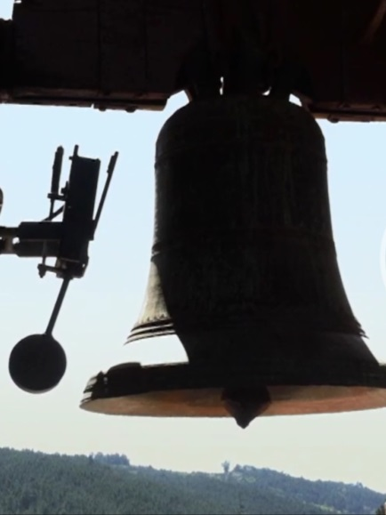
Of This Parish follows St. Anthony on a journey from a church tower to the threshold at which its bells can be heard. The film is both a sonic portrait of the Parish of Sul and a meditation on the changing role of bells in a rural community.

OME: Tales From a Vanishing Homeland
Raul Paz Pastrana / Ecuador / 39 min
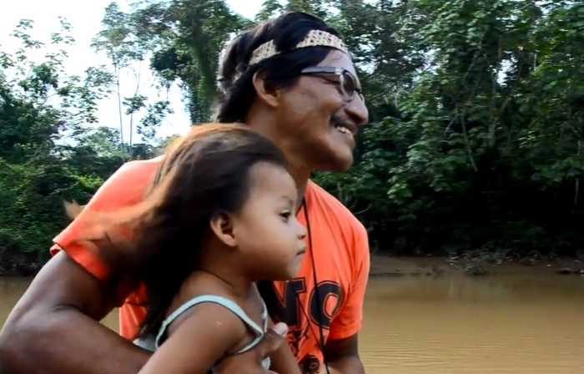
Filmed in the heart of the Ecuadorian Amazon, "OME: Tales From a Vanishing Homeland" follows the indigenous Huaorani on a journey through their pristine ancestral homeland where their traditional way of life is challenged as oil companies loom on the horizon.

One, If by land
Nandini Sikand / Mexico, UK, US / 14 min
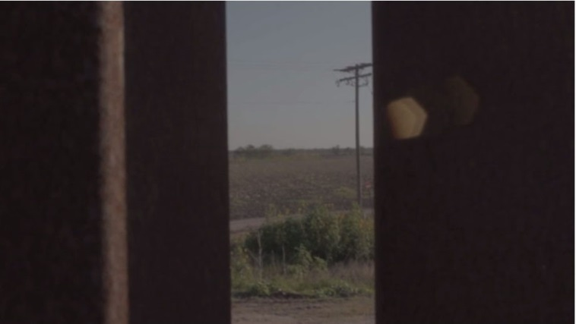
An experimental short film that explores the politics of undocumented immigration to the global North via land, sea and air, Inspired by three stories of real voyages made from Mexico, China and Mozambique. This film looks at the impossibility of arrival, a visual commemoration of the unknown immigrant.

Orient, Lisbon
Rui Silveira / Portugal / 13 min
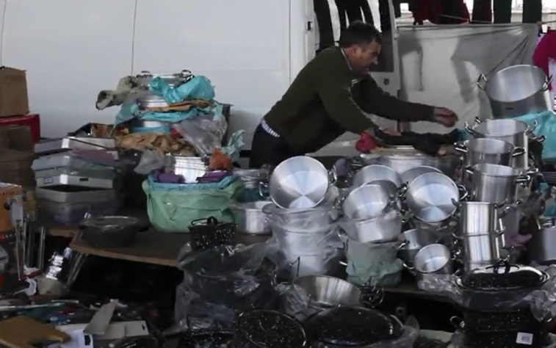
This project reveals the development of a new urban centre in Lisbon as seen by a resident for the past eleven years. Parque das NaÝes was, in 1998, a major urban renewal operation focusing on a tract of obsolete waterfront industrial areas but also affecting the surrounding working class neighborhoods, which in some cases antedated the industrial development of this area. Thus, these images focus as much on the enclaves that survived this operation as on the new areas; and how people occupy and bring life to them.

The Park in Ramallah
Philip Hopper / Palestine, State of / 15 min
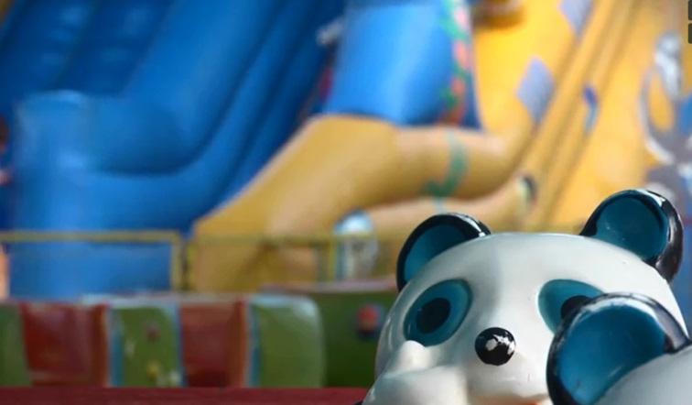
The Muntazah Ramallah, or the park in Ramallah is very different from what many in the West see of the West Bank. It is a safe place for children to play and adults to relax. However, it also raises complicated questions about what constitutes "normal" in an occupied territory.

Pin Up! The Movie
Kathleen Ryan / / 15 min
Contemporary pin up girls and the women who inspired them. Inspired by the art of Gil Elvgren and Alberto Varga, and the style sense of Marilyn Monroe and Bettie Page, the pin up is, in the words of art historian Maria Elena Buszek, “a uniquely American phenomena.” The modern pinup is enticing, captivating, independent, and omnipresent–a thoroughly 21st century woman.

A Place for Everyone
Angelos Rallis / Rwanda / 60 min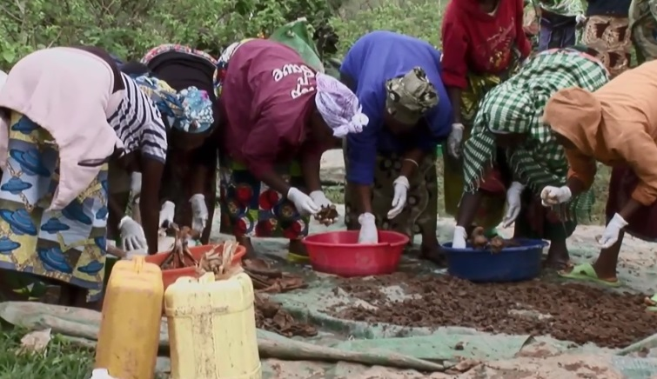

'A Place for Everyone' explores the human geography of a Rwandan village two decades after the genocide. Survivors and killers still live next to each other and a new generation of young Rwandans has grown up in a society that under goes a fragile reconciliation process. Filmed over the course of more than four years, 'A Place for Everyone' provides an intimate portray of two young Rwandans, a girl of the survivors group and a boy of the killers group, in their quest for love and hate, revenge and forgiveness.

The Place I Belong
Asher Coffield / China, Thailand, United States / 15 min
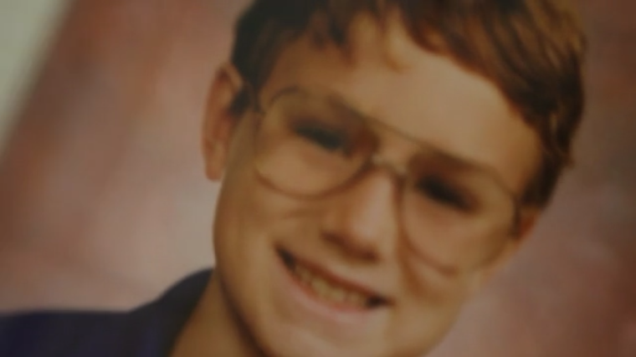
'The Place I Belong' is a personal documentary following the identity confusion that comes along with a life and childhood spent moving across the globe.

Porn Star Quotidian
Tara Pixley / USA / 20 min
A shopping cart filled with unhung art, Harry Potter memorabilia, vulva coloring books-- these are the pieces of a life that surround Ela Darling, adult film star. This view into her home and her world outside of porn presents an intimacy different from her usual on-camera roles, yet one still presented through the lens of sex-inflected performance

A Private Judgment
Diana Nicolae / Romania / 49 min
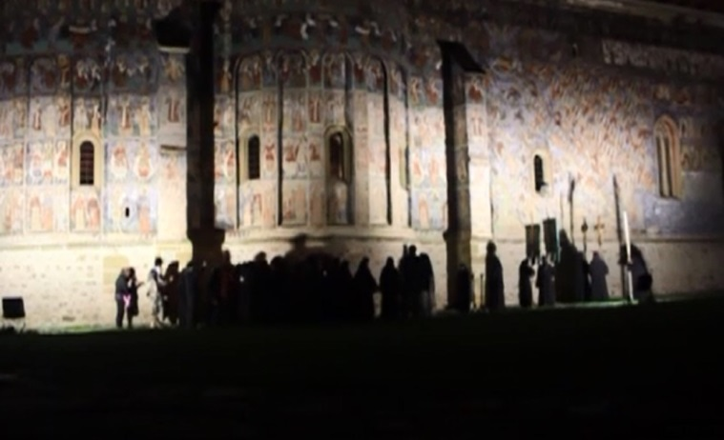
A community of camera-shy nuns in Northern Romania spends its days balancing religious devotion and repelling the incessant invasion of the modern world. Residing in a 16th century monastery and popular tourist attraction, they struggle to keep their faith and traditions alive.

The Q
Leo Berkeley / Australia / 8 min
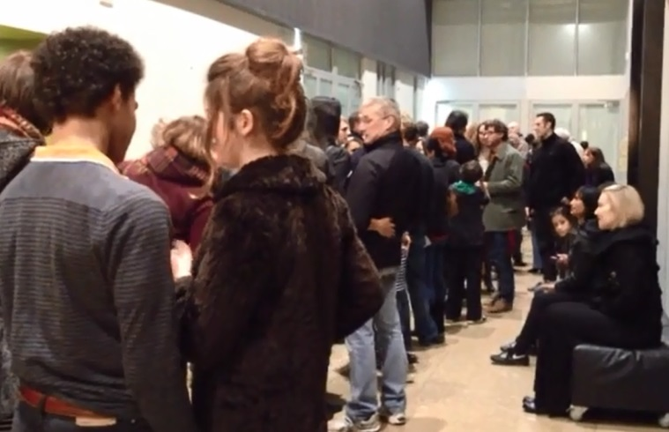
A short personal documentary about what we think about when we wait in lines.

Queering Science with Killer Tomatoes
sam smiley / USA / 5 min
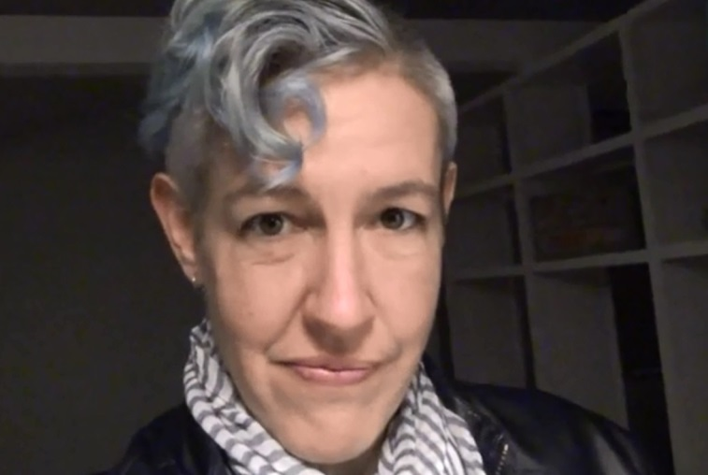
A work in progress in which I am 'performing science' through an experiment with tomato DNA.

Ritual Echoes of North Korea: The Process of an Artist
Sharad Patel / North Korea / 4 min
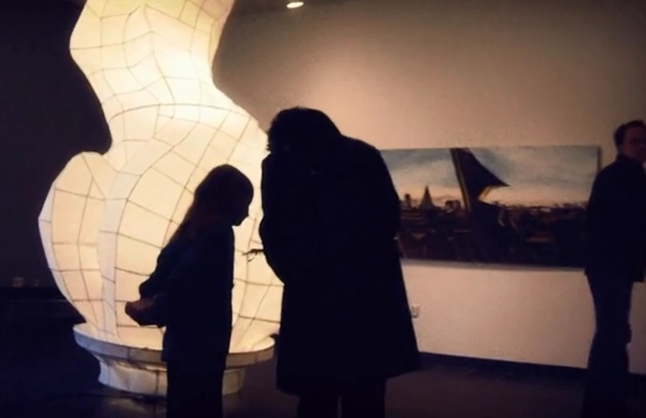
Cinematic, short documentary portrait of the development of David Chung's art installation, Pyongyang: During a rare escorted visit to North Korea, David was always greeted to the sight of the Pyongyang statue outside of his hotel window. The Pyongyang statue is a communist iconic monument in the capital of North Korea. Religions like Buddhism are actively discouraged in North Korea. In South Korea, the annual paper lantern lighting ceremony is practiced where the community puts together handmade lanterns and lights them.

Rocket Wars
Salomon Ligthelm / Greece / 5 min
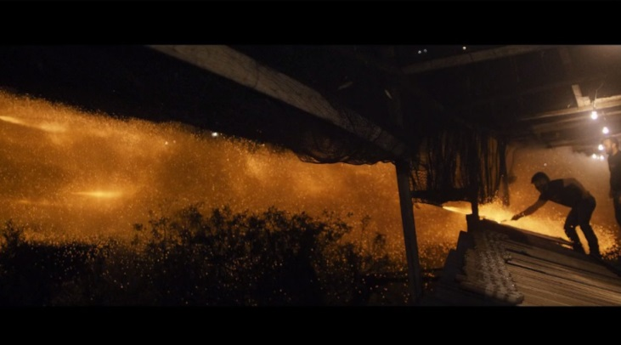
A war to keep the peace. In the small village of Vrontados on the Greek island of Chios, there is unrest. For over a century, parishioners of two Greek Orthodox churches have engaged in a battle on Holy Saturday.

The Roots of Evil
Zelimir Gvardiol / Serbia / 23 min
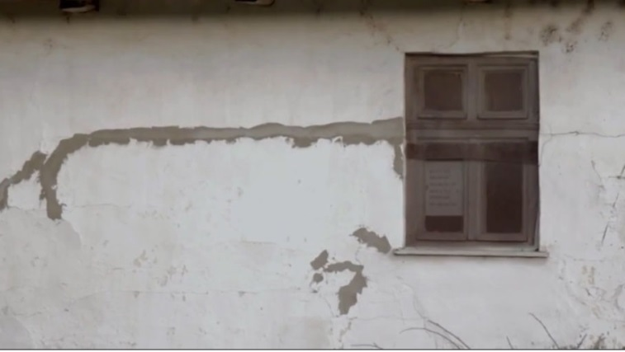
...when the only son, with an ease and relief, chops his parents and packs them into trash bags, when a woman who has been beaten numerous times massacres her husband while asleep... we seek the answer to the question:

Roxie
Marta Renzi / United States / 8 min
A documentary portrait in miniature of singer, dishwasher, storyteller, octogenarian Roxie Duncan in all her glory - - and of her hometown: Cape Charles, Virginia.

The Salt Man
Seyed Sajad Moosavi / IRAN / 16 min
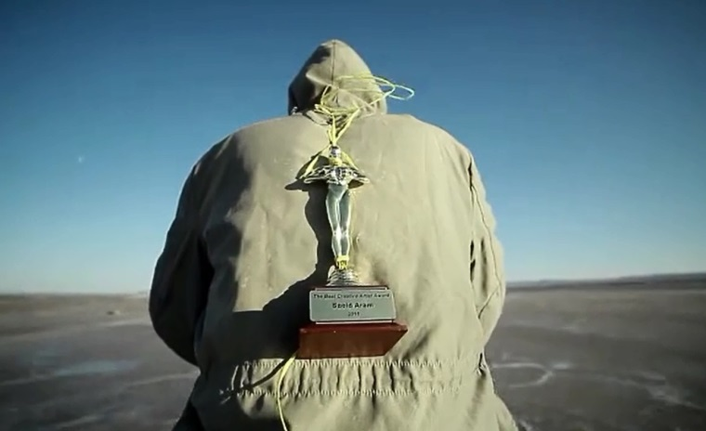
Left unsupported, an artist is obliged to work in a salt mine with his six-year-old girl. Family, children, daughter, genius, human rights, nature, and life.

Scanning The End
Juan Aguilar / Germany, Mexico / 15 min
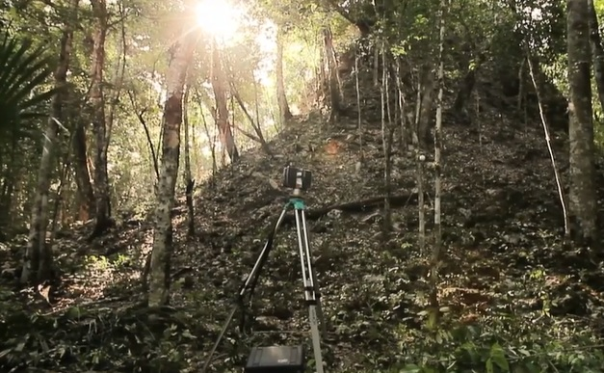
Deep in the jungle of southern Mexico lies the ancient Maya city of Uxul which is being investigated by researches from the University of Bonn, Germany under the direction of Prof. Dr. Nikolai Grube.

Sermon of the Serpent
Mark Brown / United States / 16 min
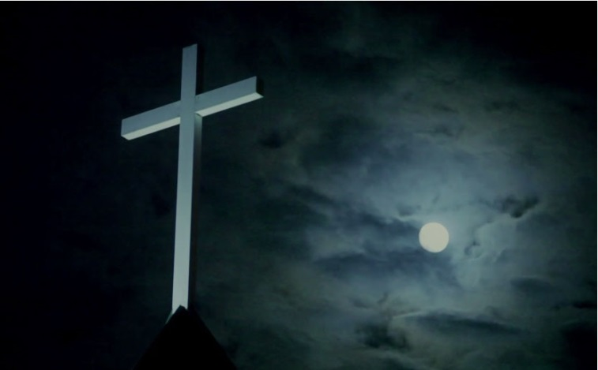
In southern West Virginia, Pentecostal Paster Mack Wolford leads one of the few remaining snake handling churches in the United States.

Shark Tears
Pino Moreau / Bahamas / 5 min
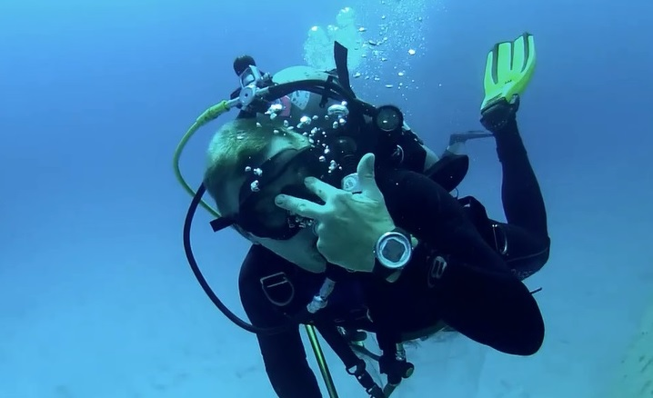
Stop shark finning, it's not good for the planet.

The Shore Break
Ryley Grunenwald / South Africa / 52 min
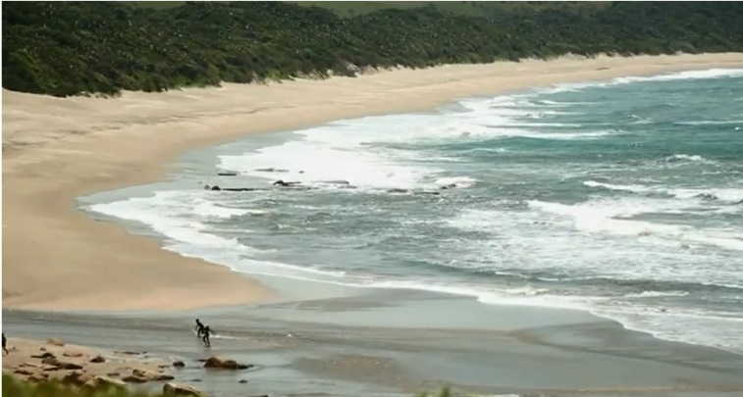
Two cousins, one proposed mining project on tribal land and a battle of epic proportions. In the Amadiba area, on South Africa’s stunning Wild Coast, the Pondo people have tended their traditional way of life for centuries.

Sigo Adelante
Kaila Taylor / Ecuador / 9 min
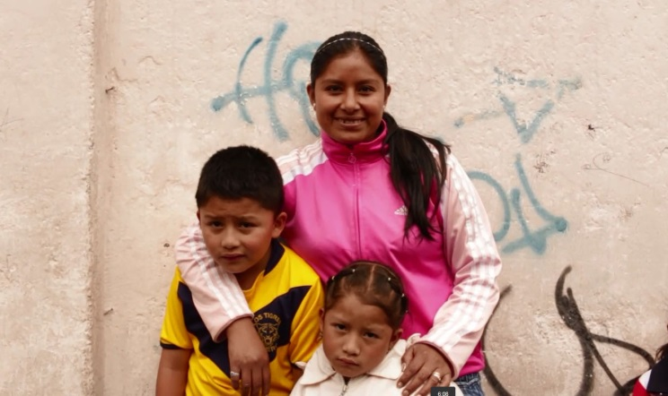
Silvia is a hard working, single mother who has faced hardships throughout her life in Ecuador. She continues forward with perseverance, however, working to support herself and her two children.

Slum Dreams
Brendan Modini / Kenya / 11 min
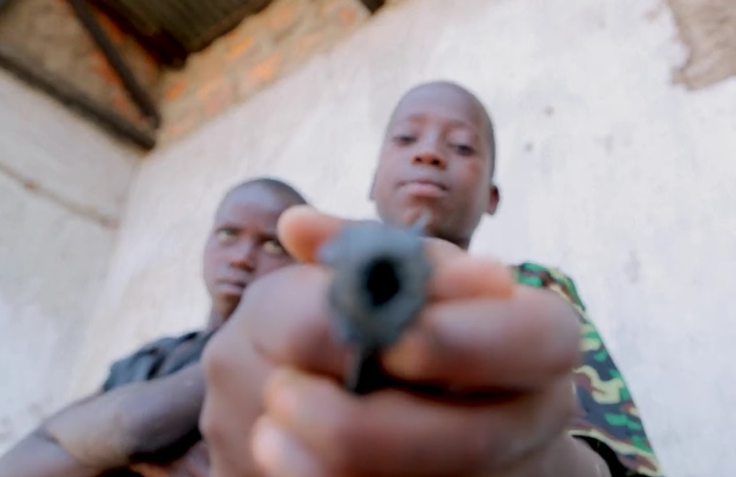
With big dreams to become a journalist and a pilot, two children from the slum must find a way to pursue their education in order to achieve their goals. The YCCM (Young County Change-Makers) is an organization in the Nyalenda Slum in Kisumu, Kenya, that provides support and guidance to help youth reach their full potential.

Tarboush (Travel Journal in Abu Dhabi)
Nirina Ralanto / United Arab Emirates / 7 min
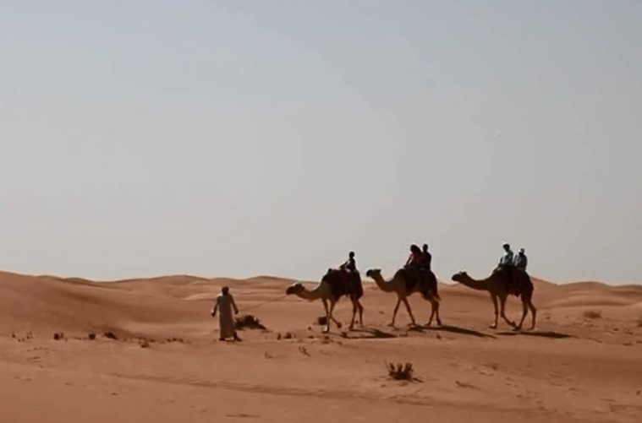
"Tarboush" is a personal meditation about the Emirati culture, from a western woman's point of view. End of August 2010, I landed in Abu Dhabi, the capital of the United Arab Emirates. I was a French teacher at Paris Sorbonne University Abu Dhabi.

Tashi's Turbine
Amitabh Joshi / Nepal / 57 min
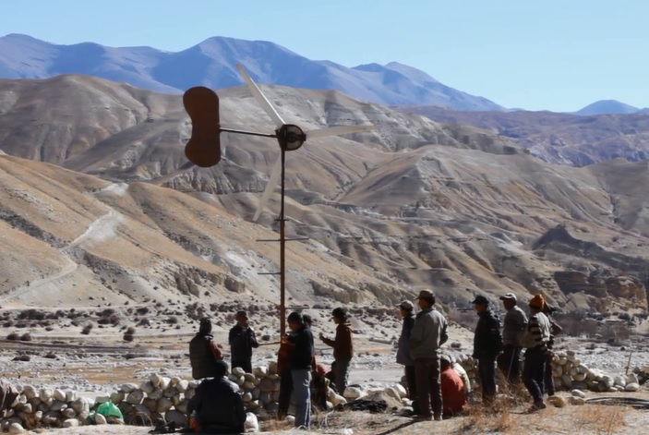
Set in the grassroots of the Himalayan Mountains, TASHI’S TURBINE is an uplifting tale of a small village’s attempt to harness renewable, sustainable energy with the power of the wind.

Taxidermy is Goodbye
Vuk Dragojevic / Canada / 14 min
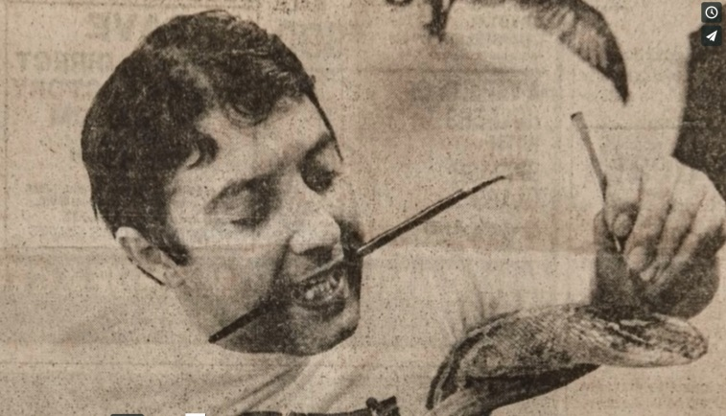
Manuel Jan owns the last working taxidermy shop in Toronto. Blind in one eye, and suffering from chronic vertigo, he continues to prepare and mount animals while reflecting on his future, his unconventional diet, and his mortality.

Thailand's Seafood Slaves
Environmental Justice Foundation . / Thailand / 15 min
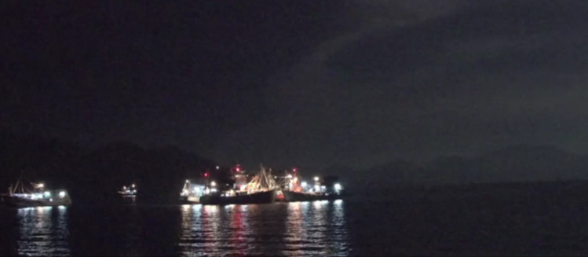
Human trafficking, slavery and murder in Kantang's seafood industry.

Thinking with the Hands
Mersolis Schöne / Austria / 10 min
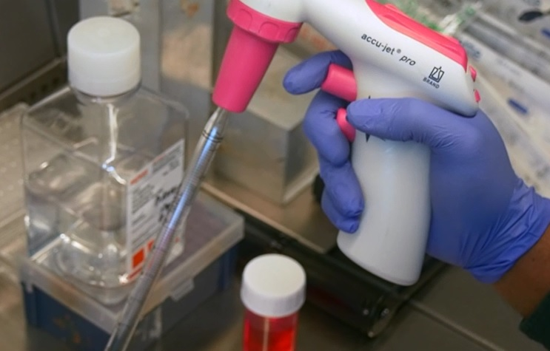
Which role does physicality play in science? „Thinking with the Hands“ is a short ethnographic documentary dedicated to the involvement of physicality in scientific knowledge production.

Tiyarus
Emilio Tellez / Mexico / 48 min
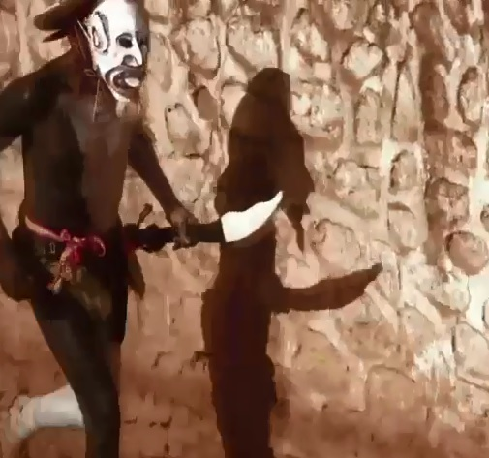
Have you ever felt you are the Devil? The Devil rides among us... on a horse, in Nayarit. This documentary is a personal approach to the Cora festivities that take place during the Holy Week in JesÏs MarÕa, Nayarit, Mexico.

To Work is to Grow. Organised Child Workers and their Demands
La KLaue / Bolivia / 32 min
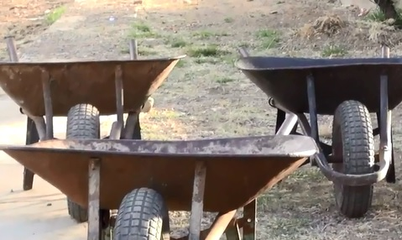
Gerald, Ruben and Neysa and their friends are children and adolescents who work as wheelbarrow pusher at the market and as prayer boys at the cemetery in the region of Cochabamba in Bolivia. They are also part of their proper labor union and they firmly defend their right to work in front of the authorities. They will present their ideas to the parliament where a new legislature concerning working children is decided.

Umudugudu! Rwanda 20 years on
Giordano Cossu / Rwanda / 36 min
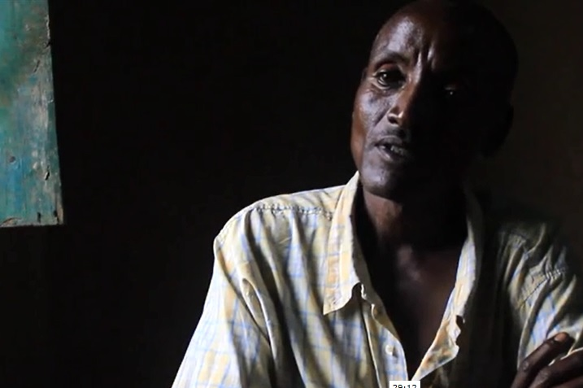
Rwanda, twenty years on: former genocide killers and survivors live together once again in former or newly built umudugudus (villages).

Unfair Game: The Politics of Poaching
John Antonelli / Swaziland, Zambia / 37 min
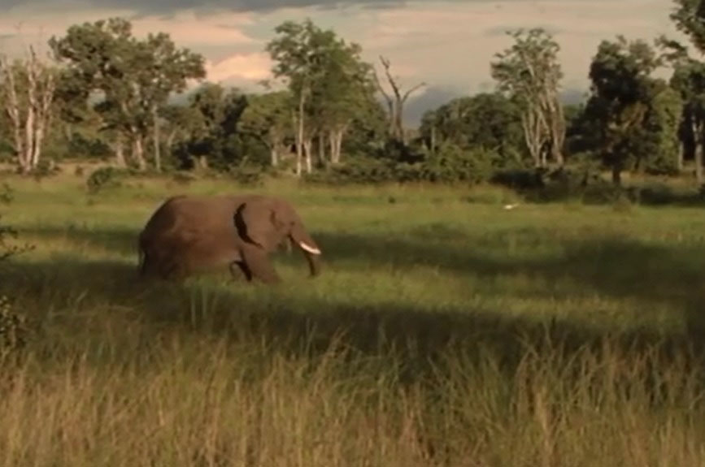
Unfair Game: The Politics of Poaching explores the ongoing conflict between wildlife conservationists, who strive to protect natural resources, and the indigenous people who have survived on and protected those resources for centuries.

Uplands
Jenny Holt / United Kingdom / 11 min
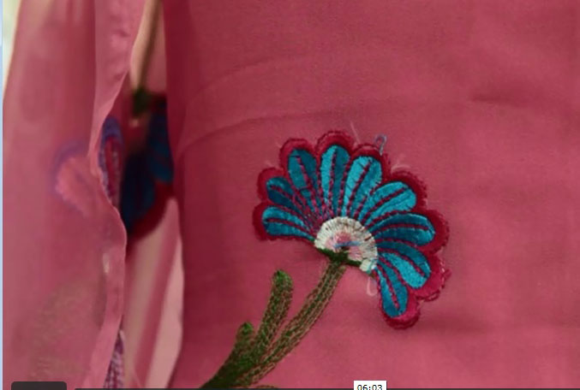
Reimagining the Northern English landscape through an Asian sensibility, and reconsidering it as a landscape of home.

Urban Tides
Simone Eleveld / Netherlands / 39 min
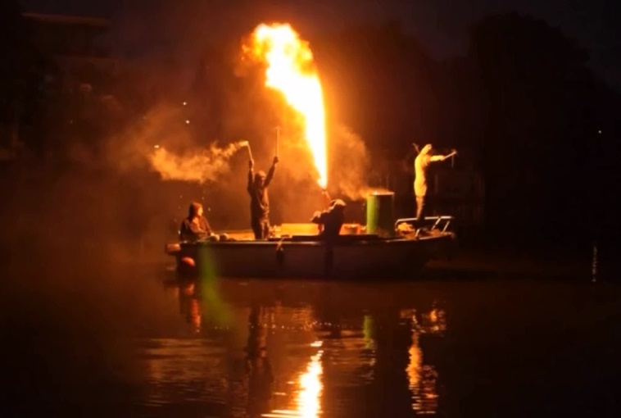
After the crisis in 2008, it seemed urban development had come to a standstill for a while. But to some people the empty plots of land seemed to beg to be put to good use. Abandoned shipyard De Ceuvel was one of these places.

Visualising the Past, Rebranding the Present IV: Bitter Coffee
Jessica Jacobs / Syrian Arab Republic / 12 min
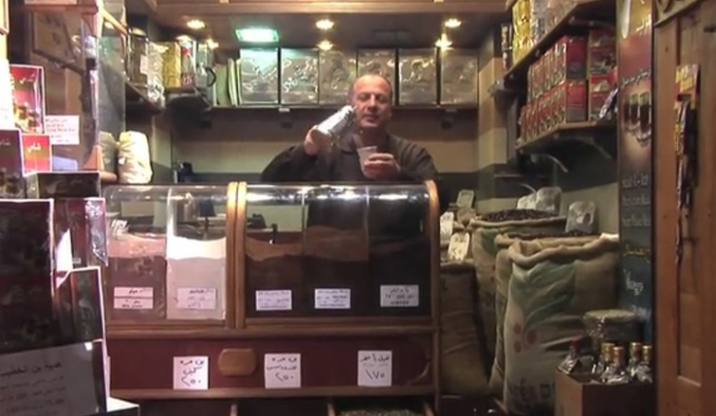
The last in a series of four films that explore our relationship to the past through the practices of heritage tourism in the Middle East.

Waiting for John
Jessica Sherry / Vanuatu / 54 min
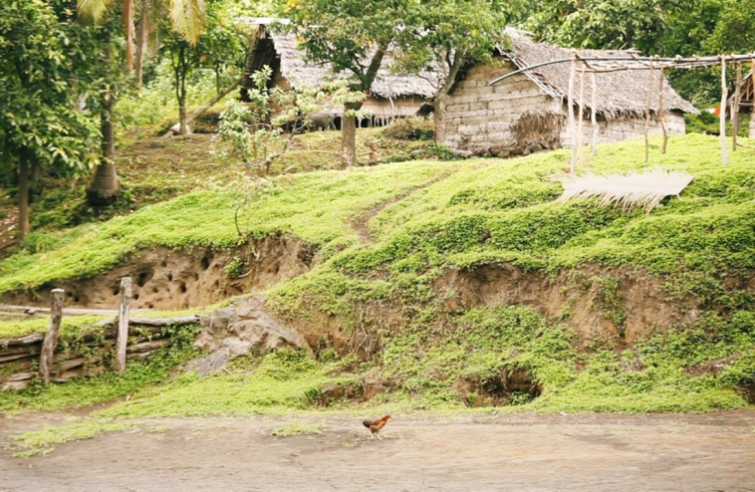
Waiting for John tells the story of America's extraordinary impact on one remote island in the South Pacific and explores the last surviving Cargo Cult, the John Frum Movement, as we follow the John Frum believers today in their struggle to preserve a culture in danger of being lost to the modern world.

We Want You to Live - Liberia's Fight against Ebola
Carl Gierstorfer / Liberia / 55 min
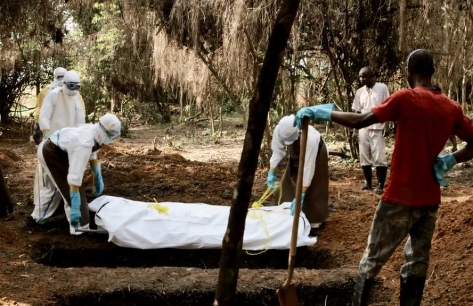
"We Want You to Live" is the character driven tale of one community's fight for survival against Ebola. Told not from the perspective of the international relief effort, but on the ground through the eyes of Liberians themselves, those on the front lines battling to bring the outbreak to an end. The documentary by Carl Gierstorfer is a film about the difficult choices Liberian people were forced to make during the Ebola outbreak. It is a tale of death, survival, guilt and forgiveness told by Liberians whose lives were turned upside down when Ebola attacked their homes, hospitals and communities.

Weekday Love
Gina Marie Kelly / United States / 5 min
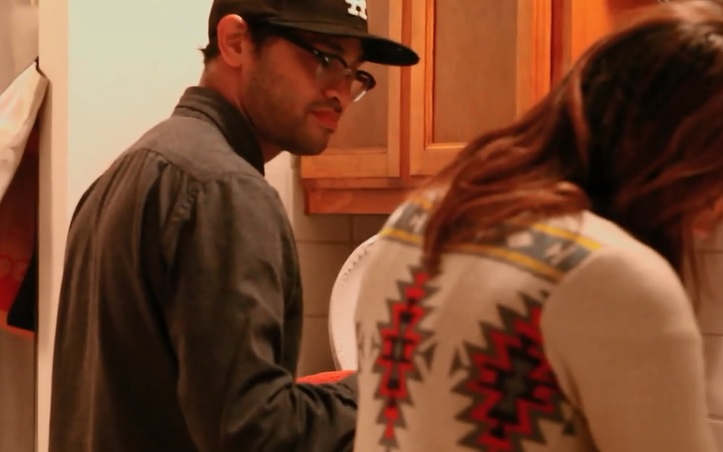
A real time, one take short that follows a couple as their nightly routine is interrupted by a neighborhood event.

What Remains
Lee Douglas, Jorge Moreno Andrés / Spain / 30 min
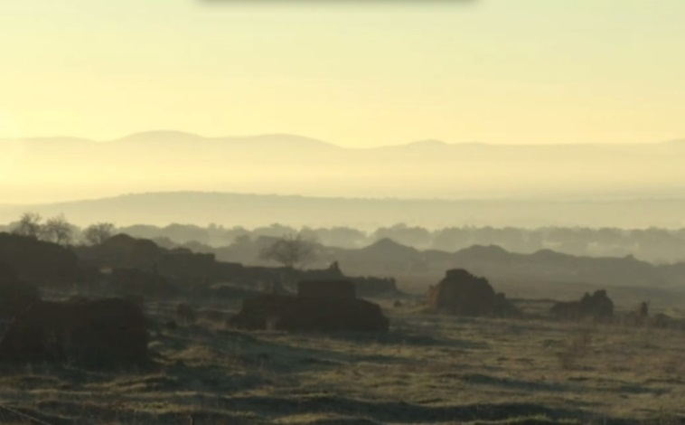
After the exhumation of a mass grave in Spain’s southern province of Ciudad Real, two local anthropologists meet Angelita González Yepes, whose family was torn apart by post-war political violence.

What's in a Name
Daniel Robin / United States / 13 min
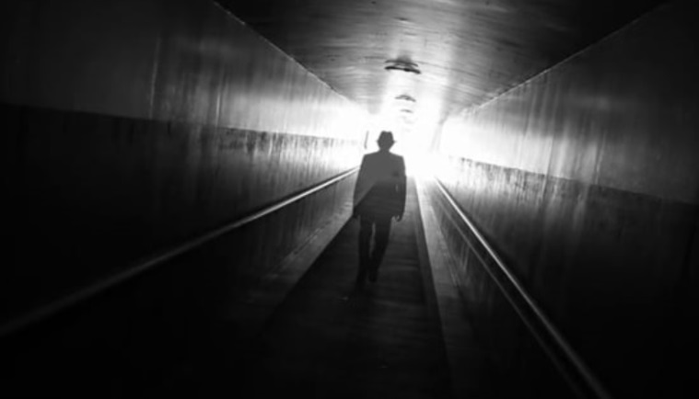
What's in a Name is about sculpting identities, both in terms of how the world sees us and how we view ourselves. These themes are woven into the juxtaposition of two stories that form a dialogue across generations.

White House
ranko paukovic / Croatia / 52 min
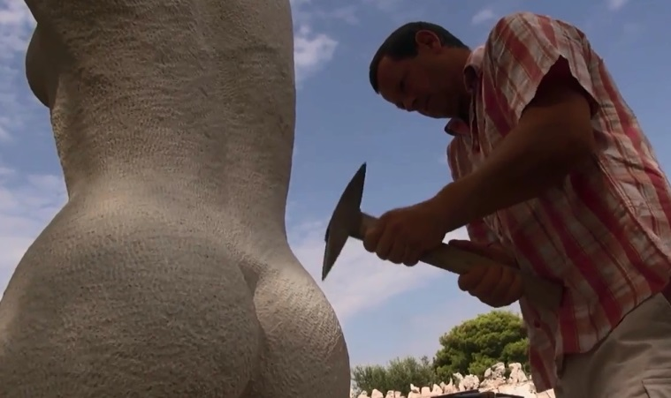
'White House' is a film about a stone from the island of Brac, Croatia. There is a legend that the White House in Washington was built with that particular stone. The story is told through intimate portraits of five people who live from this stone.

