The Ethnografilm Festival
Ethnografilm seeks to enhance our understanding of the social world through film. From the 11th through the 15th of April 2017 in Paris, France, the festival features over 100 works by documentary and academic filmmakers.

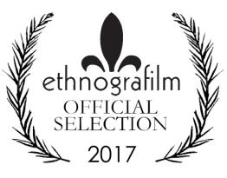

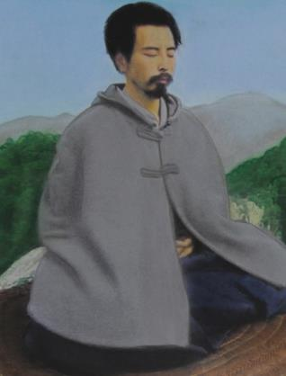

Paris! City of Light & Cinema
Ciné 13 Théâtre is located next to the Moulin de la Galette in Montmartre, the summit of the city. History, character, ambiance? Countless films have been inspired by this corner of Paris.
Take the metro to Blanche station. Step outside to find yourself in front of the historic Moulin Rouge, so memorably re-imagined by Baz Luhrmann. You’re at the foot of the delightful market street, Rue Lepic, where Amélie Poulain worked as a waitress, in director Jean-Pierre Jeunet’s eponymous film. Take a moment to buy a delectable tart at the Petit Mitrons bakery, then stroll up the hill. You’ll pass the apartment where Van Gogh lived with his brother Theo, and the Moulin de la Galette, famously painted by Renoir.
This part of the city is filled with historic film theatres—from the blockbuster Pathé on Place Clichy to the tiny Studio 28, the first avant-garde cinema in France. Here, Louis Buñuel premiered his surrealist collaboration with Dali, L’Age d’or, though by the time it premiered the two temperamental creators were no longer speaking!
The home of Ethnografilm, Ciné 13, is at the corner of Junot and Girardon. The cinema is right across the street from the print shop where Picasso once studied print-making. Down rue Junot is the former home of famous Dadaist Tristan Tzara. Austrian architect Adolf Loos designed the unusual home in 1926. The house next door once belonged to famous poster designer Francisque Poulbot. His illustrations of Parisian street urchins were so well-known that street kids became “poulbots” in the city’s ever-evolving slang. Street life in the 18th arrondissement is still fascinating. On the far side of the Butte, or hill, of Montmartre, is one of the city’s most varied and vibrant neighborhoods, with thriving West African food markets and traditional Arab cafés where you can smoke a hookah or narghile.
Our venue Ciné 13 has its own amazing story. Director Claude Lelouche bought the cinema in 1983 to use as a set. He renovated it into a 1920s-era club for his movie Edith et Marcel, the story of singer Edith Piaf’s tragic love affair with a boxer. Upon completing the film, Lelouche turned his set into an atmospheric movie theatre. Today his daughter, Salome Lelouche, runs the programming. And during Ethnografilm, April 17th to 20th 2014, every festival night we will retire to the argumentarium (that is, the cosy Ciné 13 lounge) to discuss the films over a glass of superlative Bordeaux.

Director’s Welcome
The 2017 edition of Ethnografilm is a moment to cherish for filmmakers, scholars, and all those who brought this diverse group to Paris. The Society for Social Studies of Science and the International Social Science Council have been instrumental in implementing the vision of a festival to celebrate excellence in movies that enhance our understanding of the social world.
Ethnographic film—“ethnografilm” in Greg Scott’s coinage—has been broadly defined, yielding a huge variety of styles, formats, and themes.
We have the best fringe theatre on the planet! Most important, we have a community of filmmakers and scholars gathered for present inspiration and collaborations yet to come. What could be better?
Wesley Shrum

Our 2017 festival is dedicated to the memory of
Sundar Raminathaniyer (Student of Life) Kerala, India

Challenging Audiences—and Filmmakers
How does ethnographic film articulate critical analysis with critical participation? Videographic study can make visible in powerful ways what is hidden in an arena of study. It can challenge dominant images of that arena while formulating and attempting to scale up alternative images. As a form of knowledge production and committed expertise, ethnographic film often races past the written text, challenging audiences both within and beyond its chosen field to think and do differently. To have effect, it must theorize without jargon. It must provoke without driving away or pandering to its viewers. Ethnographic film must both trouble and fit.
The Society for Social Studies of Science (4S) has long supported critical analysis of the production, distribution, and utilization of knowledge and expertise. It now also formally supports creative initiatives to articulate critique with participation. For this reason, the 4S enthusiastically supports Ethnografilm. What is videographic study for? What are ethnographic filmmakers for? The 4S challenges videographers and their audiences to wrestle with these questions, and we look to you for insight and direction. Thank you for accepting the risks and making the effort to rethink and redo knowledge and expertise through film.
—Gary Downey, Past President, 4S

Organization
Executive Director: Wesley Shrum, Louisiana State University
Associate Director: Gregory Scott, DePaul University
Assistant Director: Matthew Harsh, Concordia University
Festival Manager: Mathieu Denis
Local Festival Organizers: International Social Science Council
Festival Production Team: Jewell Simon, Luke Driskell
ART For FILM Team: Susan Arnold, Simon Baxter
Publicity and Design: Steve Coffee
Co-Founders: Wes Shrum and Greg Scott

Executive Committee
Ron Harpelle, Professor of History, Lakehead University, Canada
Kelly Saxberg, Independent Filmmaker, Thunder Bay, Canada
Molly Merryman, Kent State University
William Shewbridge, University of Maryland, Baltimore County
Kathryn Kasic, Montana State University
Michael Frierson, University of North Carolina, Greensboro
Lisa Pasold, Writer, Paris
Sylvie Jacquemin, Cinematographer and Director, Paris
Robin Starbuck, Sarah Lawrence College
Sam Smiley, Astrodime Transit Authority
Roger C. Barnes, University of the Incarnate Word
Audrey Appleby, Filmmaker and Singer
Xela Batchelder, Waynesburg University
Rik Scarce, Skidmore College

Advisory Board
Lucy Suchman, Lancaster University
Kim Fortun, Rensselaer Polytechnic Institute
Gary Downey, Virginia Tech
Diana Nicolae, Rowan University
C S Venkiteswaran, Festival Director, Kerala, India
B. Paige Miller, University of Wisconsin, River Falls
Barberine Feinberg, Département Hommes, Natures, Sociétés, Centre National de la Recherche Scientifique, Paris
Jean Claude Penrad, Directeur de l’audio visual, L’Ecole des Hautes Etudes en Sciences Sociales, Paris
Sreevasudeva Bhattathiri, Graphic Designer, Thiruvananthapuram
Linda Layne, National Science Foundation, Washington DC
Leandro Medina, Universidad de las Americas, Puebla, Mexico
Meredith Gontard, Directrice Artistique–ACM Ballet Théâtre
Kelly Moore, Loyola University, Chicago
Françoise Foucault, Comité du Film Ethnographique, Muséum National d’Histoire Naturelle, Paris
Antony Palackal, Loyola College of Social Science, Kerala, India
Wenhua Kuo, National Yang-Ming University, Taiwan
Steven Zehr, University of Southern Indiana
Madeleine Akrich, Ecoles des Mines, Paris

Partners
International Social Science Council (ISSC), has the mission of advancing the social sciences – their quality, novelty and utility – in all parts of the world.

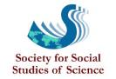
The Society for Social Studies of Science (4s), is a nonprofit, professional association with an international membership of over 1200. The objective of 4S is to bring together those interested in understanding science, technology, and medicine in their social contexts.

The Video Ethnography Laboratory was established at LSU as a resource for graduate teaching and video ethnographic research.

Journal of Video Ethnography
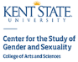

Art for Film
Ethnografilm has partnered with Lee Magnet of Baton Rouge, Louisiana to embellish the gallery of the festival theatre (Cine 13 Theatre in the Montmartre District) with artwork representing the selected films.
Through this initiative, Lee Magnet has created an absorptive environment for the screening and discussion of films selected by the festival committee. Each attending filmmaker will be presented with an artwork based on a screen shot from their film.
Susan Arnold
Director, Art for Film Program, Lee Magnet

Student Artists

Me-Gann Adolpho
Brionna Anderson
Asyiah Armwood
Hallah Bakari
Summer Beatie
Asher Bordelon
Kaylee Borrel
Kayla Bullard
Jyranie Burrell
Taylior Burton
Jaiante Caldwell
Ella Calhoun
Destiny Campbell
Everett Castle
Albert Cho
Lynn Chung
Ajah Claiborne
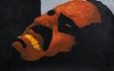Daisya Collins
Kaleb Colomb
Maya Cook
Victoria Crawford
Kassy Crissman
Ian Crump
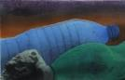Leigha Daliet
Jakayla Davis
Kyla Davis
Sydney Davis
Alaysia Deflanders
Juliane Ding
Katie Dinh
Thao Dinh
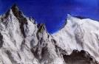Jasmine Dobbins
J Dornier
Alexander Duchmann
Leroy Dyson
Maria Elias
Hannah Elkholy
McKenzy Ellis
Attylaka Follins
Joline Fontenot
Jamie Foster
Laini Gilmore
Natalie Graham
Chris Green
Jaydon Gunn
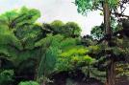Eugene Harry
Raven Heard
Sidney Hearns
D'Myjai Houston
Takeyah Howard
Johnice Hubbard
Diamond Hunter
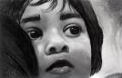Laiba Iqbal
Christopher Isaac
Tyronne Jackson
Keyvon Jackson
Jason Johnson
Ammar Johnson
Malik Johnson
Erin Johnson
Alania Jones
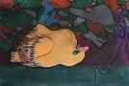Anthony Jones
A'niya Lagarde
Tessie Landry
Taryn Lavignette
Nayah Lawrence
Genesis Lee
Levondrea Leflore
Layton Lofton
Jasmine Lomas
Hannah Lu
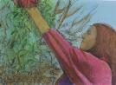Darlene Luzaran
Miracle Marcelle
Camille Martin
Ava Martin
EzeKiel McMurtry
Denis Menjivar
Georgette Metrailer
Darlene Miaranda
Madeline Miletello
Joseph Moore
Lawrence Morgan
Jasmine Morris
Lysthano Mouswaswa
Jonas Mukuri-Maka
Zipporah Myles
Nargiza Nazyrynbekova
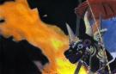Savannah Newman
Anh Nguyen
Marwan Okeil
Madison O'Rourke
Chyna Page
Anthony Palmer
Manas Patel
Alesha Patterson
Sidney Patterson
Reymon Paulino-Estrella
Janae Payne
Brandon Persica
Pratima Pinnepalli
Taniyah Porter
Erin Prejean
Joaquin Reyna
Victoria Riley
Kayla Robertson-Jacobs
Myles Robinson
Byron Sanders
Paige Sellers
Kevin Shen
Lance Sherman
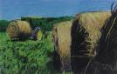Latavia Simmons
Asarel Smith
Ashlei Smith
Brianna Spears
Makya Spears
Raven Square
Lauren Stevens
Michael Stewart
Elizabeth Street
Kyira Taylor
Olivia Terito
Genevieve Terito
Lenae Tillery
Krystal Ton
Christian Turner
Dayea Turner
Lauren Voisin
Jalin Walker
Mitchell Walsh
Allen Wang
Andrea Washington
Ashlin Wharton
Jada Williams
Raegan Williams
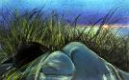A'Myrea Williams
Gaylyn Williams
A'Darian Williams
Evonne Yang

A.K.A.
Ron Harpelle / Canada / 62 Min
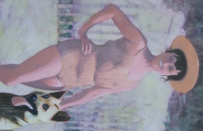
A.K.A. is a documentary about the little-known story of Ronald Ivan MacDonald, a serial impostor with only a high school education who stole the identities and obtained work as a psychologist at several universities, clinics and hospitals in Canada. MacDonald managed to stay one step ahead of the authorities until February 1966 when he was revealed to be an impostor at Lakehead University.

ada
lindsay mcintyre / Canada / 13 Min
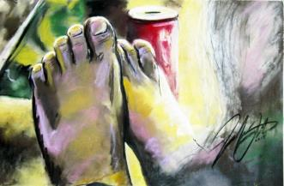
An observational video portrait of an Inuk elder addressing age and the passage of time.

After Life
Prisca Bouchet / New Zealand / 16 Min
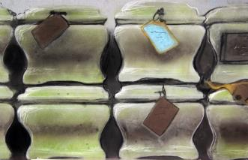
Inside the hidden world of a New Zealand funeral home.

Agen
Ivo Hardies / China / 11 Min
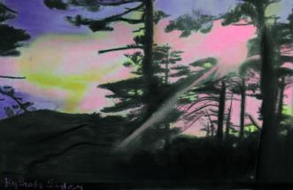
Agen is a popular medicine healer who collects most of his remedies in the forests of Yunnan, a province in Southeast China famous for its diverse ethnicities and medicinal herbs. After collecting and gathering what he needs, he goes to all regional markets and sells his remedies to all those willing to believe his claims.

Agents of Change
Abby Ginzberg (co-director) / US / 65 Min
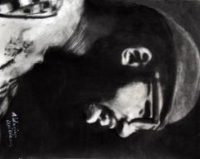
Agents of Changes examines the untold story of racial conditions on college campuses that led to protests across the country at over 1000 colleges. Through the stories of the film's characters who were caught at the crossroads of the civil rights and black power movements at a pivotal time in American history, their struggle echoes the questions about inclusiveness, identity and racial stereotyping that lie at the heart of the Black Lives Matter movement of today.

Aloha From Lavaland
Phillips Payson / Hawaii / 55 Min
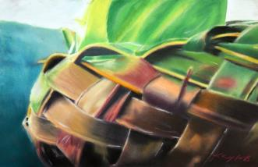
Following a volcanic eruption, a Hawaiian community under pressure shows its spirit and resilience.

Altimir
Kay Hannahan / Bulgaria/ US / 18 Min
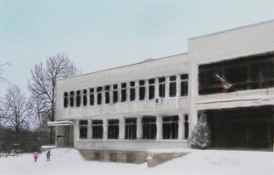
Since the collapse of the communist regime in 1989, Bulgaria has experienced the most extreme population decline in the world. Low birth rates, high death rates, and emigration have pushed many villages to the verge of extinction. Altimir explores life in one of Bulgaria’s disappearing villages haunted by the promises of communism and capitalism.

Archives of Extinction
Alyse Takayesu / US / 12 Min
Throughout the 19th century, scientists transformed living birds into dried, stuffed, and otherwise preserved scientific specimens. Today, scientists seek to transform these lifeless specimens into living birds through the emerging science of de-extinction. Exploring these transformations, Archives of Extinction evokes questions about de-animating and re-animating forms of life and about the human role in disassembling past and reassembling future ecologies.

Banh Bao Bikes
Brenda Mattick / Vietnam/ Austrailia / 19 Min
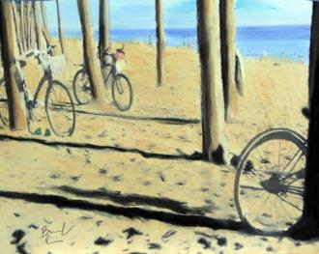
Mr Tuan remembers Vietnam's ‘Subsidy Era’ when bicycles cost more than houses.

Batrachian’s Ballad
Leonor Teles / Portugal / 11 Min
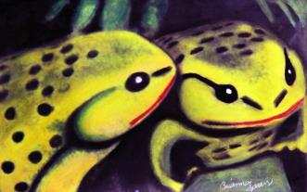
"Simultaneously strange and familiar, distant and near, disquieting and seductive, outsider and cosmopolitan, gypsies are shrouded in an aura of ambiguity. They cannot be said to be invisible, as they hardly go unnoticed." (Daniel Seabra Lopes) Like the gypsies, the frogs, made of china, don't go unnoticed to a careful observer. "Batrachian's Ballad" comes about in a context of ambiguity. A film that immerses itself in the reality of Portuguese everyday life, as a form of fabling about a xenophobic behaviour.

Before the Wave
Molly Willows / Burma / 23 Min
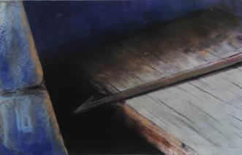
'Before the Wave' is a lyrical short documentary featuring a captivating community of indigenous stateless Moken sea nomads who live off the coast of Burma and Thailand. Today living as a ragtag community of ocean-frolicking outliers, the vibrant community fully survived the Boxing Day Tsunami ten years ago. This deeply saturated, poetic film explores their disappearing aquatic lifestyle and shifting spirituality largely due to Christian missionaries who arrived to 'save' the Moken after the fatal wave.

The Block
Maria Șalaru / Romania / 60 Min
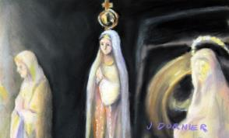
From neighbourly disputes over garlic-heavy cooking to memories of Ceaușescu’s heatless winters, this film explores the rich social and material universe of a Romanian apartment building. It follows the story of the block’s administrator, in his effort to mediate relationships between neighbours and maintain peace and order. In doing so, it crayons the rich nuances of the inhabitants’ everyday lives. The block comes to life, as its inhabitants constantly reshape it to defy the passing of time, while its failing infrastructure encroaches on their neighbourly relations. This is a film about people’s homes, and the spaces in between. In those spaces, the pipes don’t only carry hot water – they carry meanings from one inhabitant to the next.

A Bold Peace
Matthew Eddy, Director, Michael Dreiling, Co-Director / Costa Rica / 59 Min
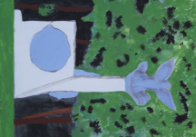
Costa Rica's civil war in 1948 shook the country to its foundations, culminating in the decision to abolish the military. As Costa Ricans dismantled their military establishment, they intentionally cultivated security relationships with other nations through treaties, international laws, and international organizations. Over the last 68 years, the Costa Rican model has survived several serious crises, but the current threats may be the most formidable of all.

The Bolshoi Maestro
Sara Gossi, Gabriela Forfotӑ / Latvia / 16 Min
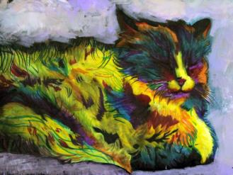
Maskachka / Maskačka. Walking...We walk so much that our shoes need a pause and maybe someone to bring them to life again. So do people. And to do that we need some tools. The question is: which tools?

Booked for Safekeeping
Bradly Dever Treadaway / US / 8 Min
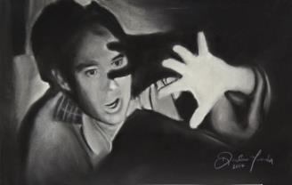
Booked For Safekeeping addresses faltering outlets for the containment and expression of violent impulses, the reactionary bluster of discourse in contemporary society and the isolation and paranoia developing within American communities.

Bounce Brothers (rough cut)
Jahaan Chandler / US / 8 min, rough cut
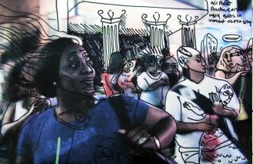

Three bouncers in New Orleans share their night life on Frenchman Street in New Orleans.
Bright Flower and the Scars from the Stone
Jade Rainho / Brazil / 29 Min
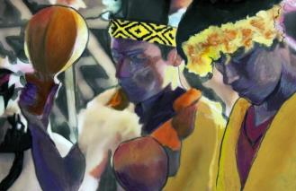
Bright Flower is the matriarch of an indigenous family of Guarani-Kaiowá shamans living in the Reserve of Dourados, MS, Brazil. There, deprived of their original way of life, they struggle to survive preserving ancient knowledges and cultural habits, while dealing with the effects and ailments caused by the continuous explosions of an asphalt plant, which has been blasting and exploring a sacred stone in the territory of the village for over 40 years. This documentary was made in October and November 2012, completely independently, as a way to give voice to their history and channels, and to bring these to public knowledge.

Call for Grace
Laeticia Merli / Mongolia / 30 Min
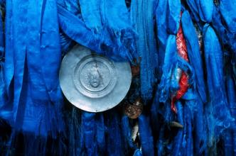

Ever since the 1990s, Mongolia has been trying to reclaim its cultural identity, smothered by the Soviet regime for 70 years. Between tradition and modernity, shamanism, outlawed for all those years, is now finding its place in society and constructing a new identity in an urban world. This film presents daily life in a shamanic center in Ulaanbaatar and its shaman Tömör.
The Camp
Madeleine Swift / UK / 9 Min
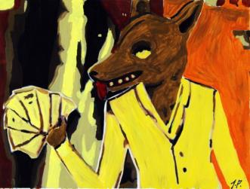
When I was eight years old and after a difficult year my family moved to a holiday camp set above a beautiful cove in Devon, England. And so began 30 years of memories, some sad, but most wonderfully happy. 'The Camp' tells the story of this special place through animation, photography, illustration and original cine-film footage, dealing with the experiences of a young girl and the nostalgia of an unusual childhood.

Carousel
Luka Popadić / Serbia / 15 Min
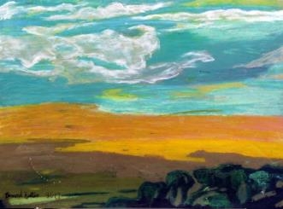
The movie depicts a Serbian choir, The Singing Women of Požega, a group of enthusiastic elderly women full of life who share their daily routine with us. Through poetic pictures, seasoned with a lot of humour, we learn about their views of love, joy as well as the ephemerality of life.

Cattle Market
Sean Parnell / UK / 11 Min
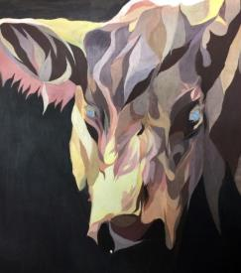
Cattle Market is an observational and sensory documentary experience that explores the market floor operations at the Ashford Livestock Market. Combining intimate and detailed visuals, and an immersive sound experience, Cattle Market allows the audience to experience the bustling atmosphere that makes this environment such a unique place.

Changa Revisited
Leonard Kamerling / Tanzania / 60 Min
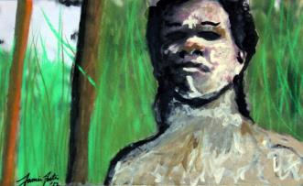
'What can you do except change...?'

Chernobyl-Fukushima: Living With the Legacy
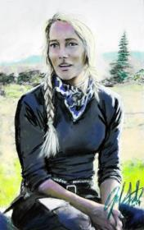
Olivier Julien / Belarus, Japan, Norway / 52 Min
To live with it, or to relocate and leave everything behind... This is the choice Japanese people from the Fukushima region are confronted with. 25 years ago, after Chernobyl, the people from Belarus and the Sami from Norway were confronted with the same choice. Many chose to stay and have been living since with the consequences. They are the only ones that can really answer the questions, doubts and fears of the inhabitants of the newly contaminated zones. That’s why the inhabitants of the village of Itate, 40 km from Fukushima turned to them.

Children of the Kalahari
Velina Ninkova / Norway Namibia / 45 Min
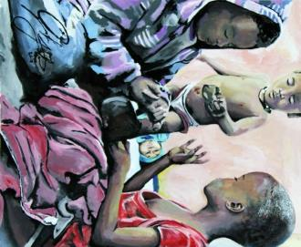
Observation film about the everyday life of Bushmen (Ju/'hoan) children on a resettlement farm in central eastern Namibia.

Chosen People
Qihui Wu / US/China / 18 Min
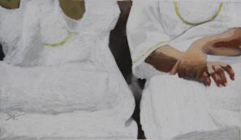
Through Cinéma vérité on the daily activity of a Hebrew Israelite church in the south side of Chicago, the film Chosen People provides a poignant and subtle mediation on relations among history, memory and identity.

Cicada Music in Ohio
Umru Rothenberg / US / 12 Min
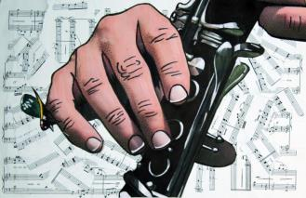
David Rothenberg and Lucie Vitkova, clarinetist and accordionist, travel to Ohio to make music with 17-year cicadas, and they meet the world expert on these bugs, biologist John Cooley.

Civil Rights Stories
Stacy Fitzpatrick / Ireland / 9 Min
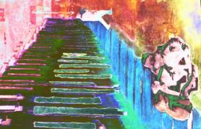
Looking at the origin of Civil Rights Movement in Northern Ireland from a human perspective. This film focuses on the people behind the Civil Rights Movement detailing the personal motivation. The Civil Rights Movement in Northern Ireland in the 1960's preceded a long and violent political time known as 'The Troubles'. This film reveals the beginning of the Civil Rights Movement in Derry, Northern Ireland from a personal and intimate perspective. It recalls how poor living conditions and in-equality drove ordinary people to make a change for the people of Northern Ireland. How one person's tragic experiences related to this discrimination directly instigated the movement that would change the future for many.

Cobblestone Stories
Mark Neupert / Netherlands / 10 Min
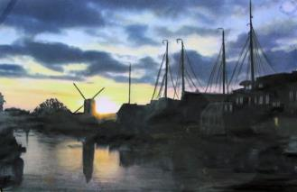
In this ethnographic documentary, anthropologist Mark Neupert explores life at the human-scale in Leiden, the Netherlands, examining how urban planning principles, such as mixed-use, walkability, bikeability, and public spaces create a good human habitiat. Filmed over the course of a year, this film shows modern life in an old urban pattern and looks at the connection between urban design, physical activity, and the sense of community.

Corner Chronicles
Nicolas Gulino / Canada / 13 Min
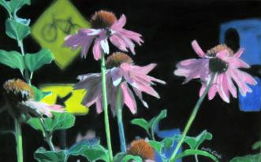
A Montreal inner city intersection comes under the gaze of its residents and passersby who contemplate the past, the present, and their place in it. An urban documentary offering an impressionist portrait of a neighbourhood in transition.

Data Mining the Deceased
Julia Creet / Canada, Iceland, United Kingdom, United States / 56 Min
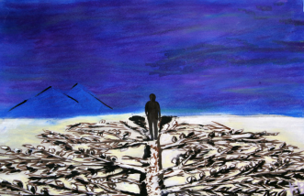
“Data Mining the Deceased” explores the industry behind the exponential intensity in genealogy. What are the motivations of the key players and how are their ambitions affecting the millions of North Americans who are searching for answers?

The Devil and the Holy Water
Diego Maria Malara / Ethiopia / 13 Min
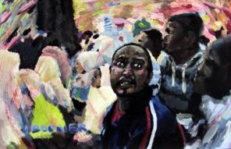
For centuries, exorcism has been a daily practice in the Ethiopian Orthodox Church. But as Ethiopia has undergone extensive social change, exorcism has been revolutionized. New problems produce new demons, and new demons require dramatic new rituals. Shot in Addis Abeba, ‘The Devil and the Holy Water’ is a short documentary that portrays exorcisms conducted by the controversial priest Mehmer Girma, whose charisma gathers hundreds of people from across Ethiopia and around the world. Narrated by a woman exorcized by Mehmer Girma, the film gives an intimate account of the reality of demonic affliction in modern Ethiopian life.

Dish Life
Chloe Thomas / UK / 8 Min
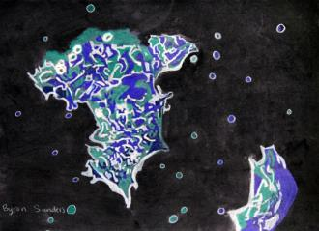
'It's like having thousands of pets' What scientists really think about the stem cells they look after.

Dogs of Democracy
Mary Zournazi / Greece / 58 Min
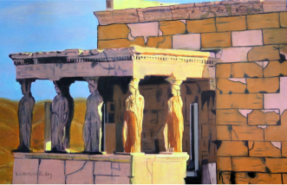
Dogs of Democracy is a documentary about the stray dogs of Athens and the people who take care of them. A universal story about love and loyalty and what we might learn from animals.

#doinggood
Loeke de Waal / Netherlands / 14 Min
Voluntourism is all over social media. It appears to be the perfect tool to showcase your adventurous, humanitarian side. We follow Dutch 21 y/o Mitchell on his quest for world citizenship and purpose. The world of a volunteer turns out to be one full of new encounters and discoveries, but what’s the truth behind that cute new profile picture?

The Drover's Boy
Margaret McHugh / Australia / 11 Min
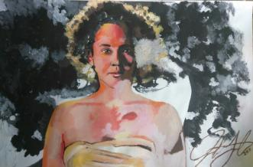
This award-winning hybrid documentary is based on a ballad by Australian bush legend Ted Egan. It retells a story of forbidden love between a white drover and his Aboriginal wife, who travelled with him disguised as a drover's boy, in 1920s outback Australia.

Dusk
DI Wu / UK / 2 Min
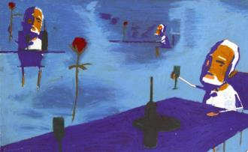
My short is an experimental animated documentary. aesthetically, the piece is trying to explore a unique hand-drawn style in combination with some 2D illustration elements as well as some digitals with timelapse footages. Inspired by many documentaries, i am aiming to take the narrator's raw emotions and fashion them into the animation. The animation is to visualise the emotions as well as the words to invoke certain emotions in viewers so that they understand the feeling of getting old.

The Dybbuk: A Tale of Wandering Souls
Krzysztof Kopczynski / Israel / 53 Min
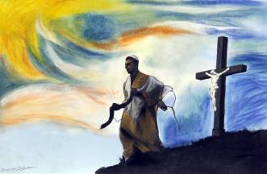
Ukraine, Uman, just before the Euromaidan protests. A conflict between orthodox Jews and Ukrainian nationalists escalates. Demons of the dreadful past incessantly hunt both communities.

Entretejido
Patricia Alvarez / Peru / 15 Min
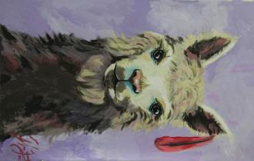
Entretejido is a sensorial immersion into the textures that compose the Peruvian supply chain of alpaca fashions, from animal to runway.

Extended Family
Ramona Sonderegger / Switzerland / 31 Min
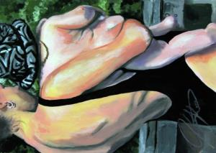
Mummy, mama and daddy; mummy, mama and sperm donor: The film Extended Family offers an intimate insight into two same-sex families’ lives, who found a way to create their families within a legal grey zone in Switzerland. Swiss law bans access to adoption and any assisted reproductive medicine for same-sex couples. The portrayed rainbow families therefore do not exist officially. Nevertheless, according to estimations, there are between 6'000 and 30'000 children living in rainbow families in Switzerland.

Facing the Mountain
Ross Harrison, Vaibhav Kaul / India / 20 Min
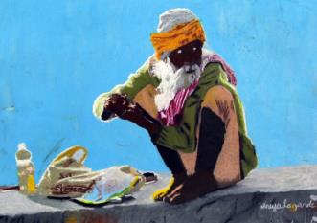
Set in the sacred valley of Kedarnath in India’s lofty Garhwal Himalayas, Facing the Mountain explores what it means to live through disaster in a rapidly changing natural and social environment. -- Long description: Coping with extremes is part of life for people across the Himalayas. Uncertain summers follow freezing winters, as monsoon rains deluge the mountains, carrying the danger of landslides and floods. But in June 2013, in the Indian state of Uttarakhand, conditions fatefully aligned to produce an unprecedented disaster.

first and last
Robert Richards / UK / 10 Min
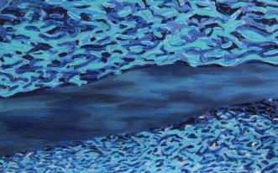
On the road that winds through the moorland straddling the Scotland England border we meet the travellers that stop for a break by the granite border markings in the weeks just before the 2016 EU referendum .

The Flock
Joe Hobson / US / 56 Min
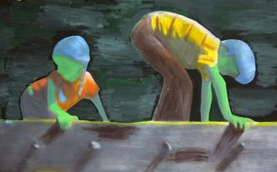
Seeking to understand his childhood, Joe reconnects with the people he grew up with, having each share their own experiences of living in such an extreme religious movement. By looking at why the followers joined the movement and how it shaped their families, he uncovers the long-term effect it had on the movement’s children.

Folk-Cinema Vayana
Mario Calderaro / Italy / 17 Min

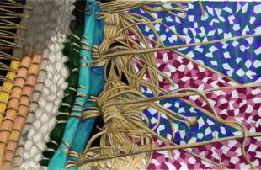
"Vyana" is a vedic variation on an old friend mother's name in my countryside residence. The piece is made within the theorical frame of the "image-sound": the Anthropology of Sound's concept I developed all along my academic path. And within the sharing utopistic manifesto known as Folk Cinema where people involved in a cinematic production deserve the same authorial acknowledgement. The movie is middle-lenght with quadraphonic audio and shows two typical moment of that woman life: the shearing of the sheeps and the work on the loom.

Ghosts of Our Forest
Daniel Roher / Uganda / 65 Min
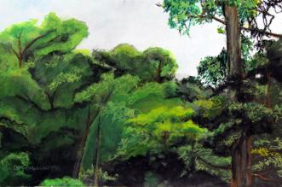
After an indigenous Ugandan tribe is violently removed from its forest home, the survivors are left to reconcile with the ghosts of their ancestors as they struggle to maintain their cultural identity.

Gyalmu's House
Gavin Carver, Asmita Shrish / Nepal/UK / 19 Min
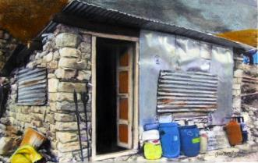
In 2015 an earthquake of terrible power devastated the Langtang Valley in Nepal, taking hundreds of lives from the small community. A year later Nima Gyalmu, a woman of extraordinary strength, dignity and humour rebuilds her house in this remote and shattered place while trying to come to terms with her new world.

Hanging
Nick LeDonne / US / 6 Min
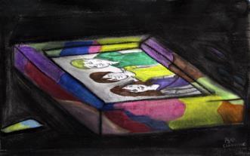
An abstracted animated documentary based off of Nick LeDonne's personal struggle with depression and suicidal thoughts after a near attempted hanging in November 2014. His feelings of depression are personified through a dark luring fog and a loving mother desperately trying to keep her son alive.

Hanging Fish
Jose Carlos Barquero Montero / Panama / 11 Min
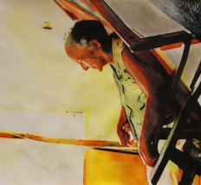
At Villa de Los Santos - Panamá. At a river full of life. A washerwoman and a fisherman share their memories as weather, pollution and economic development condemned their trades into oblivion, taking away their traditions and their lives on Rio La Villa.

Harvest: Quyurciq
Andre Lewis / US / 20 Min
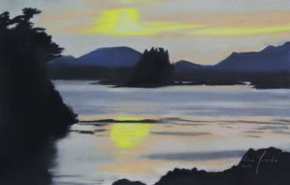
Colonial Russia’s pursuit of sea otter fur brought disease, slavery and cultural genocide to Alaska’s indigenous peoples - and near extinction to the otters themselves. But with otter populations revitalized in Southeast Alaska today, the respectful hunting and craftwork of these animals reconnects young coastal Natives to their subsistence roots.

Hermits
He Shiping, Fu Peng, Zhou Chengyu / China / 60 Min
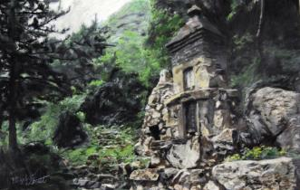
25 years ago, American author Bill Porter (a.k.a. Red Pine) went to the Zhongnan Mountains to seek out modern Chinese hermits. His resulting book, Road to Heaven, was a touchstone for many westerners wondering what remained of Buddhist and Daoist asceticism in China. Now, for the first time, Bill Porter revisits Zhongnan to seek out those who seek from within, living quiet lives of deep devotion in some of the world's most stunning locales. It took the crew 3 years and 14 visits deep into the mountains to accomplish this film.

Honk: A Festival of Activist Street Bands
Patrick Johnson / US / 7 Min
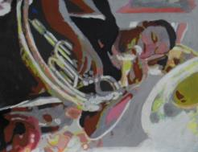
Honk! is a festival of activist street bands who reclaim public spaces with their brash sound, political messages, and outrageous community oriented performances. Originating in Somerville Massachusetts and celebrating its 10th anniversary, the festival has spread to cities throughout the world. Watch as these bands work to change the world through their music and activism, and learn about their cultural impact from festival organizers and participants.

Huan Nuo Yuan
Thomas Riccio / China / 19 Min
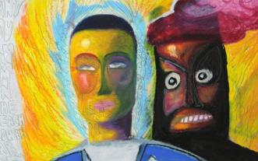
A documentation of the Huan Nuo Yuan ritual of the Miao people who live deep in the Wu Ling Mountains of western Huan, China. The Badai conduct the two day ritual, a practice that goes back thousands of year.

I Am Ocean: Pua Case
Jeff Reed / US / 3 Min
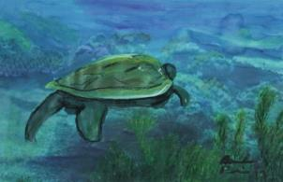
As a mother and teacher, chanter and dancer, cultural practitioner and activist, Pua Case is quintessential Storyteller -- and her lessons run deep. Raised by her grandmother in Waimea on Hawai'i Island, Pua knows intimately of the relationship her people shared with the land and the sea. From the summit of Mauna Kea to the depths of the Pacific Ocean, her profound connection to both fuels her passion, shapes her prayers, and ignites her belief that a deeper understanding of 'home' will restore our natural balance with the environment. In this short film, Pua explores the spiritual currents that run from mountain to ocean and how her life has been shaped by each ebb and flow.

I'm Not Leaving Eldon
Jessica Bollag / Swiss / 49 Min
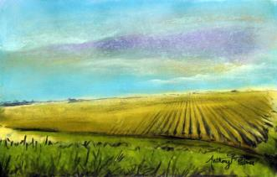
The state of Iowa is the largest producer of soy and corn in the U.S.. In the town of Eldon, Iowa, the multi-national corporations, Cargill and John Deere, are the most important job sources - mostly in the low income bracket. In the town there are hardly any public services. The houses are often placed between vast fields. Five young people talk about their daily lives in this rural area. Firing and outsourcing are real threats. Beside all this, the protagonists are labeled with negative stereotypes: white trash, rednecks and hillbillies. The five friends of Eldon are very close to each other.

Ichiro and the Wave
Isaac Kerlow / Indonesia / 11 Min
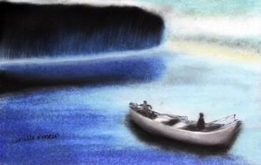
Ichiro was fishing near the coast of Banda Aceh, Indonesia, when the 2004 tsunami struck his boat. Stranded on an island during the devastation he wondered if he would ever see his family again.

'if...then...'
John Mann / US / 13 Min
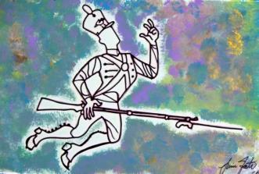
'if...then...' is a short personal essay film exploring the nature and impact of accidents in childhood

Jerusalem Voices
Dandan Liu / Israel / 23 Min
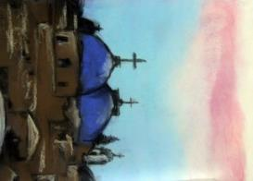
"Jerusalem Voices" presents a fresh, intimate look at life in the holy land through the eyes of three young locals: an orthodox Jewish settler, a Palestinian boy who lives in a refugee camp, and a Palestinian girl with Israeli citizenship caught in between sides. While mainstream news coverage of the region focuses on violence, this documentary focuses on daily life and how the conflict shapes the everyday experience of its residents. From sunrise to sunset, street scenes and rhythms of Jerusalem weave throughout the film as its young characters navigate through their peculiar, often contrasting, worlds.

Kanu Belong Karen
Daniel von Rüdiger / Papua / 17 Min
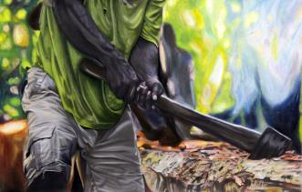
Kanu belong Keram is a document of the building of a canoe in the remote village Kambot. It is located at the jungle river Keram, which is a side stream of the great jungle river Sepik in Papua New Guinea. The building of a canoe can be seen as an example of the importance and greatness of community work. Just the strength of many people can achieve something so big and heavy. The indigene population is highly adapted to their environment. The strength of their bodies, the synchronization as a group and practical know how is compensating the lack of technical equipment

The Land Beneath Our Feet
Sarita Siegel / Liberia / 60 Min
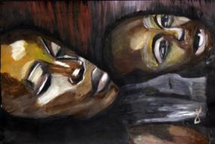
When lost footage from the 1920s depicting a corporate land grab in the early days of globalization arrives back in Liberia, it sparks inquiry into how Liberians lost sovereignty over the very land that sustains them.

Laundry Lives
Sarah Pink, Nadia Astari / Indonesia / 40 Min

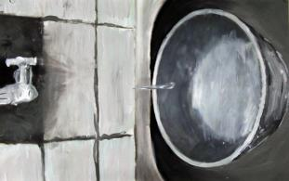
Laundry Lives takes us into the usually invisible everyday worlds of five middle class Indonesians - Lia, Dyna, Ning, Adi and Nur. As Indonesia's economy and market grows there are hidden implications for the domestic lives of the country’s rapidly expanding professional middle classes, and for environmental sustainability. Laundry Lives captures this moment of change, showing the shifting gender relations, new technologies and environmental concerns that need to be accounted for in the design of sustainable futures.

Let’s Get Rhythm
Irene Chagall / USA / 54 min
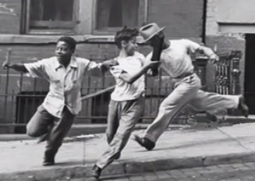
The wondrous hand-clapping games of inner-city playground in New York City and the remote corners of the world alike become a music genre and a fertile subject for exploration in this delightful homage to the beauty of the beat. Three 8-year old girls charm with personal insights of the hand-clapping experience while archival footage collected by Alan Lomax and choice observations by ethnomusicologists, folklorists, and just plain folks stress the empowering impact of the practice on the lives of women.

Lost Manchurian Shamans
Kin Taii / China / 66 Min
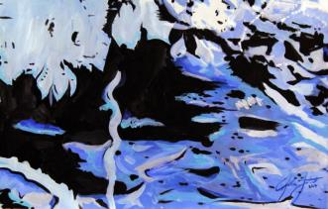
This film tells the story of Manchurian shaman culture, reaching back to its roots in history and its tribal identity. It brings to life the origins of the Manchurian peoples, showing their spirit and soul. Throughout the film, director Kin Taii takes his camera to various locations where he meets elderly shamans, as well as a new generation of shamans, sharing their insights and thoughts and the important ceremonies of Manchurian shamanism. While bringing to light the emerging hopes of the Manchurian people, he shows the wider connections of shamanism to people’s lives.

Make-It-Rail
Danny Hoffman / Liberia / 5 Min
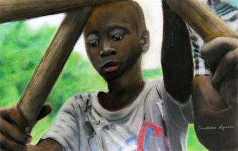
In the ruins of central Liberia's iron ore mines, groups of local boys work together to move people and goods along abandoned railroad tracks. This is the Make-It-Rail.

Marcel Taille, Herdsman and Dairyman
Martin BÌ_del / Germany, France / 25 Min
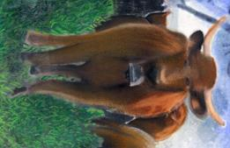
Together with his sister Aline and his brother Joseph, Marcel is running a cattle farm in the mountainous French departement Cantal. In early summer, with the transhumance to the mountain pastures, his favoured way of working and living begins: the daily routine of a herdsman and dairyman. With passionate commitment he continuous the working life he always lived, regardless of increasing bodily strain. During the first weeks of the summer season of 2015, when the film was shot, his brother Joseph was helping out, because, as almost every year, the family had difficulties finding a seasonal worker. The men live and work for four months in the mountains, milking and producing cheese in daily routine.

Marie's Dictionary
Emmanuel Vaughan-Lee / US Native American / 10 Min
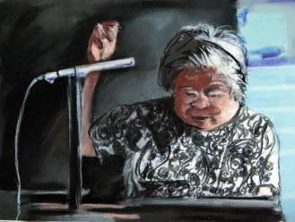
This short documentary tells the story of Marie Wilcox, the last fluent speaker of the Wukchumni language and the dictionary she created in an effort to keep her language alive.

Measure Up
Jess Pardoe / UK / 11 Min
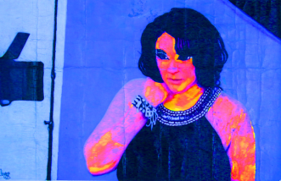
Plus vs straight size is an ongoing battle, but why must we discriminate and separate them? Documentary about sizes in the plus size modelling industry, media representation, and body confidence.

Meissa
Emilia Rüf / Senegal/Finland / 23 Min
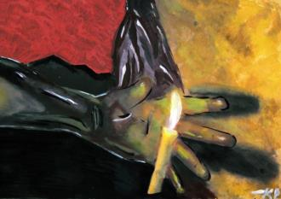
Meïssa is a portrait of Meïssa Fall a Senegalese bicycle repairman, artist and philosopher. The camera follows Meïssa on his daily ventures juggling between the identities of an artist and that of a mechanic. At a metal workshop, under the supervision of the artist, workers transform abandoned metal parts into imaginative sculptures and masks. Through his down to earth philosophy Meïssa explores the role of the artist in society and the meaning of making art as leaving a trace in the world.

Memory of Forgotten War
Deann Borshay Liem, Ramsay Liem / Korea / 38 Min
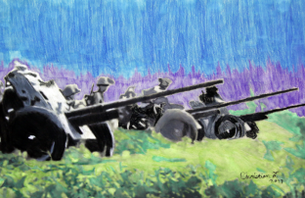
Memory of Forgotten War conveys the human costs of military conflict through deeply personal accounts of the Korean War (1950-53) by four Korean-American survivors. Their stories take audiences through the trajectory of the war, from extensive bombing campaigns, to day-to-day struggle for survival and separation from family members across the DMZ. Decades later, each person reunites with relatives in North Korea, conveying beyond words the meaning of family loss. These stories belie the notion that war ends when the guns are silenced and foreshadow the future of countless others displaced by ongoing military conflict today

Mile
Melody Howse / Germany / 6 Min
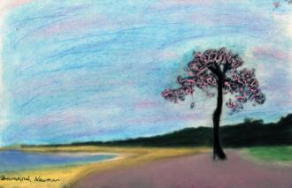
Machinima and visual interpretation of the online experience of motivation.

Natural Selection
Cynthia Cazañas Garín / Cuba / 12 Min
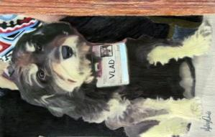
This documentary reflects the mistreatment of animals, mainly dogs and cats, which is an usual and insensible practice today in Cuba. These practices are the direct result of Cuba's lack of an Animal Protection Act.

The Network Keeper
David Dufresne-Denis / Canada / 5 Min
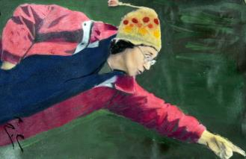
In Haute-Gaspésie (Qc), it is still impossible to get a high-speed Internet connection in some areas. Thankfully, there is Ginette and her trusty relay system.

Nicobar, a long way…
Richa Hushing / Nicobar / 60 Min
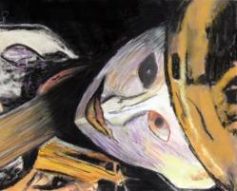
Deep in the Bay of Bengal, the Nicobar archipelago, a tribal reserve protected under Andaman and Nicobar Protection of Aboriginal Tribes Regulation, was one of the worst hit by the Tsunami of 26th December 2004. Self-subsistent and relatively isolated, post Tsunami the aboriginal world was suddenly invaded by unprecedented aid, developmental initiatives and mainstream integration. The film observes Nicobarese identity and cultural resilience.

Nobody Home
michal bentovim / Israel / 58 Min
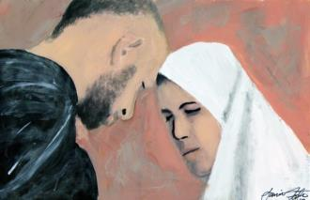
Mount of Olives – overlooking Temple Mount and the absent Holy Temple. Tradition proclaims this is the closest point on earth to heavenly sanctity, and burial here ensures proximity to eternity. Yet among the tombs we find the living: those who have chosen this holy mount for their home, who have elected to live in the shadow of death in the hope of finding redemption. This is an impressionistic portrait of a holy mount shrouded in history and prophecy, the people who live on it, and their search for meaning, faith and calling.

Not Black Enough
Tracey Anarella / US / 57 Min
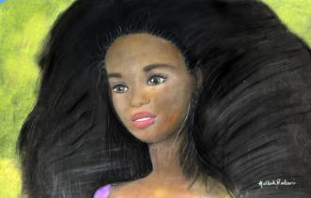
A Film by Tracey Anarella Not Black Enough is a film about class warfare and the cross-tides that African-Americans are dealing with within the black community. The film takes a sometimes humorous, always personal, brutally honest and insightful look into a seldom-explored phenomenon that is pervasive in the black culture- The ostracizing of blacks for being Not Black Enough. Not Black Enough, a feature length documentary, will explore the reasons behind this practice of fear and loathing internal to the black community.

Ocumicho sauvé par le diable (eng)
Fred Choffat / Switzerland / 26 Min
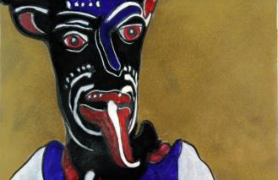
The virgin, the devil, dollars and Marcelino. How did this begin? How could the Purépecha Indians of Ocumicho, Michoacán, who have a devoted cult to the virgin, come to make devils out of clay that are to become famous folk-art objects across the world!?! Around the comal they tell of a certain Marcelino, a man unlike any other. A man who made tortillas like the women. A man who it seems met the devil!!

The Offering
William Silva Reddington, Guille Isa / Peru / 7 Min
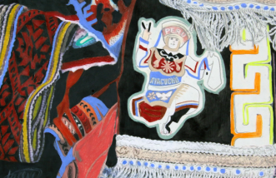
Two musicians and a dancer make an ancient and sacred ritual offering to the earth.

The Paradise
Tomás Faiman / Uruguay / 20 Min
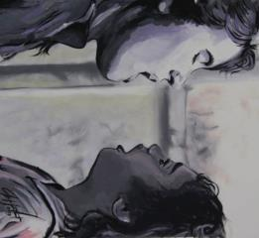
As often happens in life, there are no individuals guided by a clear and unique purpose, which pursued with perseverance. It is, rather, an audiovisual essay about a place and people living in that context. "El Paraiso" refers to a place, on a trip, imaginary and real that is anchored in the memory of the author. It is a documentary about the look, captive in a universe with an apparent normality that conceals a sordid reality.

People Like Us
Tina Gharavi / UK / 12 Min
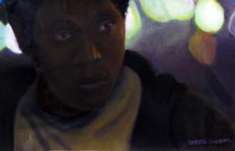
How do you cope with being convicted of a crime you know you did not commit? What happens when you are condemned to death row and spend over 18 or 30 (sometimes many more) years of your life locked away; often not knowing how long you will be alive? How do people survive when placed in such extraordinary situations? Since DNA evidence has come into play, approximately 300 people have been released from death row after tests showed they had been wrongfully convicted. Resurrection After Exoneration (a charity based in the US) is continuing the battle to release those condemned to death in the US where scientific evidence can contradict the verdict.

Peumulia Jamee
Goh Chiew Tong / Myanmar / 23 Min
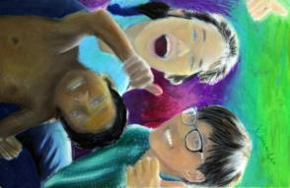
In Buddhist-majority Myanmar, unfair citizenship laws have rendered the Rohingya Muslims stateless. Desperate to break the cycle of persecution, poverty and exclusion, the Rohingya have been escaping to nearby Southeast Asian countries through illegal smuggling networks. Boatloads of Rohingya were left stranded in the Andaman Sea in May 2015, following collective rejection from Malaysia, Thailand and Indonesia. Thankfully, fishermen from Aceh — a province in Indonesia — spotted the boats at sea and brought them to shore. However, despite having found a place of refuge, the Rohingya are escaping from their refugee camps.

Port of Entry
Marisa Pearl / US / 14 Min
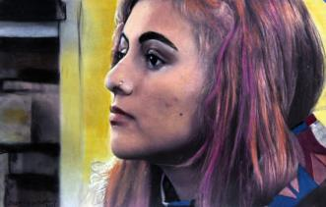
A roadside motel in Newark New Jersey harbors refugees during their first night in America. 'Port of Entry' captures a group of newcomers during their first moments in the country, exploring the sense of loss and hope that pervades the refugee experience.

The Possibility of Spirits
Mattijs van de Port / Brazil / 72 Min
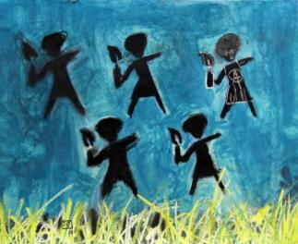
What is it that you film when you film a spirit? Shot in Bahia (Brazil), The Possibility of Spirits is an essay film that keeps the baffling mystery of spirit possession center stage. In a poetic assemblage of images and words, it offers an alternative for the kind of documentary that either exoticizes spirit possession in spectacular imagery, or extinguishes the wonder of the phenomenon in explanatory prose.

Present Moment
Aimie Vallat, Noah Dassel / US / 8 Min
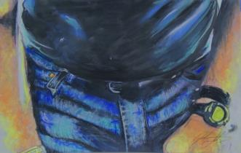
PRESENT MOMENT is a collaborative film project documenting a family negotiating the realities of a longterm, degenerative illness. The film is a celebration of living life well, despite whatever health challenges one might face: our protagonist's wisdom, honesty and courage inspires the viewer while reminding them of their own innate resiliency.

The Pursuit: 50 Years in the Fight for LGBT Rights
Ilana Trachtman / USA / 57 Min
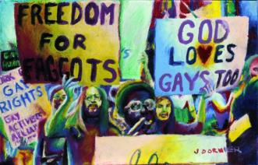
The Pursuit is a reflection on the fight for LGBT rights, more than 50 years since protesters gathered in front of Independence Hall and called for an end to discrimination against homosexuals. Contrasting stories from LGBT experiences past and present, a complex and vibrant picture emerges that demonstrates both how far the community has come and how far there is left to go.

Queen
Victoria Quamme / US / 6 Min
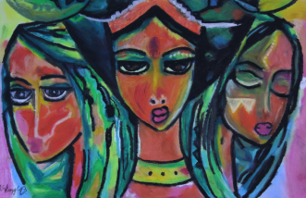
A poetic portrait of a beekeeper and her bees as they both prepare for the coming winter.

Raising the Words
Chloe Ellingson / Canada / 15 Min
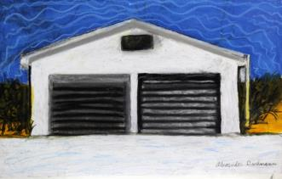
After generations of systematic cultural assimilation, Indigenous languages across Canada are endangered. In light of a building Indigenous political revival, however, languages in many communities are being revived. Transcending the longstanding stigmatization experienced by their ancestors, an empowered young generation in Tyendinaga Mohawk Territory is revitalizing the Mohawk language. Raising the Words, a short documentary film by Chloë Ellingson, paints a lyrical portrait of six speakers who are a guiding light for a silenced language.

RAMI
Hassan Fouad / Lebanon/ UK / 12 Min
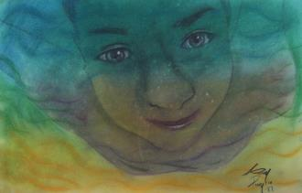
A Palestinian handicap football couch lives in Buss camp for refugees, founder of Al Nasr football club making out several players who are playing in the Lebanese premiere league . Although of his physical disability and extreme poverty he still willing to achieve his goals.

Rebuilding Hope
Ismary Mart’nez / Ecuador / 15 Min
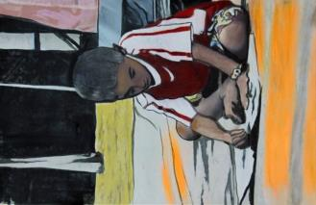
Participatory documentary video that narrates the devastating earthquake that hit Ecuador in April 2016 as told by Sarita, one the children at a refugee center in Manta.

Rest Stop
Isabelle INGOLD / France / 55 Min
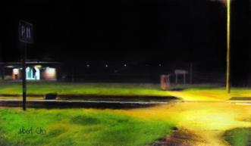
Picturing a highway rest stop, this documentary traces out the portrait of Europe today.

Rising
Mara Alper / Bali / 5 Min
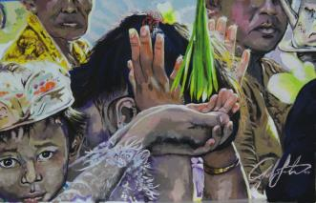
Sacred traditions of the Bali Hindu culture are revealed with evocative images, music, sounds and words. Ceremonies for fire, water, and air portray a sense of Balinese spirit in this poetic experimental documentary.

River Nomads
Eric Hahonou / Nigeria, Niger, Mali / 43 Min
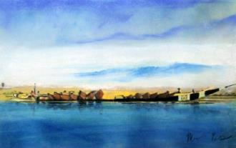
'River Nomads' is a humanist film following the journey of nomadic fishermen along the Niger River from Nigeria to Mali. The first in a series of three, 'River Nomads' focuses on the lifestyle of such nomadic fishermen. Additionally, the film tries to answer the question of why there have been less and less nomads participating in annual crossings.

The Sad Monk
Diana Frankovic / Nepal / 11 Min
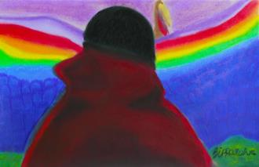
A Tibetan buddhist monk is grappling with existential anxiety. His insights challenge a universal human foible: the obsessive pursuit of happiness. The Sad Monk takes a look underneath the surface of a distinct and idealised environment; the holistic upbringing and rhythm of life in the monasteries of Nepal.

Scandal in Ivansk
David Blumenfeld / Israel / 77 Min
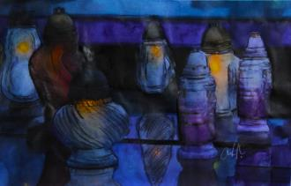
A photographer journeys to his grandfather's former Polish shtetl in search of memories and how they are formed...and forgotten.

Seeing Glass
Hannah Rifkin / US / 6 Min
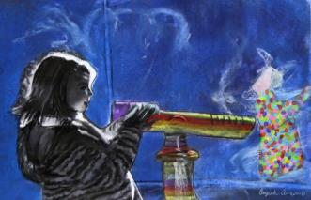
An experimental short film conveying the feeling of entrapment that animals face in the zoo and exploring the connection humans have to the animals they observe. This film examines the ability of humanizing and connecting with another creature while still showing the tangible barrier that exists between the two.

Shahyad
Alon Wohlfeiler Kahaty / Israel / 51 Min
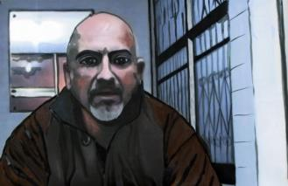
Every time turmoil with Iran occurs, the television studios in Isreal are calling Miki, the local expert on Iran. Miki, who came to isreal in 1979 from Iran has no academnic education. On a daily basis, you can find Miki at his printing house 'Cat Print' located on a side street in Holon. This is the entrance gate to the Iranian community in Israel. Miki Kamel Pinhassi is a 47-year-old bachelor. For the last 20 years he publishes the newspaper 'SHAHIYAD'. Over the years, his business became a life project. The tiny shop became the junction between the Iranian Community and the establishment.

Shepherds in the Cave
Anthony Grieco / Italy / 60 Min
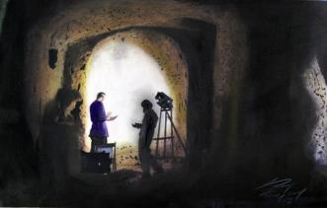
An international team of art restorers, archeologists and volunteers begin work on the restoration of religious frescoes inside a network of ancient caves. Faced with local bureaucratic challenges and systemic neglect of archeological sites, the team encounters a community of shepherds and migrants that have used the caves for centuries and discover a living culture worth preserving most of all. (Feature-length documentary produced with support from The Canada Council for the Arts.)

Siren Song: Women Singers in Pakistan
Fawzia Afzal-Khan / Pakistan/ US / 11 Min
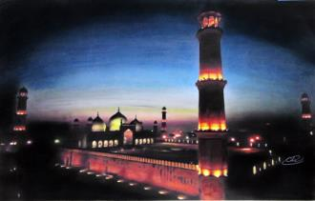
Women are often neglected in history, and women artists more so, especially in some Muslim societies. This documentary focuses on the roles played by women singers throughout the history of Pakistan from its creation in 1947 to the present. These singers’ stories are woven into the fabric of the country, sometimes as reactions to historical events, other times as voices speaking out in opposition to the oppression of women, and in some cases, leading the way forward.

Small People. Big Trees
Vadim Vitovtsev / Central African Republic / 45 Min
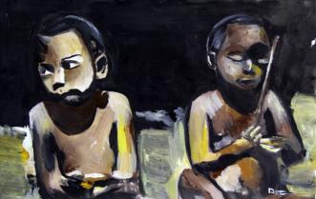
The Central African Republic. Here in the shade of sub-panel rainforests lives a tribe of the shortest people on Earth -- the Baka pigmies. As it was hundreds years ago they hunt for meat and gather gifts of big trees. They pray to the spirits of the forest and teach their children to respect the forest, to take from it only what is of great need. But little by little their traditional mode is changing under the pressure of of the 'Big World' ?ulture.

The Song Collector
Erik Koto / India / 54 Min
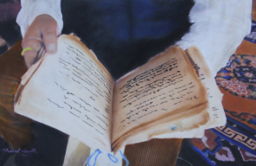
In the 1960s Morup Namgyal sparked a cultural movement that would bring about profound change in his homeland of Ladakh. It was a movement built on education, tradition, and preservation. What Morup could not imagine at that time was that he would ultimately embrace development and modernization. Through the intimate interactions of three generations of the Namgyal family, The Song Collector explores the uneasy relationship between culture and development and ultimately offers a new vision, inspired by the Buddhist concept of the ‘middle path’, that seeks to find a lasting coexistence between tradition and modernization.

The Stag's Mirror
Robin Starbuck / US / 10 Min
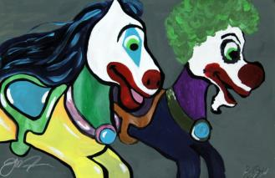

(still) hunters and gatherers
Henrikke Baumann, Gibran Vita / Sweden / 12 Min
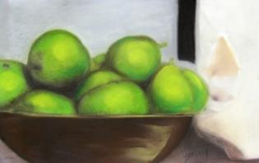
The advent of the anthropocene was preceded by the advent of the holocene. One of the characteristics of the holocene is that it was a period with stable temperature and weather patterns, which in turn enabled the development of an agricultural society. Before that, human subsistence relied heavily on hunting and gathering. Given climate change and more unstable weather patterns, present-day practices of hunting and gathering for subsistence become relevant to explore. In this study, focus is turned onto hunting and gathering in urban environments. Empirical cases mainly in the Göteborg region (Sweden) are documented.

Struggle and Hope
Kari Barber / USA / 65 Min
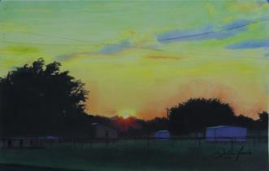
Among the wealth of untold stories in American history is the rise and slow disappearance of all-black towns that sprung up in the American West following the end of the Civil War. Founded in an effort to convince the U.S. to create an all-black state, most of these towns have now been swallowed up by nearby counties and cities, or are clinging desperately for their survival. Struggle & Hope mines the stories of the last-remaining residents of these towns, while charting their heroic efforts to ensure their town retains its independence, character, and even hopes for a better future.

Tayo Tayo
Patrick Chadwick / France, Italy, Switzerland / 10 Min
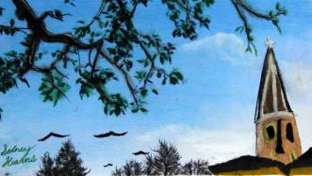
Yeb Saño, a former diplomat, leads a group of climate pilgrims on a journey across Europe. They pass through the Alps, and head towards Paris in the wake of the terrorist attacks. Along the way they connect with communities who share their vision of peace and religious tolerance. Filipino street artist AG Saño tells his story of surviving Typhoon Haiyan, and of losing his best friend Agit who perished in the storm. The pilgrimage is an inner journey for many of the pilgrims, and a meditation on how we relate to each other, to nature, and to the other species who co-exist with us. The pilgrimage ends in Paris, where the UN climate conference takes place within a tense political atmosphere.

Tereza's House
Aida Vidan / Croatia/US / 14 Min
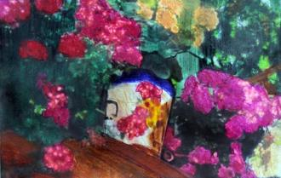
Tereza’s House is a poetic-documentary about the life of a woman from a Croatian island who lived through three wars and whose family migrated to several continents.

Undercover in Underwear
Diane Agatha / UK / 20 Min
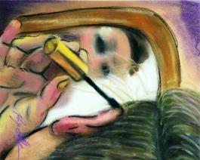
The Internet provides an infinite place of freedmon where self, mind and body are dislocated. We are able to reinvent and present ourselves the way we want. It is in this world that Circle, my alter ego, was born. This film is the result of my journey, exploring and embracing my own desire, while reflectinng on representations of female sexuality in the era of the Web 2.0. "Undercover in Underwear" presents a unique glimpse into camming, an online and interactive branch of adult entertainment. The film shows different points of view at play: the viewer, the performer, the audience and the anthropologist. This shift of perspective is an attempt to abolish stereotypes

Unfair Game: The Politics of Poaching
John Antonelli / Kenya / 37 Min
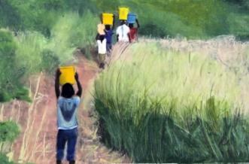
Explores the ongoing conflict between wildlife conservationists, who strive to protect natural resources, and the indigenous people who have survived on and protected those resources for centuries.

Unity: Dress-scapes of Accra
Mara Lin Visser / Ghana / 37 Min
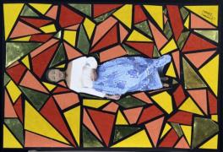
The comeback of African print seems to be emerging in the fashion system of Accra. While following Allan, a fashion designer and his wife Cynthia, this mosaic film shows the great diversity of tailor-made fashion and hybrid styles; the ways the African wear is used and the expression of culture by wearing the African prints. The process of sowing a dress shows the marriage of both fabric & design, tradition & creativity ànd husband & wife.

Ushering in the Spirit
Sam Hampton / US / 13 Min
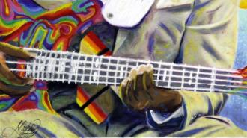
A Documentary Short Film by Sam Hampton 13 minutes - USA A intimate and unflinching account of a Sunday afternoon church service that took place at St. John Baptist Church in Rochester, New York.

Vishneva, Belarus Soviet Union Poland
Jacob J. Podber / US / 3 Min
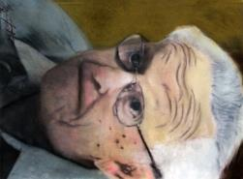
“Vishneva, Belarus Soviet Union Poland” is grounded in the oral history testimony of a Holocaust survivor and has been deconstructed by the interviewee’s son. Unlike most oral histories that focus on the words of the interviewee, “Vishneva, Belarus Soviet Union Poland” uses silent images from the interview superimposed with typed memories that describe the unspoken pain borne by father and son through more than half a century.

La voix des Tatuyos
Louis Bidou / France / 52 Min
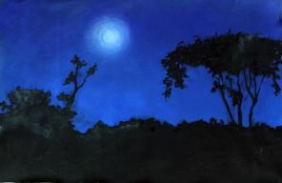
Anthropologist Patrice Bidou turned over to his son Louis the material he had recorded 40 years earlier on the shamanistic practices among the Tatuyo Indians of the Colombian Amazon. Louis Bidou and Norman Tahrat decide to go to the Amazonian forest and return these fragments of their ancestral patrimony to the descendants of the shamans. On arrival they find a society that has organized itself to be able to conserve the integrity of their world to face the increasing influence of the outside world. The Tatuyos have reinvented a transmission system by re-appropriating Western methodologies and adapting them to their own context.

Walking The Crooked Tune, A fiddler's journey out of the past
Charles Cohen / USA / 10 Min
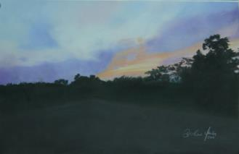
After picking up an archaic music tradition from a historic musical family now long gone, Fiddler Dave Bing stands as a keeper of a blend of Old Time that is gaining new appreciation from a younger generation, guaranteeing to both change and preserve the music.

White Mountain
Emma Charles / Sweden / 22 Min
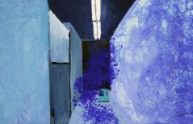
White Mountain is 16mm docu-fiction focusing on the Pionen Data Center in Stockholm. In 2008, this former Cold War-era civil defence bunker was redesigned by architect Albert France-Lanord as a data center to house servers for clients, which at one point included Wikileaks and The Pirate Bay. Playing on the science fiction aesthetic, White Mountain uncovers the varying forms of temporality brought about through an exploration of data space and geology. Starting by surveying the rough topography of the surrounding Södermalm landscape, the film gradually pushes beneath the surface, illuminating the ordinarily concealed network infrastructure. As the camera idles on the florescent-lit server stacks, issues of privacy, surveillance and digital sovereignty inevitably emanate.

Wurray
Keith Lapulung Dhamarrandji / Austrailia / 13 Min
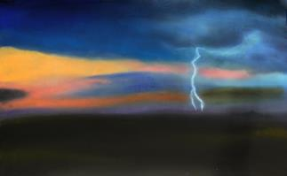
Yolngu song men trace the epic dreamtime story of their great nomadic warrior, Wurray, across the wilderness of North East Arnhem Land at the very top-end of Australia.

Zona Intangible
Rustin Thompson / Peru / 60 Min
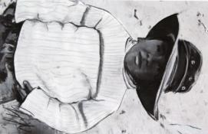
In this story of resilience and hope, Seattle-based writer-director Ann Hedreen traces the unlikely connection between the people of an asentamiento humano (human settlement), building a new life from an abandoned gravel pit in Lima, Peru, one of the world's most sprawling megacities, and her great-uncle, a Swedish-American pioneer of the modern Peruvian fishing industry. The film reveals how a single act of generosity ripples forward and backward through time, improving lives in the present and adding new understanding to the role of an outsider in the history of a country.

